Yaroslav Artsishevsky

How the mind is born

Practical methods of teaching science education to children in China

Publishing Solutions Under license from Ridero 2022

UDC 00 LBC j92 A88

Fonts provided by ParaType

А88

**Yaroslav Artsishevsky**

How the mind is born : Practical methods of teaching children science education in China / Yaroslav Artsishevsky. - [b. m.] : Publishing Solutions, 2022. - 340 с.

ISBN 978-5-0055-9712-0

In this book, the author is primarily addressing professionals who are in any way related to the increasingly popular STEM education around the world. Thanks to her experience in China, the author describes in detail the particularities of teaching methods (editing, classroom management and many others) for creating a successful learning environment in China. The material will be useful for educators wishing to diversify classroom activities, improve teaching methods and lessons in general.

**UDC 00 BBK y92**

In accordance with the Federal Law of December 29, 2010 № 436-FZ

16+

ISBN 978-5-0055-9712-0 © Yaroslav Artsiszewski, 2022

# Table of contents

Addressing the reader 11

Part 1. Science teacher 13

Chapter 1: The Story of Me and the Connection

since education 16

Chapter 2: Statistics 18

* 1. About education 18
  2. An excursion into Chinese history 20
  3. Education in China and learning

English 27

* 1. My journey to China 30

Chapter 3. STEAM, or Science, Technology,

Engineering, Art and Math 33

* 1. What is STEAM education 33
  2. Blended learning 38
  3. Edutainment 39
  4. My first steps in China 40

Part 2. Training part. 45

Chapter 4: The Three Main Components of Science Education 48

Chapter 5. The Teacher, or the Question of WHO 51

* 1. How to be a good teacher 53
  2. Languages or the ability to express one's thoughts 55
  3. Voice 56
  4. Body Language 57
  5. Public speaking skills 59
  6. Science teacher 63
  7. My introduction to the country 66

Chapter 6. Lesson Plan, or the HOW question 69

* 1. Example lesson plan template 70
  2. Comments on the lesson plan template 72
  3. Example of simplified plans for

10 lessons 82

* 1. Food in China 89

Chapter 7: Equipment, or the "WHAT" Question 91

* 1. Use of equipment 92
  2. Types of equipment 93
  3. Logistics and storage conditions 96
  4. Caring for the environment 97
  5. The Environment in China 98

Chapter 8: The Lesson. How the process happens. 100

* 1. Before the lesson 100
  2. During the lesson 105
  3. After class. 106
  4. Communities in China 110

Part 3. Class Management, or Class-

management 113

Chapter 9. What is Class Management? 116

* 1. Universal classroom strategies-

management 118

* 1. Classroom management strategies for an individualized approach to the student 128

Chapter 10. Classroom Management in Science Lessons131

* 1. Space organization 133
  2. Discipline and Rules 139
  3. Teamwork 142
  4. System of rewards and punishments 145
  5. Gamification 148
  6. Roles 153
  7. A change of context and mode of action, a release of excess energy 155
  8. Time Management, or Time Management 158
  9. My move to Shanghai 160

Chapter 11. Security 162

* 1. Safety of science classrooms 163
  2. Use of protective gear 166
  3. Equipment and materials inspection 168
  4. Think carefully before you

Bring plants or animals into the classroom 171

* 1. Preventing burns and fires 173
  2. Cleaning up broken glass and spills

fluids 176

* 1. Installation of emergency procedures 177
  2. Safety rules for students 177

Part 4. Teaching methods 181

Chapter 12. On the various methods of teaching 186

Chapter 13. Storytelling 246

* 1. What is Storytelling? 247
  2. Practical application of Storytelling 251
  3. Personal Storytelling Experience 255
  4. STEM science education 257

Part 5. About science and its directions 259

Chapter 14. How Science Works 263

* 1. Areas of Science 264
  2. Scientific method 269
  3. Science at work 273
  4. The engineering design process 276

Appendix 1: On Safety in the Conduct of Science Classes 282

Chapter P1. Where can I find a general checklist of questions

on the safety of science lessons? 285

Chapter P2. General checklist of work procedures for laboratory work 291

Chapter P3. How to prevent accidents

and minimize their consequences? 298

Chapter P4. How to identify chemicals for use in elementary classrooms and how to

Handle them? 305

Chapter P5. What protective equipment elementary school teachers and students should

apply during science classes? 311

Chapter P6. What guidelines define the characteristics of elementary classrooms, laboratories, and classrooms for

science classes? 316

Chapter P7. What are the precautions for having animals in the classroom? 320

Chapter P8. What precautions should be taken when using

plants in the classroom? 326

Chapter P9. What safety issues need to be considered when planning and conducting field trips

and in field experiments? 330

Chapter P10. What is the legal responsibility of an elementary school teacher

for the safety of scientific pursuits? 334

Links 339

### First they ignore you, then they laugh at you, then they fight you.

**And then you win.**

*Mahatma Gandhi*

*Dedicated to all my past, present and future partners.*

# Address to reader

Greetings, dear reader. In this book I would like to talk about many things. And in the course of my narration, I will need to address the reader often. In many fiction books I have often encountered an approach where the author speaks to the reader on a "first name" basis. I myself am the type of person who tries to establish a friendly and informal relationship from the first moments. At the same time I would like to express my respect for the time the reader has taken to read my book. And the book contains a lot of methodological advice, which is better conveyed in a more formal way. That is why I want to address the reader as "You" in my narrative. But when we get to know each other in person, then we can get right down to informal conversations.

So, if you, dear reader, are reading this book, it means you have a desire to learn something new. Or maybe you want to change or even improve something.

Who would be interested in this book?

First of all, to those people who are in any way related to STEM or science education. All over the world and especially in China.

To all teachers and especially to teachers of English who would like to diversify classroom activities, improve teaching methods, and improve lessons in general.

The book will be useful to educational institutions, attentive parents, and inquisitive students.

All the information in this book is the result of my personal research and its interpretation. If some of the techniques described in the book don't work with a particular group of students, it doesn't mean they won't work with another audience, or that they are useless. I strongly recommend using them several times before drawing conclusions.

**Part 1.**

**Science teacher**

From the very first pages I will gradually unravel the mysteries of the world of education. It will be a combination of my journey, facts and techniques that I find important and useful. So let's imagine we are going on a journey. Every story has a beginning. It can be a set of facts and events. Or a set of reasons why things happen in the future. Right now I'm sitting in front of my laptop, writing this text. I'm trying to organize my thoughts into a logical chain. It may not be as beautiful as the world's bestsellers, but it's also how I see what I want to talk about.

to be.

Perhaps some parts of the book will be about something unrelated to science education. Still, this information, in my opinion, needs to be learned as well.

# Chapter 1. The Story of Me and

# with education

For as long as I can remember, I have always been interested in life in other countries. At first, of course, it was the United States of America. Then the focus slowly shifted to the East. Eventually China became my center of attraction. A magical aura always surrounded that country. It wasn't that I was familiar with its history or culture, or spoke Chinese. No. It was just a country that attracted me to it.

My reasoning was that China's economy is growing the fastest in the world. There are more Chinese people than anyone else in the world. China produces a lot of products. That means that in the future this country will be the best!

Curiously enough, almost the same reasoning helped me to choose future higher education in the field of information technology. And, as it is clear now, I was not mistaken: both of these fields are really quite strong and are developing vigorously at the moment.

One day in my life there came a moment when I had to choose where to go next. At one end of the scale was Moscow, the capital of Russia. I had a few

I've been to this city once, I've lived in the suburbs, and I have an approximate idea of what's going on there. Of course, life in the capital is completely different, there are a lot of interesting things there. And yet I had already been there.

The counterbalance was China. I had no acquaintances there; I knew neither the language nor the culture of that country. But for a long time I had a burning interest in it. As it turned out, it was no accident...

# Chapter 2. Statistics

## About education

Education. From my childhood, I remember that education is synonymous with learning. First at school, the basics of the world around us are learned. By high school, learning becomes more in-depth. In high school, the learning process became more serious. In the transition to work, the term "education" became synonymous with

"money."

Every person in this world begins to learn something new from the moment they are born. The first teachers are parents or grandparents. After a few years, this role is taken over by the kindergarten teachers. Then school, college and university take over.

As we know, education is a huge market. In the Russian education we can count about ten directions1. It is a huge market for education in the Russian Federation, and there are about ten areas of education1.

1 For more details on education in Russia, see the website of the Federal State Statistics Service at https:// rosstat.gov.ru/folder/13398#.

What happens next? After you graduate with a degree?

More often than not, a recent student becomes an employee of a company and his education continues at best in corporate trainings. But even this is good. After all, for others it simply stops. Unfortunately, the rating of self-education in Russia is low1.

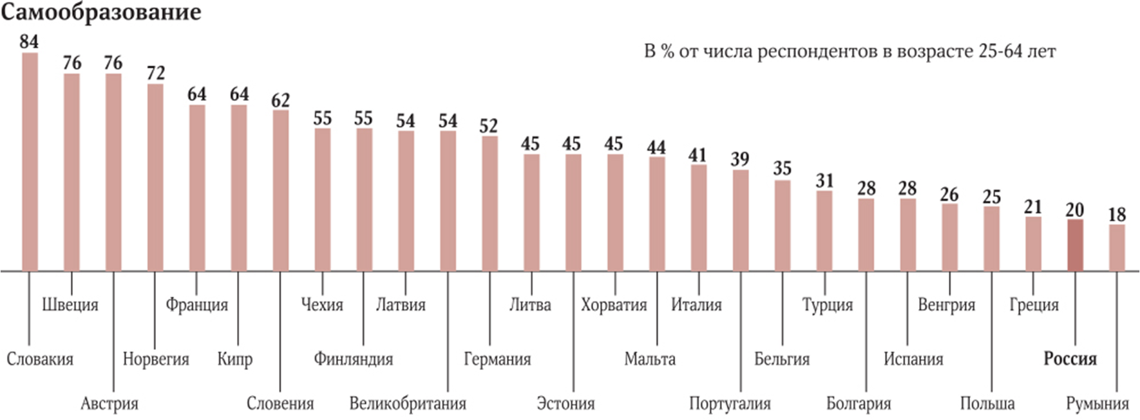

The trend of lifelong learning is gaining popularity in the world. When everyone can learn something new over the course of a lifetime in accordance with their current tasks and occupation.

The education market is constantly changing. New technologies and computerization are pushing standard

1 According to research by the newspaper Izvestia, Link https://iz.ru/ news/719297.

learning patterns going forward. And this pressure became even stronger during the COVID-19 coronavirus pandemic.

## A History of China

Being in China for a while, I started comparing different aspects of Chinese life. Like, for example, eating, looking at life, relationships between people. They are very different from the usual ways of life in Russia, Europe or North America. So the question in my mind was, "Why? In my opinion it is very important to understand the history besides statistics, numbers and rankings. Why things are the way they are now, and what led to the current situation

What's the best way to get things done?

Since this book describes science education in China, I have decided to include a brief history of the country over the past one hundred and fifty years. Because traditions and attitudes to life over this period of time also influence contemporary Chinese society.

So, what was going on there?

After the Qin Manchurian dynasty came to power in the mid-17th century, China gradually began to isolate itself from other states. The authorities considered contact with foreigners to be extremely dangerous. However, advanced China was la-

The Middle East was an important piece for the European bourgeoisie. The Middle Kingdom actively exported tea and silk, in return receiving opium from Great Britain, which the latter in turn exported from India. Opium smoking became a plague on the Chinese, and the authorities prohibited imports. Opium wars began, in which the Celestial Empire was defeated. Anglia took Hong Kong, France and the U.S. were not spared. In the end, China was colonized by European states.

### Consequences of the Opium Wars

The defeat in the opium wars undermined the local population's confidence in the country's government. The weakening of imperial power caused social destabilization in China. The Qin dynasty was unable to establish mutual understanding among the different segments of society. Opposition groups emerged here and there, directly threatening the official government. Unrest and revolts swept the country.

One of the most famous and powerful was the Taiping Movement, led by the peasant Hong Xiuquan. The movement advocated the strengthening of Confucian values. In 1850, the Taipings staged an uprising. Within a short time, they conquered the entire Yangtze River valley, declaring a new state.

with the capital city of Nanjing. The Chinese often refer to Nanjing as the former capital.

The Taiping dreamed of creating a utopian state with a just society. They actively fought the local feudal lords and the imperial dynasty. However, their plans were not fated to materialize: in 1864, the official government of the Celestial Empire liquidated the Taiping state.

### Qi Xi's reign

This was the period of the reign of Empress Qi Xi (1861-1908). She was actively engaged in the modernization of the country, considering her main task to strengthen China. The empress dreamed of taking all the best achievements in science and technology of other countries and putting them at the service of China. The industrial sector began to develop rapidly, but it was dominated by foreign enterprises. The budget was mainly spent on the armed forces and the strengthening of industries. This had an impact on the formation of the Chinese bourgeoisie. However, the lack of change in agriculture slowed down the industrialization of the state. The course of consolidation did not produce the results that

was expected of him.

The lack of necessary reforms exacerbated the crisis in the state. The second half of 1899 was marked by the activity of the society "Kulak in the name of

The Ihetoan (Peace and Justice). Its supporters opposed the destruction of traditional Chinese values and the attributes of European civilization.

Empress Ci Xi decided to use the forces of the Ihe Tuan group for the good of her country, to fight Western influence and restore China to its former glory. She signed a decree declaring war on the countries of Europe and allowed the participants to

"Ikhetuan" to enter Beijing. This news prompted the heads of European countries and Japan to send their troops to the Chinese capital to suppress the uprising. On August 14, 1900, the interventionists entered Beijing. They succeeded in crushing the uprising. The representatives of the European powers then imposed even stricter conditions on China. Foreigners were allowed to keep their troops and navy in China, and the Celestial Empire was obliged to pay an impressive contribution.

For a better understanding of life at that time, I recommend watching the old black-and-white videos, colored by Artificial Intelligence. To feel the spirit of the time. For example, at this link:

<https://www.youtube.com/watch?v=5bQwGlMEeOE> or QR code.



### PRC

At the end of the nineteenth century, China experienced a profound crisis, which resulted in the revolution of 1911-1912. The monarchy was overthrown and China became a republic.

On July 1, 1921, the Communist Party of China was established. In October 1949, the establishment of a new state, the People's Republic of China, was announced. The Communist Party, which came to power, initiated a major transformation of Chinese society.

One of the most important reforms was the agrarian reform. 47 million hectares of land were taken from the landlords and divided among the peasants. Foreigners' property in China was nationalized, and trade and industry were placed in the hands of the Celestial Government. At the same time, the process of industrialization continued apace. In this process, the Soviet Union rendered tangible assistance to China.

### Peculiarities of the crisis in China

The crisis in the Celestial Empire was fundamentally different from the Eastern European scenario. China was accelerating its development, striving to regain its former glory. In 1958, Communist Party chief Mao Tse-tung endorsed a new "three banners" policy, which aimed to achieve accelerated

growth through the development of small-scale industry. Local governments took the initiative in economic planning. People's communes, which worked for free, were supposed to develop small industries. To meet the global challenge of building communism, the Celestial government even prepared for a nuclear missile war. This caused a cooling in relations between China and the USSR.

The "three banners" course failed. Because of the abolition of the monetary incentive to work, production began to fall. Famine broke out in some provinces of China. The country was thrown backward instead of forward, and an economic crisis loomed. Against this background, groups opposing Mao Zedong's policies multiplied, prompting the Party Chairman to wage an open struggle against his opponents. He wanted to attract young people to his side, urging them to commit violence in the name of the revolution and the creation of a communist society. Mao Tse-tung's supporters began pogroms across the country, destroying universities, ministries, theaters and stores. This movement went down in history as the Great Proletarian Cultural Revolution. Its consequences were devastation and chaos. It was clear that Mao Zedong's course had outlived its usefulness. The final denouement came with the death of the communist leader in 1976.

The next leader of the state, Deng Xiaoping, wanted to

to throw all its forces into taking the Celestial Empire out of the crisis.

It was his course that politics began to follow. A new era in Chinese history began.

Industry began to develop in the state. Foreign investment gradually returned to the country, co-operatives reappeared in agriculture, and the laws of the market economy began to work. The reforms had a positive effect on the state.

But relations between China and the USSR continued to deteriorate, as the Chinese authorities began to make territorial claims on the USSR. However, against this background, China's relations with other powers improved. After the collapse of the Soviet Union, good relations between the Celestial Empire and Russia were restored.

In 1989, an anti-communist uprising erupted in Tiananmen Square. But it collapsed. Not only was the Communist regime not overthrown, but on the contrary, it was toughened.

The Communist Party of China has continued to pursue the development of the state and the strengthening of international ties. The industrial development policy has borne tangible fruit, and since the early 2000s, the pace of China's development has attracted more and more attention from the international community.

## Education in China and learning English

The first contacts between the Chinese and the English came with the beginning of trade between the two countries. The first schools where English was taught opened in Macao in the 1630s. English became widely spoken between 1911 and 1949, when it was studied in Christian colleges and missionary schools. After the proclamation of the People's Republic of China, Russian became the official foreign language. However, when relations with the Soviet Union began to deteriorate, English was reintroduced into the education system. During the Cultural Revolution, condemnation of English-speaking culture continued unabated until U.S. President Nixon paid an official visit to the Middle Kingdom.

Under Xiaoping, the situation changed. The open-door policy made English and other languages more popular among the Chinese. But English was at its peak between 1970 and 1990, becoming a means of communication in tourism and commerce.

Since the end of the Cultural Revolution, when the United States began to establish strong diplomatic ties with China, the number of English speakers in the country has grown: in 2000, the number of English speakers reached

200 million people. Now more than 50 million children in China are learning the language in schools.

China ranked 47th among the 88 countries with "low English proficiency. This was most likely due to the fact that English was quite good in the big cities, while people living in the provinces had a very limited vocabulary. According to The Telegraph (2017), less than 1 percent of the population uses English in their conversation.

According to research by China Daily, many people in China start learning English in kindergarten. Schoolchildren are taught it from the 3rd grade. The situation in foreign-born boarding schools varies, but English is predominantly present from the 1st grade onward.

But learning a language early does not always guarantee good language skills later on. Many experts criticize pedagogy for being based only on testable skills. Learning the rules of grammar is mostly a matter of memorization. But don't discount creative tasks such as writing: in China, it is considered an integral part of children's learning of English.

Linguists have long recognized the ineffectiveness of language learning methods based on rote memorization of grammar rules and memorization of new words. This approach provides little or no opportunity for learners to apply

The problem arises from the widespread use of the Mandarin, which is the dominant dialect in the Middle Kingdom. This problem arises from the widespread use of Mandarin: it is the dominant dialect in the Middle Kingdom. This problem is caused by the widespread use of Mandarin: it is the dominant dialect in the Celestial Empire.

Since 2010, Guangdong Province has introduced a compulsory examination for all students. It includes English language test, 80% of which is written component, and the remaining 20% is listening comprehension. The speaking component is required only for those who take advanced English courses.

The Chinese students, however, are under great pressure year after year to achieve the required aca- demic performance. Especially before the Gaokao. **Gaokao** is the Chinese national university entrance examination. The exam takes 2 to 3 days and consists of three subjects: Chinese, Mathematics and a foreign language. It is usually English. Because the economy is growing and the market is expanding, communication with foreign partners is an issue. So, taking the Gaokao and learning a foreign language enables Chinese students to have

good future and go to a foreign university.

Of course, over the past ten years, the English language learning market has gained enormous popularity as an after-school program. Although in mid-2021 the government began to regulate the extracurricular

The first one is the "children's education," in order to reduce the burden on students.

## My journey to China

I remember that day often. Because I consider it the starting point, the beginning of my story. The visa was ready, a little research on my first steps in China was done. I also found an agent who assured me there would be a job, I just had to fly in.

I had a long flight to Beijing. The total travel time was about 20 hours, during which I changed three planes.

At the same time, on the one hand, I felt excitement and anticipation of adventure and discovery. Because I had never been to Asia before. Because it was a new, unfamiliar language to me. Because I only knew one person in the whole country, a job agent. Because China was my dream.

On the other hand, I was scared and stressed. The unknown was frightening. Because I had never been to Asia before. Because it was a new, unfamiliar language to me. Because I only knew one person in the whole country, a job search agent. Because it's a huge unknown China.

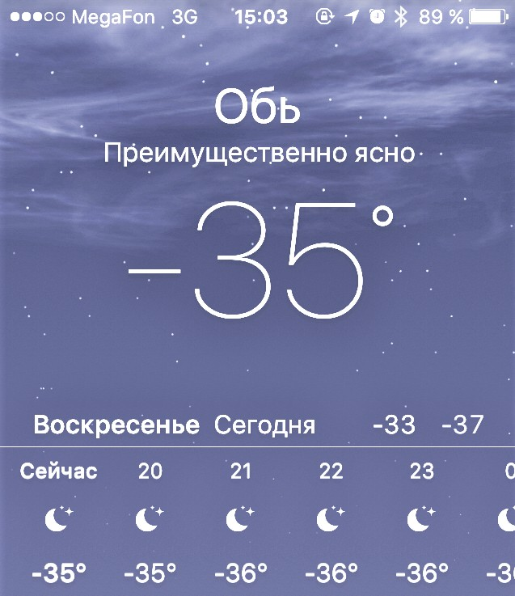

On the way to the Chinese capital, I had a layover in Novosibirsk, a city in central Siberia. As I was about to land, the plane's commander announced that the air temperature at the airport was minus 37 degrees Celsius.

I didn't know then that I would have to walk from the plane to the airport building. A cold start, in a word. That might have been normal for people from Siberia. This was the first time I had ever been in such temperature conditions.

My arrival in Beijing was scheduled for January 22, 2018, at 5:10. But the plane landed a little earlier, and I set foot on Chinese soil at 5:00 a.m. sharp.

Why do I remember that time so accurately? Because very often in China people ask me how long I've been in the country. So for the sake of interest, I started to calculate the exact time. And I answered very precisely1.

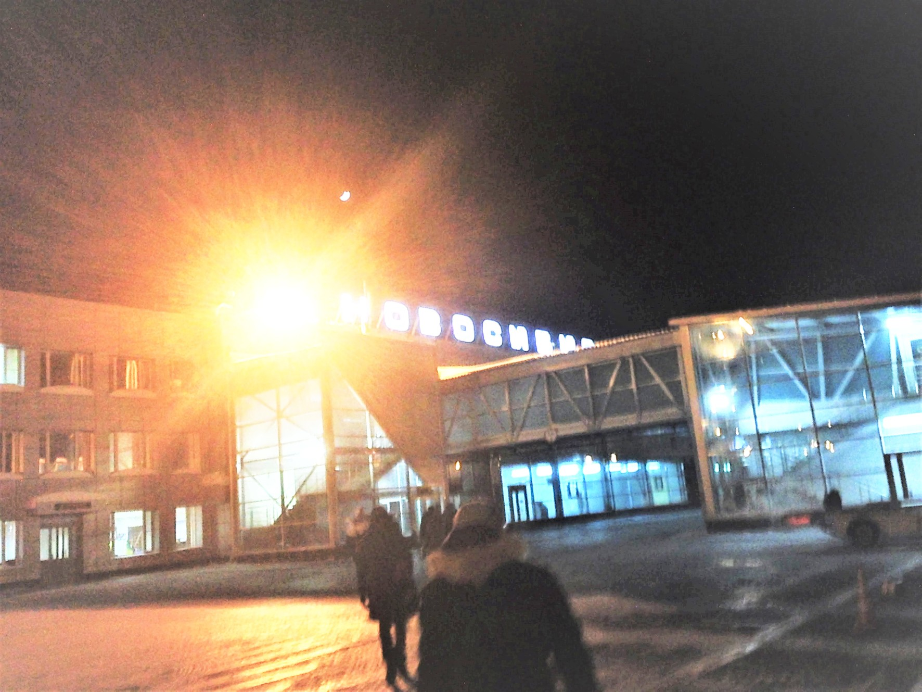

1 For example, at the time of this text I have been in China for 3 years, 8 months, 29 days and about 18 hours.

# Chapter 3. STEAM, or Science, Technology,

# Engineering, Art and Math

## What is STEAM education

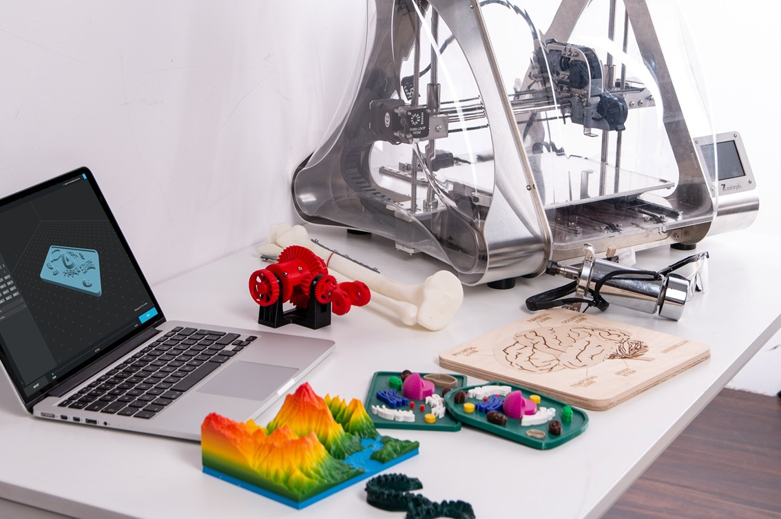

STEM is a curriculum for teaching four specific disciplines: science, technology, engineering, and mathematics in an interdisciplinary and applied way. Rather than teaching the

The four disciplines are not separate, STEM combines them into a single learning paradigm, based on real-world examples. Art, or art, is a complement in this combination, and the acronym is different: STEAM. Art allows the application of creativity and self-expression through creativity.

Historically, the United States has been a leader in this area of education.

The term "STEM" was introduced by employees of the U.S. National Science Foundation to describe a new educational paradigm in 2001. With its help, they planned to meet the growing need of the U.S. for highly qualified technical specialists for industrial and scientific development.

In 2009, the Barack Obama administration announced the Teach Innovation Campaign to motivate and inspire students to excel in STEM subjects.

Ten departments of the United States government partnered on the Committee on Basic Education (CoSTEM). CoSTEM was developing a joint national strategy for investing federal funds in STEM K-12 education, which envisioned increased public participation in STEM education.

1 https://obamawhitehouse.archives.gov/administration/eop/ostp/ nstc/committees/costem

The U.S. Department of Education currently offers a number of STEM-based programs, including STEM-focused research and youth programs and the development of better post-graduate education for STEM workers. The U.S. Department of Education currently offers a number of STEM-based programs, including STEM-focused research programs, STEM grant selection programs, and general programs that support STEM education.

According to analysts from the U.S. Bureau of Labor Statistics, the need for STEM talent will outpace other specialties by 76% over the next ten years. About 10 million people will be needed for the U.S. market alone, and the shortage of personnel persists despite an increase in the rate of training1.

### STEM education in China

Currently, STEM education is becoming increasingly popular all over the world and especially in China.

To promote STEM education in the Celestial Empire, the Chinese government issued a national innovation strategy guide in 2016, which states that by 2020 China should be an innovative country; by 2030 it should be at the forefront of innovation; and by 2050 it should be

1 [https://www.bls.gov/emp/tables/stem-employment.htm](http://www.bls.gov/emp/tables/stem-employment.htm)

The world's most powerful country in technological innovation.

In February 2017, China's Ministry of Education announced the official addition of STEM education to the elementary school curriculum, the first official state recognition of STEM education. And later, in May 2018, the launch ceremony and press conference of the China STEM Education Action Plan 2029 was held in Beijing. This plan aims to enable as many students as possible to benefit from STEM education and equip all students with scientific thinking and the ability to innovate. In response to the government's stimulating policies, schools in both the public and private sectors across the country have launched STEM education programs.

However, effective implementation of STEM curricula requires teachers who specialize in STEM education and the relevant context to be taught.

### The importance of STEM education

According to a report by STEMconnector.org, 8.65 million STEM workers were needed in the U.S. in 2018. The manufacturing sector faced a critical shortage of nearly 600,000 workers.

According to the report, 1.7 million new jobs were created in cloud computing alone between 2011 and 2015. The U.S. Bureau of Labor Statistics reported that the bulk of STEM jobs had that percentage by 2018:

* computer technology - 71%;
* traditional engineering - 16%;
* physical sciences - 7%;
* the field of natural sciences - 4%;
* math - 2%.

Not all STEM jobs require a college degree or even a bachelor's degree. Among entry-level STEM jobs less than half of them. However, having a degree has a significant impact on wages - entry-level STEM jobs are 26% higher than non-STEM jobs.

The need for STEM professionals is not just in the United States. For example, the United Kingdom wants to produce 100,000 STEM majors each year, just to meet the demand. In Germany, there is a shortage of 210,000 math, computer science, science and technology majors.

## Blended learning

What sets STEM education apart from traditional and math education is its blended learning environment. It teaches computational thinking and focuses on real-world problem solving. STEM education begins at a young age.

* **Elementary School (Grades 1-4).** STEM education focuses on an introductory course in science, technology, engineering and mathematics as well as orienting students towards STEM professions. It is learning based on standards, structure, and real-world problems. The goal is to keep the students interested in continuing their courses - both in and out of school.
* **Middle School (grades 5-9).** At this stage, learning becomes more rigorous and complex. At this level, STEM-related professions begin to be taught.
* **High School (Grades 10-11).** The curriculum is focused on the application of subjects in a complex or special environment. Many special STEM courses are now available at this level, as well as preparation for secondary education and employment. More emphasis is placed on expanding STEM learning opportunities, as well as applying skills in practice.

Also, according to statistics, girls are significantly less likely to enroll in a master's program or start a career in STEM fields. Boys are more inclined to study engineering and technology fields, while girls prefer such fields as biology and chemistry. Overall, the STEMconnect report states that males are three times more interested in STEM careers.

## Edutainment

Now let's look at another method in education. Although it can rather be called an approach, as it is a rather complex concept.

**Edutainment is** an approach that transforms learning from a boring "obligation" to an enjoyable process. It combines learning and gaming technology - the name itself is a combination of two English words: **education** and **entertainment.**

There is nothing revolutionary about this approach: in childhood, everyone learns through play. What is revolutionary is to extend this approach to other disciplines. After all, there is a stereotype in society that learning is not a game, that knowledge is acquired through pain, sweat and tears.

What are the pros of the game approach and why will it be even more popular in the future?

* **An easy entrance to learning.** The game format lets you know that something interesting and enjoyable is about to happen. The student is involved in the learning process quickly, without negative emotions. Everyone has played different games as a child; the game format is familiar to the students.
* **Additional motivation.** It is provided by game techniques: here are the goals, and there will be a reward for success in achieving them. Plus there is a competitive moment. All of this stimulates the student to complete the training to the end and to prove himself/herself.
* **Disempowering safety**. In play, the student is bolder. And if the game imitates real work, it can reveal important moments: pain points or unexpected strengths. And when the brain is relaxed, it absorbs information better.

## My first steps in China

China greeted me with an early morning and cool January weather. The air was foggy. I couldn't see the sun because of the gray sky. Upon arrival, my agent put me up in an apartment in the south of Beijing. It was a long way from here, at Liangxiang University Town station. I was given a studio on the 10th floor with only basic necessities. There's also

could make a local SIM card and change some money.

It was cold, and after a long flight the first day I just rested at home. After a good night's sleep, I decided to go out to get some groceries and scout the area. I had no idea what I could buy here and how much it would cost. Almost unfamiliar assortment, strange smells, no one knows English and no one accepts Visa cards. It was my first personal encounter with the outside world on my first evening.

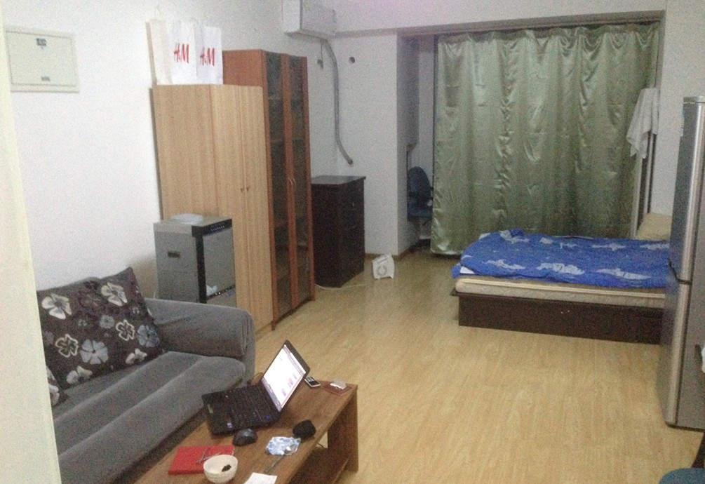

That time I bought the minimum amount of groceries, and then I looked up each item on the receipt and counted it in rubles to compare the prices with what I was used to. I had to

to use a picture interpreter. But it was interesting - everything was different from the usual way of doing things.

*Here are a few facts about the products in China that immediately caught my eye:*

* Noodles are sold everywhere. So is rice.
* Prices are usually quoted for 500 grams. This is a Chinese measure of weight, called a "jin.
* Vegetables were cheaper than in Russia.
* Products can be strange. For example, a blue egg turned out to be black inside.
* Dairy products are not common.

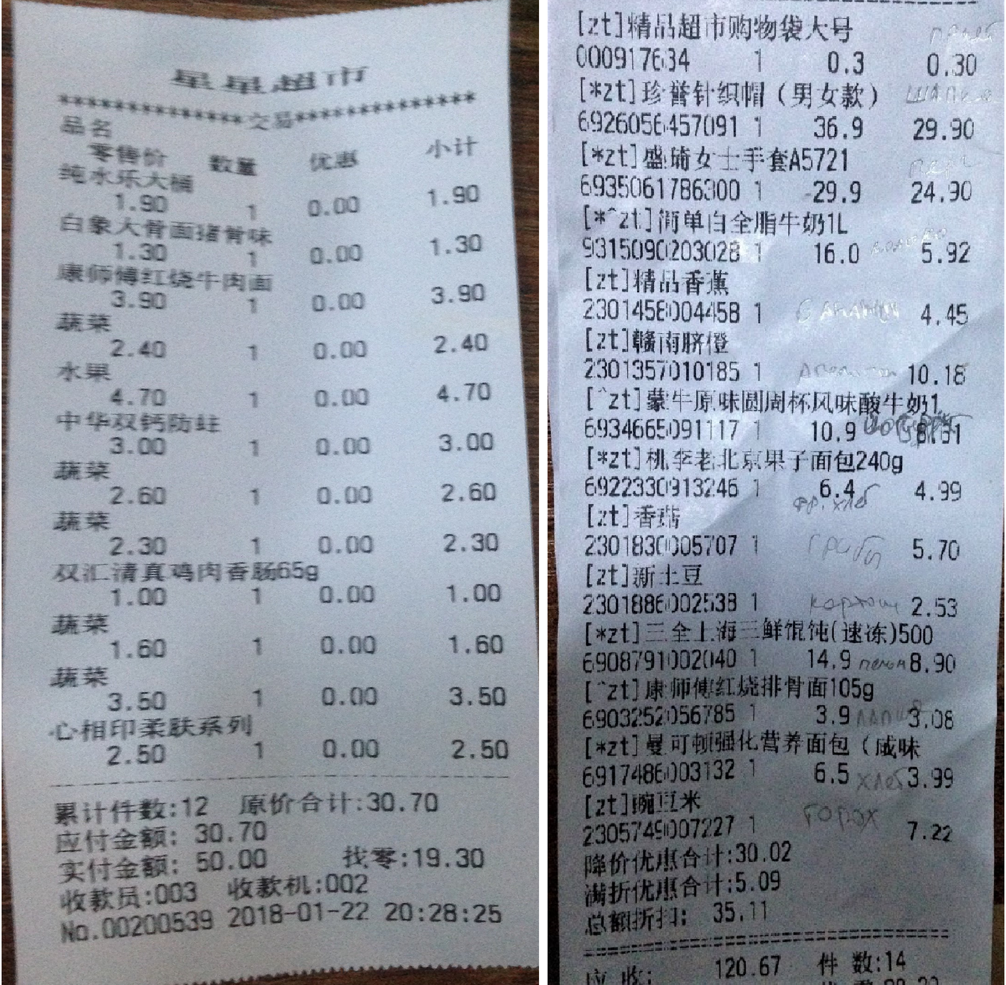

A few days later, the agent informed me that I had a meeting to attend in person. The meeting place was in another part of Beijing, 2.5 hours away from my neighborhood. I had to wake up at 5 a.m. in order to be there on time.

I had prepared everything I needed the night before and had studied the route, when suddenly in the evening the lights went out in the apartment and all electrical appliances stopped working. As it turned out, the meters had to be topped up - when they reached 0, they cut off all electricity. My agent transferred money to the meter, but it took 24 hours to credit it.

The darkness, the cold, and most unpleasant of all, the inability to charge my phone. I put it on airplane mode to save power and went to sleep.

There was an early rise in the morning, the first trip down to the subway, and a long drive. I took my laptop to charge my phone in case of an emergency. Which, of course, it was, because the main device in China is a cell phone. Without it, nowhere. In second place is the power bank, which I also did not have at the time.

I arrived at the rendezvous point after all. It was cold, my laptop had long since died, and my phone had very little charge, so the agent and I could only text each other. The language barrier also made our communication prolonged; explaining simple things took a long time. Suddenly the telephone also went out. Suddenly,

without warning, probably because of the cold. And we, trying to understand each other, didn't have time to tell each other the exact place of the meeting. And it was eight minutes before the appointed time...

After gathering my thoughts, I decided that I could go to a cell phone store (they probably have chargers there). After telling me on my fingers that I needed to charge my phone, I got a charger. Finally it turned on and I was able to send a message.

An interesting thing happened. It showed me that all kinds of situations can happen unexpectedly. And you have to be ready to apply all possible communication skills. And, of course, erudition, wit, and all life experience.

**Part 2.**

**Training section**

In this part of the book I have compiled my own experiences, those of my acquaintances and colleagues, and what I have discovered through conversations with people in some way related to education. The information has been tested in my practice, in my research and development of communication methods, in working with groups of people, in discussions with other educators, and in the development of teaching materials for related disciplines.

All of the information described has been tested and applied in its original or slightly modified form.

# Chapter 4. The Three Main Components of Science Education

We live in a wonderful world. The vibrant nature, the many resources, the scientific and technical achievements of mankind. Knowledge is increasing, and technology is penetrating more and more deeply into our lives. Science has a great influence on this process.

Understanding this new and diverse world requires mastering basic scientific knowledge. And, of course, we need to understand how to communicate that knowledge to others.

Teaching science lessons is a little different from teaching, for example, English. Although there are many similarities. Let's take a closer look at this issue.

So, nowadays in the science education market, we can think of three main and integral components of a science lesson.

We can represent them as a triangle:

* **teacher;**
* **lesson plan;**
* **equipment.**

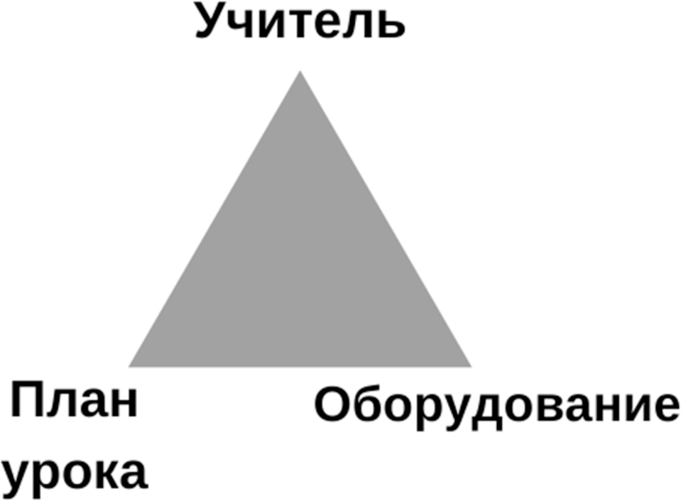

It is important to understand that this triangle has different properties compared to, for example, the project management triangle (also known as the "Triple Constraint" or the "Iron Triangle"), which shows the constraint model of project management. This triangle includes other parameters: time, cost, and quality. Only two parameters can exist together in it, while the third one usually drops out. It is important to keep this triangle in mind in other workflows.

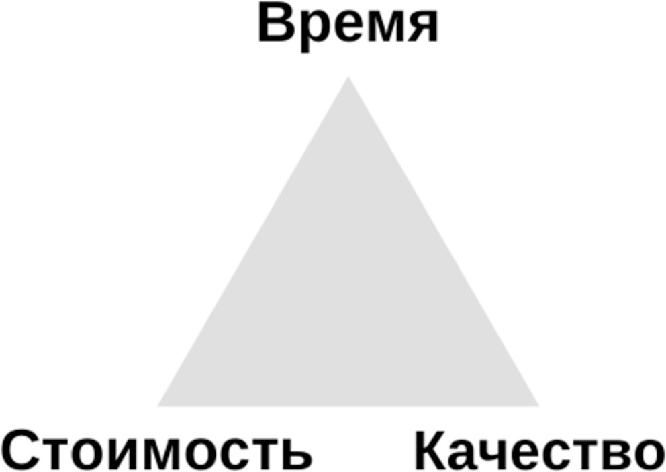

In our triangle of science education, all 3 parameters must be present together; without them, a great science lesson is impossible.

In the following, we will take a closer look at these three main "ingredients" and how to balance them.

# Chapter 5. The Teacher, or The Question "WHO"

I hope my esteemed reader has an idea of how a good teacher differs from a not-so-good one. If not, sooner or later this understanding will come. I will tell you how I found it. Of course, the introduction to teachers begins with 1-

the school's grade level. At this stage, teachers have the primary task of teaching their students. That's what happened to me when I went to the first grade in the small town of Slavyansk-on-Kuban in southern Russia. Lessons went my way, and I was far from being the best student. After graduation, when I went to university, I encountered a different kind of teacher - a teacher in a higher education institution. It was a lot more serious in terms of information, presentation and direction than when I was in high school. But the feeling of boredom that underpinned my "inner wackiness" didn't leave me here either. I was expelled for that, incidentally, after my first year. I subsequently had to repeat the course.

The study continued as usual, and the knowledge was absorbed accordingly. When one day, at the end of the third year, a fellow student and friend of mine called Grubak asked me to join him for extra training to get

He was a second graduate in linguistics, in addition to his first technical degree. He motivated this for two simple reasons. First, our other fellow student and friend, nicknamed Chesnok, had already gone there a year ago, and second, the additional education

"The English interpreter will be a useful complement to our technical specialties.

That's how, thanks to Grubac and Chesnok, I went to get another education.

At the beginning of the course our group was assigned a teacher, whom we had already met during our freshman and sophomore years as part of the general university program. Back then I was a messed-up student and my English, despite two years at university, was at a very low level. And now I was to study for two more years with the same teacher. I decided, with a heavy heart, that I could at least give it a try, and then we'd see.

This time, however, I encountered something interesting. The teacher's approach to the student changed. As a result of gradual work, the teacher and I came to a steady understanding of the basics and continuous development. I was motivated to learn. Not right away, of course, but it happened.

This change in approach to learning also affected the other university subjects that were part of my core curriculum. As a result, I finished my fifth year with an A in almost all subjects.

So thank you, Nadezhda Leonidovna Pshe-nichnova! Thanks to your efforts, at least one rascal was able to master the English language.

But I realized this later, only a few years later. It was then that I realized how much the teacher's personality meant to the learning process. There are teachers who are tape recorders, who simply transmit the program. And there are teachers who are trying to change things, to improve things. That's my main and important difference.

Of course, much depends on the working conditions of the teacher and his or her working environment. And the educational system in different countries does not always allow a person to realize his or her pedagogical potential. I don't want to touch on pedagogy and pedagogical policies or the Soviet legacy of all educational institutions here. These are only my observations and impressions. And they boil down to the fact that a good teacher is the most important link in the educational process.

## How to Be a Good Teacher

Good teachers are not born, they are made. Like any other skill, the art of teaching requires practice. The more the better. It's just like in sports, the main thing is regularity. Different ages of students, like different muscle groups, will strengthen a teaching skill faster.

Now for the teaching of applied disciplines. For a science teacher, the teacher's own education will be the pre-requisite. Often it is an engineering degree. And another enlightenment that came to me about five years after graduation. In my fifth year, during the graduation ceremony, the head of the department, Oleg Fedorovich Kovalev, said one phrase that I often recall to this day.

"The most important skill of an engineer is the ability to search for and find the right information.

The same phrase can be applied to the preparation of science lessons. Doing a little research yourself and getting to the bottom of things often works better than material from methodological manuals. Because you can see for yourself exactly how it works and what subtleties there are.

For example, to put on rubber gloves quickly, you need to have dry hands. Better yet, use baby powder. This is a subtlety that is not usually mentioned in chemical experiments.

So, what should teachers focus on if they want to become better and stronger? Here are a few guidelines that have helped me and others in my community achieve certain communication goals.

## Languages or the ability to express one's thoughts

The most important thing in any communication is the opportunity to be heard. It is the basis of communication. The verbal channel is very important in communication. It's important to know and understand what you're saying. And in this case the vocabulary takes second place to communicating *clearly*. Confidence in conveying the message is the basis for success.

The ability to express oneself is closely linked to vocabulary and the ability to construct sentences. It's simple and obvious logic. Everyone feels more confident when they have something to say.

When speaking in your native language, it is enough to prepare the material. If you are communicating in a foreign language, you also need to be able to use your vocabulary fluently. To accelerate the training process, the greatest attention should be paid to preparing the material and learning new words if the training is conducted in a foreign language.

In the language.

Preparation for lessons will be discussed in more detail in another chapter of this book.

## G olos

If the previous section was about *what* to say, this paragraph will be about *how* to say it.

All teachers are, to some extent, actors. And great teachers are great actors. Voice acting can turn a monotone speech into a real work of art. In my literature classes at school it was called "reading with expression", with intonation. But I never really understood what reading with expression meant and what had to be "expressed". Usually, in response to the teacher's call to read with expression, the students would just "turn up the volume.

And it was necessary to express emotions, coloring the voice according to the context. For example, positive moments had to be said loudly and cheerfully. Negative moments - in a serious or sad voice. Important things - loudly and clearly. Whispering makes the listener listen, and pauses give the speech a special quality and sensuality.

Playing with the voice allows any ordinary "gray" text to turn "colored" in the ears of any listener.

Special attention should be paid to the development of speech skills. You can watch actors in the theater or take an acting course. Also for practice and training you can take a simple story or poem and reread it in different voices, inton-

The text will be used in the same way as the text. This will allow you to use the tried-and-true patterns in your normal speech as well.

## Language body

The nonverbal channel of information also carries enormous power. It can be understood in any language. Body language and gestures can quickly and clearly complement speech, reinforcing the emotions conveyed by the voice. While voice acting adds color to a narration, body language and gestures give volume to speech. The gestures duplicate the verbal description. And the airspace itself becomes

"canvas" to convey the message.

Body language is closely related to cultural characteristics. For example, Italians actively gesture.

The development of this skill also needs attention. Without practice, it will also remain in place, just as in the case of working with the voice. You can practice with a demonstration of each word in the message: big, small, sad - or you can draw shapes of objects in the air and just show different little things with your fingers. Watching rap singers and actors will also reveal many secrets about body language.

And now for the most interesting part! This raises the question of the correlation between the verbal and the non-verbal component

in the process of communication. So, according to numerous studies,

* Only 10% of information is transmitted by means of speech, that is, by *what* we say,
* 30% is conveyed by intonation, that is, by the *way* we speak,
* Sixty percent of the meaning is in the non-verbal body language, that is, in postures, gestures, and facial expressions.

Schematically it looks like this:

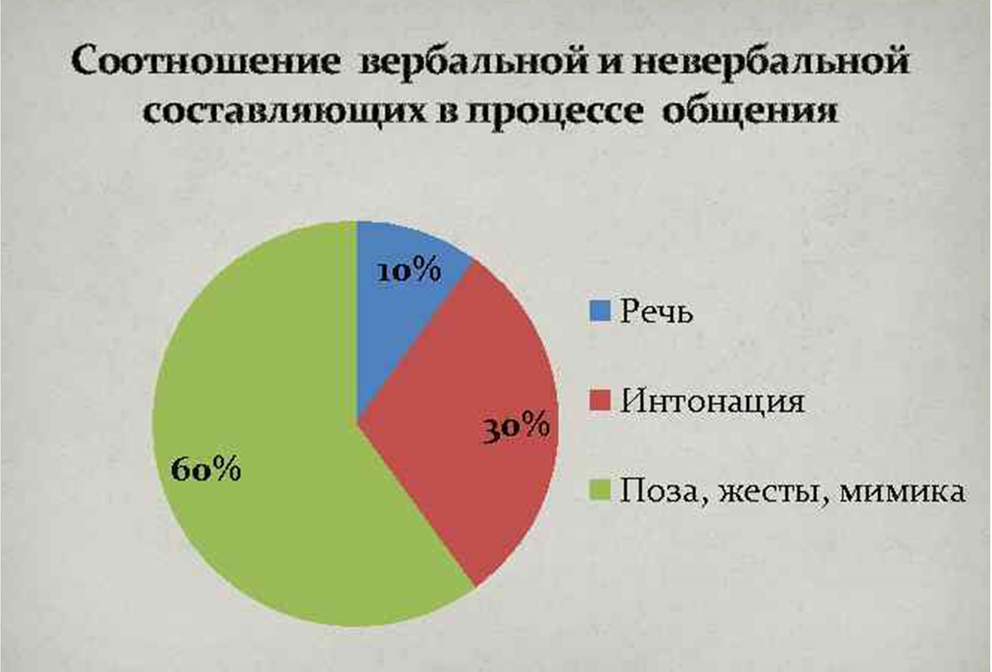

Finally, we can add that the non-verbal component is influenced by the internal state, or, simply put, how we feel at the time of the communication.

A person who doesn't know what to say, or who is speaking in front of a class or other audience for the first time, feels inhibited. This will also affect their body stiffness. A confident person, on the other hand, feels and behaves freely.

It is especially important to note where the teacher stands in relation to the students. To achieve greater comportment, try to keep the teacher's and student's faces aligned when communicating verbally. This is especially important at the beginning of training, when students feel uncomfortable.

## Public Speaking Skills

Any lesson can be considered a performance in front of an audience.

"The speaker broadcasts and the audience listens. The main time in communication is devoted to the speaker. He interacts with the audience, who asks questions. The speaker also manages the audience.

Isn't this description of public speaking entirely consistent with the flow of the class? So why not use in the classroom the same techniques that professional speakers already have?

The following methods and tips for improving communication with different audiences have been tried not only by me personally, but also by my colleagues. By

I can say with certainty that they increase the effectiveness of the lesson. Here are a few "tips and tricks" on how to improve your public speaking:

* **Study the classroom before class.** Arrive early, quietly explore the room. Walk around and touch certain objects in the classroom. Through touch, the brain builds a tactile map of the place, which means that the speaker will feel at home there. A simple example: when we wake up in the dark at night and look for a light switch or water, we know where these objects are located. That's why we feel comfortable.
* **Prepare everything you need.** It makes sense to prepare everything basic and necessary for a speech. It doesn't matter what kind of speech, class, meeting, or meeting you're speaking about. A whiteboard and markers are definitely needed at all times. You might be thirsty, and it's a good idea to know where the toilets are and how to adjust the air-conditioning. Feeling "at home" gives you confidence.
* **Understand the structure of the report.** The topic of lesson preparation will be covered later, but for now let's just note that in terms of preparing for a presentation, it is important to understand what parts of your presentation you have. In such cases, a simple and clear lesson plan will be helpful. It should be written down on paper and read through several times.
* **Keeping track of time**. Good time management skills come with experience. You should plan in advance how long each part of the lesson will take. It is not always possible to hit the target at once and pay everything off clearly by the minute. But even a rough time plan will help you know whether to start in a hurry or whether you can do something more in-depth.
* **Move around the "stage".** Once you have determined the area in which the performance will take place, make the most of it. You can get as close as possible to someone in the audience or go to the end of the room. This will attract additional attention from the audience, because a narrator standing in one place is not as interesting as a moving person. Standing in one place, you can deliver one part of the talk, and moving to another, you can start the next part. By the way, gesticulation skills work well here.
* **Understand and represent your audience**. Just imagine who our listener is. What their age, occupation, interests, what they like to do and what language they speak. You can imagine yourself as this person and sit somewhere in a room and imagine yourself in this character. I'm sure you can do better that way.

"feel" the texture of the upcoming performance.

* **Make eye contact with all listeners**. This technique gives each listener a sense of persona

of a personal approach. "The person on stage looked at me, noticed me, and singled me out! - that's the feeling that usually arises in the subconscious of the listener. Personally, the tactic of looking at different listeners at random and then going back to each of them again helps me.

* **Interact with the audience.** It is always a good idea to ask the class questions, even the simplest ones. Giving the entire audience or an individual something to say adds to the interactivity of the presentation. The focus of the audience's attention shifts. The fact that the listener is now engaged in a conversation with the speaker will attract the attention of other students. And maybe someone else will be asked, too!
* **Use your own style of behavior and interaction**. After observing other speakers, from your own experience and testing different communication methods, you develop your own speaking style, your own intonation and facial expressions. Individual body language and the ability to link one part of a presentation to another. Confidence grows and an understanding of what else can be improved. The speaker's own style will always be remembered by his or her audience.
* **Smile**. This simple rule can add that zest and comfort to any conversation that we often lack.

Of course, public speaking is a big special subject. How to prepare for a speech, manage an audience, avoid unpleasant moments and cope with unforeseen situations. A teacher who knows these methods has a great advantage. I hope the reader will adopt the techniques described as soon as possible.

## Lecturer in science

The key to successful science teaching is the professionalism of the teacher. In addition to teaching skills, you need something that lets you know right away that you are a professional in your field.

There is something called the "duck principle. If something looks like a duck, quacks like a duck, and moves like a duck, it is a duck.

### Using the right language

This is the clearest and easiest method to use for anyone who wants to achieve a high level of professionalism in their field (remember the duck principle). It's about using the right language or set of words. A common substitution of simple words already marks out a teacher as a professional in the eyes of the

not only the students, but also any other public. Simple examples:

* instead of the word "action," we use the word "experiment" or "procedure;
* instead of the word "object," the word "tool;
* replace the word "thing" with the word "equipment.

### Correct use of the equipment

It's simple. If there's a manual for something, it's worth studying it. In other words, you need to understand how things work. For example, for chemical experiments, it's important to measure the right amount of substances and mix them in the right order. For physics experiments, the position of the objects used or the speed will be critical. The same is true for everything else. Usually, understanding comes after reviewing the lesson plan and subsequent practice. This gives the teacher a confidence that is very easy to feel and very hard to fake.

Usually after phrases like:

* "For this experiment we will use powder A, liquid B, a medium beaker, a punching bag, a tray, and absorbent cotton.

or

* "For protection we will use a gown, gloves, and goggles."
* it becomes immediately clear that we are dealing with a truly scientific approach.

### Use of scientific methods and appropriate terms

This approach is more comprehensive than simply using the right language to communicate. Generally, behind scientific terms or methods there is a whole definition of actions to be taken or considered. Here is a list of some of them:

* make a scientific observation;
* categorize;
* measure;
* calculate;
* communicate;
* predict;
* to hypothesize;
* to draw a conclusion.

On the one hand, these may seem like simple words, but in a scientific context they carry special weight. For example, the term "scientific observation" carries with it an observation with a purpose: to detect motion, to find regularities or features of the behavior of the observed object.

"Prediction" should give an understanding of how a ball that has been thrown at a wall might behave.

"Conclusion" is a kind of final analysis after scientific observation and hypothesis testing by means of experiment.

## My introduction to

I can say with certainty that the first two weeks of living in China change one's thinking and perception of the world significantly. I don't know if it works for "vacation" or "short business trip", when you know in advance that the changes are temporary. But when you know especially that it's for a long time, you change yourself willy-nilly. The most striking impression is, of course, the language: everyone speaks Chinese, and no one knows English. With the exception of the subway and the airport, only Chinese is spoken everywhere. In the center of Beijing or Shanghai or other megacities this is not a problem. But once you get out of the way

from the center - and that's it, you're doomed to misunderstanding.

In such cases, of course, the electronic translator is very helpful, especially with the speech recognition function. The text-to-picture translation function is also a great help. It will be useful, for example, in restaurants with pictures of dishes, which immediately become much more attractive than those with only text on the menu.

In China, more than anywhere else in the world, you start to realize the necessity of the cell phone. Everything here is tied to messengers and applications. In addition to exchanging messages, calls and files, messengers allow you to pay for purchases, make acquaintances, listen to music, trade and publish news. If we talk about apps, everything has them. All social and public services have long ago switched to electronic document management. Eating, shopping, delivering, working within a company, as well as checking and paying taxes - everything is done through apps. They are everywhere and there are a lot of them.

I gradually got into this life: I learned how to buy my own groceries and other necessities, how to move around the city, and how to socialize.

It so happened that the workday and my new responsibilities started at 8 o'clock in the morning and I had to get up at 5:30. When you live far from the center of the city, you have to drive for a long time. And it was not only me, but also thousands of other people who were also rushing to work in the early hours of the morning. As a consequence, there were traffic jams on the roads and crowding on the subway. The one-way trip took me two hours and involved four subway transfers.

I can tell you it's tinny. And I really feel sorry for the people who spend 3-4 hours a day to get to work.

At times like this, you realize how important it is to sit and not to stand. Because then it would take another two hours to drive back. The Chinese New Year was coming up, and after the holidays I planned to move closer to work. Then I learned three simple tips that I still use when I need to travel

to a long distance:

* There are fewer people at the beginning and end of the train, and it's much easier to find a free seat;
* If the train you need to transfer to is empty and you are not in the front row, you should skip it - then you can definitely get on the next one;
* in a full carriage it is better to go to the middle, where people are already sitting, not standing at the door - sooner or later someone will stand up, and you can take his place.

# Chapter 6. Lesson Plan, or The Question "HOW"

Teaching aids, teaching materials, tracking programs, manuals such as this book, and, of course, lesson plans all have one goal: to reveal the whole process of delivering knowledge to students. The methods may be completely different.

There is even a whole science, pedagogy, devoted to the question of *how* to teach. In addition, I will give here a number of my observations and conclusions about science lessons.

Different institutions and training centers may follow their own formats and rules. Often they reflect the very idea of a particular institution, taking into account the formats and necessary standards that the taught material should meet. This is generally a good thing, because it is easier to handle large volumes of data if they are clearly structured.

The basic idea of a lesson plan is that it should be simple and logical. If the teacher can understand the material in a simple way, it will also be easier for him or her to convey this information to the students. The following paragraph gives an example of a lesson plan that can be adapted to any kind of lesson.

## Sample lesson plan template

### Technical information

School name, grade level, curriculum standard, lesson length, lesson title and number, topic or project.

### Information common to the learning process

General information for the children's current level, a brief (summary) of the lesson, lesson objectives and goals, keywords, a memo for all lessons (can be a separate document).

### Preparing for the lesson

Preparation of materials, organization of furniture and space, preparation of children before they come to class.

### LESSON PROCESS

**Zero step**

Setting or repeating the classroom rules, setting or repeating the reward system, briefly repeating the previous lesson, briefly reviewing the topic of today's lesson, moving on to the next step.

### Activity 1. Type, name, approximate time, materials used

**A short description**, *example of key dialogues*, step-by-step instructions for action, and an example of a transition.

### Activity 2. Type, name, approximate time, materials used

**A short description**, *example of key dialogues,* step-by-step instructions for action, and an example of a transition.

### Activity 3. Type, name, approximate time, materials used

**A short description**, *example of key dialogues*, step-by-step instructions for action, and an example of a transition.

### Conclusion

Cleaning the workplace, repeating what you can do at home.

### After class.

Lesson brief, student assessments on several parameters, packing materials.

## Comments on the lesson plan template

Now let's decipher all the terms and look in more detail at the logic of including the relevant items in the lesson plan.

**Technical information is** the section that contains data for classification, naming and other information that facilitates document retrieval and storage.

*The name of the school is the full or abbreviated name of the institution for which the plan is intended, or the educational unit that developed the plan.

*Grade level - the age or grade for which the curriculum is intended. You can enter the internal name of the level of the students in the unit here.

*Standard of educational program - to which educational program the course belongs.

* Lesson length - Duration of the lesson in minutes. It can have more than one value if the lesson is to be taught in different schools.

time difference. The time difference should be reflected in the description of the lesson process below.

*Title and Lesson Number - A memorable name and sequential number for the lesson.

* To which topic or project does it refer - an indication of the module or block of topics within which a group of lessons is studied.

**Information common to the learning process -** this section contains information that will help guide you through the entire course. It gives an understanding of the details and interaction with the students.

*General information for the current level of children - what to look for when teaching certain students in their current location. Whether more time should be spent on discipline and how to deliver age-appropriate information.

*A brief summary of the lesson - a short, concise description of the lesson in a few sentences. It is necessary for better understanding by the teacher, as well as for publication in other sources as required.

*Lesson Objectives and Goals - a list of what needs to be done in the lesson, what knowledge to convey as a priority, and what to focus on.

*Key words are a set of words or terms that should be used in the lesson and that should be repeated several times to the students during the lesson.

*All Lessons Memo - Additional information for all lessons in general, containing details of teaching, where students are to gather, which route to take them to class and if so, where to escort all students after the lesson, student logistics, school rules or other organizational matters. Can be a separate document.

**Preparing for the lesson -** a section describing the preparation for the lesson itself. What to prepare directly at the lesson site.

*Prepare the materials - what to bring beforehand and what to pay attention to when studying the lesson. For example, freeze the water or pre-mix the reagents for the reaction. Of course, you should unpack the parts that come in the factory packaging so that they can be accessed quickly. Also check the electronic devices and make sure that they work.

*Organize furniture and space - Arrange tables and chairs according to the planned lesson. Darkness in the classroom or additional ventilation devices may be necessary.

*Gather information about the students - it is desirable to obtain a list of students in advance and to specify the age of each student. For the first lesson or the first few lessons, it is advisable for the children to have a nametag. If the information system allows it, the student's background can be downloaded in advance for easy and quick identification.

*Preparing the children before they come to class - in some cases, the children have to be picked up from the assembly point. Or tell them a background story that puts them in the mood for the lesson. This preparation can be a personal transition to the lesson, especially the first few times.

**Lesson Process -** this section contains the steps of the lesson itself. In fact, this is where the lesson begins. You can consider that the teaching time has already started and the interaction with the students has begun. These guidelines can be used selectively. It all depends on the teacher and the purpose of the lesson. I call this step **zero.**

### Zero step

*Introductions - In the first lessons, it is important to introduce yourself to the students and other teachers, if there are any in the class. It is advisable to write their names in large print somewhere in the classroom and/or on their nametags so that they are easy to remember.

You can then ask each student to tell you their name, age, and what they like. You can ask them one at a time. The answers should also be written on the board according to their seating arrangements in the classroom. At this stage it is already possible to understand the communicative abilities of each child.

If possible, it would be helpful to take a group photo and put their name above each student to help you remember them faster.

*Setting or repeating the rules of classroom behavior. Rules are the foundation of classroom management. They will help guide the lesson. It is important that they are clear and communicated to the students in a memorable way. Examples can be given to show the importance of these rules. It is advisable to repeat the rules every lesson. This point will be described in more detail in the section on classroom management.

*Setting or repeating a system of rewards - It is logical to tell the students about praise and disapproval. To make it immediately clear "what is good

and what is bad. This point will be described in more detail in the section on class management.

*Short review of the previous lesson - a quick question-and-answer session on the topic of the previous lesson. The teacher may briefly repeat key topics from the previous lesson or lessons, especially if they are related to the current lesson.

*A brief overview of today's topic - if the lesson plan does not involve revealing secrets, you can briefly tell them what will happen today and what interesting things await them. That way students will be more motivated. You can ask them a couple of questions about whether anyone is familiar with the topic of the lesson.

*Transitioning to the next step - A few previous questions to the students can serve as a good transition to the next step in the lesson. The purpose of the transition is to act as a link for a softer presentation of the material. Then the lesson will look like a film.

**Next,** let's break down the next steps of the lesson. You can call them by different names. I use the word "Activity" because here we mean interaction with students. This block is a special section,

to quickly see the highlights of this activity.

**Activity No.** - ordinal number of the activity.

You can use abbreviations such as **A1.**

**Type -** what **kind** of activity will be performed within this activity. In science classrooms this could be *demonstration* and *action*. Demonstration is a process where only teachers interact with the material and students watch.

Action is the process of having students use the lesson materials for some kind of experiment or experiment. This is described in more detail in the chapter on lesson preparation.

**The name is** the name of the activity that reflects its essence. It can be funny and memorable.

**The approximate time is the** approximate time that it is recommended to spend on a given activity. Of course, it may vary depending on various factors.

**Used materials -** a list of materials that are needed for this activity. The order of their use will be specified in a short description and step-by-step instructions.

In the information part of the activity, it is desirable to rely on color code for better recognition. Not all text blocks are mandatory, some may be omitted.

**A short description** is a description of the action or idea behind the activity. May contain a bit of theory to be given to the students.

*An example of key dialogues* is an example of a conversation between teachers or questions addressed directly to students.

Step-by-step instructions are required when an experiment is to be performed. It is necessary when the order or quantity of materials is important for the correct result.

An example of a transition is a tip on how to simply and logically move on to the next activity.

**Conclusion -** this section indicates how to conclude the lesson within the lesson.

*Cleaning of the workspace - active experiments and other activities often leave a lot of material that needs to be cleaned up. The room may need to be tidied up.

view, arrange chairs in their places, or simply clean up the trash. In addition, this habit is useful for future skills. As a rule, parents also support the development of such skills in their children.

*Repetition is a short repetition of what you have learned at the end. It always contributes to better consolidation. Usually conducted in the form of sample questions and answers on a passed topic or as a repetition of key points during practical experiments.

*What you can do at home - Preferably, there should be an opportunity to continue practicing at home with the theory or lesson material that was given in class. This kind of practice makes the student more attached to the subject. If possible, the homework should not be similar to what has already been done in school. Dry theory or problems with no obvious practical application will not be as interesting as something vivid and memorable. For example, you could give the children some of the material used in the lesson or tools they used in class to take with them. The student will be happy to continue practicing at home, where he or she will have more time than in the school classroom.

**After the lesson -** here are the tasks that should be completed after the lesson, if possible. Of course, practices may vary from school to school.

*A brief textual description of the lesson, describing what was done and how it was useful. It can be used to send out to parents, publish in general chats or on the website, or present to parents after the lesson.

*Assessment of students - Usually takes place after or during the lesson, depending on the requirements of the educational program. Assessment is carried out according to several parameters: social (discipline), communication, mastery of material, level of English, teamwork, etc. For different courses or even topics, different evaluation parameters can be used. The main thing is that they should be understandable and that the evaluation should not take too much time for the teacher.

*Packaging of materials - All instructional materials that were used for experiments in the classroom should always be put away in a storage area. Specific guidelines for storing materials can also be stated in this paragraph.

## Example of simplified plans for 10 lessons

I want to give an example of a very simple lesson plan to show the logic. The plans are not as detailed as the examples above. But they can be further developed using the facilities and components that are available to the teacher.

### Plants

* There is a huge, beautiful world around us. Plants are marked in green. What do we know about them? A rich variety. See pictures. Facts.
* Plants first get small, then grow big, and then they die. It turns out that plants have a life cycle. Seed - sprout - adult plant - flower - fruit. Tell and show each stage.
* Going outside, collecting roots, leaves, flowers and fruits in special containers. Show with what to collect and how.
* Review of collected materials in a microscope and under a magnifying glass.
* Seed Review. Disassemble a sunflower, nut, or bean seed. Find all the parts.
* A collage of leaves and flowers - laminate and frame. You can secure it with double-sided tape. Show all the parts of the plants in the collage.

### Chemistry and states of matter

* Three states of matter - Solid, Liquid and Gas. Their properties in terms of volume filling. Show slides or maps. Ask for examples from life.
* Everything is made up of molecules. The building blocks of matter. The arrangement and behavior of molecules in the FIG state.
* Practice with the arrangement of molecules. 3D or 2D puzzle game by arrangement (collect water molecule).
* Substances can go from one state to another. How? Through the action of different temperatures. Demonstration with ice.
* What happens when different substances are mixed together? Sometimes nothing, and sometimes a chemical reaction (dissolve soda in water, tint vinegar, and mix on a tray).
* Another reaction.

### Electricity

* Electricity is everywhere; it helps us in our daily lives. There are two kinds of electricity: static and permanent.
* Static electricity. Atoms: proton, ne-tron, electron. H stretches to E. The theory is that when there is a lot of it, the electron jumps. Example as in sweater.
* Practice. A balloon that attracts papers. Attach the balloon to the wall. How the Balloon Affects

on salt and pepper. The aluminum can and the impact of the ball.

* A stick with static electricity and flying foil. Theory, demonstration, practice.
* Van de Graaff machine. Demonstration. Explain the rules, and the students can try one at a time.
* More experiments1.

### The human body

* The human body is a complex organism that is not yet fully understood. What can the body do? Our body has 12 systems that work together. We will now look at a few of them.
* Skeleton. Bones: 270 in childhood, 206 in adulthood. Main bones. Connected by joints. Putting the skeleton together.
* Organs are something like devices with specific functions and locations. List and examine the photo. Find on the body. Puzzle.
* Muscles and the heart. Muscles are located throughout the body. They are needed for movement. Explain how they work. The heart is an organ of muscles that pumps blood like a pump, without rest or breaks for lunch or sleep. Pump example: how the heart works.

1 Some examples https://iswitch.com.sg/fun-static-electricity- home-experiments/

* The skin is a mysterious and large organ. The skin system protects. Drainage. The different colors of the skin.
* Assemble a model of the human body.

### Magnets

* The trick with magnets. Why is it attracted? Because they are magnets. What are magnets?
* Magnetic and non-magnetic materials. Can all materials have magnetic properties? No. Only iron, nickel and cobalt. Or alloys which contain them. Test.
* Magnets have poles. Take the example of the earth's South and North poles. The opposite poles attract. Those of the same name repel each other. Test with 2 magnets. Assemble a tower with repulsive rings.
* Magnetic field. You can't see it. How can we see it? A frame with magnetic dust. Draw the fields in different magnets.
* MF is also at the ground. The field has a direction. This is used in the operation of the compass. Make a com- pass. A paper clip and a magnet.
* Make a magnetic souvenir.

### Programming with Mycrobit

* The modern world demands communication with devices. Special instructional language. Introduce the Mycrobit device and explain the connection.
* How to program once connected. How to build an environment. How to drag and drop blocks. How to save and transfer to the device
* Simple program. Demonstration step by step, all students repeat. Uploading the program to the device.
* Example of the second program. Slightly more complicated than the first. Less help for students
* Example of a third program. The students work independently.

### The Solar System and Space

* We live on Earth. What is Earth? And what's beyond that? What do we see in the sky? Stars. The sun is a star. Around it are the planets.
* What is the Sun. Creates the solar system. All the planets revolve around it - show the model. That's not the way it used to be thought.
* Solar system with a list of planets. Distinguishing features.
* Who travels in space? Astronauts. There is no air in space, weightlessness, cold, etc. You have to wear a special suit. Simulation of the suit.
* How to explore distant planets? Satellites and Rovers. They work on radio communication. Receive commands and execute them. A simple game - execution. Working with RK-rover (VR, AR).

### Chemistry lab and slime

* There are many things in a chemistry lab that look complicated and scary. In fact, everything has a purpose. Substances have different properties. Studying the list and what applies where.
* In chemistry, it is important to be precise. Measuring substances correctly. Examples for accurate water transfer.
* Sometimes we need indicators to see behavior. Mixing hot and cold tinted water. Examples of distribution.
* It is important to measure out the right amount. The reaction time and the ratio of the ingredients makes a difference. Make Slime with different properties.

### Balance and structure

* We see many simple fi gures in our lives. They are everywhere. Repetition and searching around.
* If you stack simple shapes side by side, you get complex 3D shapes. Review and search for shapes around.
* What are the figures for? For example, to build something: buildings, mechanisms. What kind of figures make up a house - 2D or 3D?
* Why did they build towers? To see more space and accommodate more people. The tower had to be strong. How do we do that? You use triangles. It is the strongest figure. The test and practice of building a tower.
* You can also build a bridge using triangles. View photo. Try to build a bridge between two tables.

### Water World

* The water world is enormous. 71% of the planet's surface is water. There was life in water long before the dinosaurs. Life emerged from the water. What's out there in the depths? Look at the structure of the ocean.
* Now let's build a model of the ocean in a bottle. When we walked on the beach, what was under our feet. The sand is the rocks. Friction of the rocks, make sand. We add sand to the bottle.
* What else? Shells. Their function is protection. Consider examples. Add to the bottle.
* Sea creatures. There are all kinds. Some live in the depths, and some even fly. Photo. Adding fish and other sea creatures.
* Plants. Grow differently. Algae, for example. Their function is filtration and oxygenation. Because the fish in the water also need oxygen (photo example). Experiment with filter and dirty water. Add plants to the model.
* Water. Blue and salty. Distribute water to the students. They will add the salt themselves. Add it to the bottle. Format it with the name.

## Food in China

Of course, this question is relevant from day one: What and where to eat? Chinese food is special, and people who come from Europe or America usually don't understand what they can eat to make it look like a familiar meal.

Every province in China has its own dishes. Sichuan cuisine is famous for its spicy dishes. The northern provinces have a lot of dumplings, as well as food similar to Russian food. The southern provinces have a mix of many ingredients. All together create their own taste and flavor, which sometimes seems strange.

There are some very unusual dishes as well. For example, fried tofu that stinks, pork skin sliced into strips and pickled, chicken legs, goose and duck heads. In China in general, legs and heads are particularly prized. For example, an appetizer in the form of chicken feet can be found in any store. This is a well-known dish, it is served in restaurants, and children eat it from a young age.

There are many ways to prepare eggs in China alone. Eggs are soaked in tea, soy sauce, or fermented in other ways.

When I first arrived, I discovered that mu-sulma food in China is reminiscent of kazakh food. Unlike the original Chinese cooking methods, the food is not overcooked

in oil and do not mix with different sauces and spices. In the early days it was my salvation.

Of course, after a few months, you remember homemade food: dairy products, soups and snacks. You can't get enough of it. When you miss your native diet, you can calmly take the subway to the other end of the city, spending an hour or an hour and a half on the way, just to taste borscht in a Russian restaurant.

Over time, I found the best solution for myself - I started cooking myself. It's easy to find the right products, if you know where and how to find them.

Food is an interesting topic in any country. But especially in China. And it can be raised at any level of conversation. Even one of the simple greetings, "How are you?" (chīfàn mǎ) literally translates as "Have you eaten? After several years, I have developed my own understanding of Chinese food. Where and what to eat, what kinds of dumplings, fast food and deli cakes are better. I was able to appreciate and understand the local peculiarities

and Chinese preferences for certain foods.

The great famine in China in 1959-1961 had a huge impact on modern cuisine. Apparently, this is why it is now the norm for the Chinese to order more food than they can eat.

# Chapter 7. Equipment, or The Question "WHAT"

The right equipment and the right materials and tools can make a classroom experience unforgettable for students. By using material objects in experiments, learning transitions from theory to practice. Everyone knows that practice is the best way to learn a material. Sometimes theory is even pushed aside in favor of practice. In comparison, imagine having to describe the sound of the sea, the taste of ice cream or a parachute jump. Until you've experienced it, it's hard to know what it is.

It's the same with science experiments. In the classroom, any material object can partially or fully participate in a science experiment. It makes it easier to convey theoretical knowledge to the students. In addition to simple demonstrations, students have the opportunity to create and perform the experiment themselves. Touch and, so to speak, "get their hands dirty". This practice makes it easier for them to memorize the material and apply it successfully in the future.

## Using equipment

Of course, it is important to understand exactly how the equipment is to be used in the classroom, especially in a specific experiment. The question is what functions will be provided by the object. And what else could be considered.

For example, an ordinary plastic cup can serve as a vessel for liquids, can be a geometric figure, and can even be a hat for some product. Continuing to think in the same direction, it is possible to endow any object with various (sometimes surprising) properties. One that will interest the students. This is possible when the teacher has presentation skills and a little imagination.

A former colleague of mine, Artem, once showed me a good example. He had to present a small stone. A rock! For children, this is an ordinary thing that can be found literally under their feet. But a stone can be a magical talisman of knowledge. A stone can be given a name. It can become a best friend. With it it is possible to walk and sleep. In a word, it can be incredibly powerful!

Of course, within the lesson or, more precisely, in the lesson plan, there should be a list of materials that can be used. If complex experiments are planned, it is better to describe the entire sequence of use and the number of components required.

The "Materials used" section and the "Step-by-Step instructions" section are just for understanding how to use the materials. The section "Materials to be used" and the paragraph "Step-by-step instructions for use" are intended precisely to understand how and in which order the materials will be used.

## Types of equipment

In order to understand what material things are worth using and how to do it, you have to classify them correctly. After all, in one experience the same beaker can be thought of as a paper object, and in another as a vessel for powder or liquid.

It is important to always keep safety in mind when working with materials. Sharp objects, loose powders, electricity, high temperatures, and exposure to chemicals can be harmful to the health of teachers and students!

### The box

All materials are usually delivered from a warehouse or other location by a set of lessons. Of course, everything must be packaged for easy transportation. As a rule, it is easiest to transport materials in boxes or crates, wooden or plastic.

A lesson usually includes several activities, each with its own set of equipment and materials.

The box itself can also be part of an experiment - as a platform or as an obstacle in physics experiments.

Usually after the lesson, all equipment and materials needed for the lesson should be properly packed back into the box for later transportation to storage or to the next lesson location.

### Equipment and tools

As a rule, these are reusable materials: electronic devices, tools, demonstration materials. Information on how to use them will be given in the lesson plan. Perhaps some of the tools or equipment should be prepared before the lesson. For example, to connect electricity, to assemble a device with several parts or to charge something. And after the lesson, you may need to disassemble, pack or, for example, clean the glass tubes after the experiments.

It is important to understand that if the lesson is planned by the methodologists, the time for preparation and taking care of the equipment after the lesson should be minimized as much as possible. The teacher should focus on the pro-

The process of learning, not what and how to prepare and store.

### Consumables

This type of material runs out periodically. Each lesson or activity requires a specific set of supplies.

Examples of such materials: soda, wooden sticks, litmus paper, vinegar, tissues, etc. They will be consumed as part of the experiment.

Of course, this type of material needs to be replenished as supplies are used up. It is advisable to keep an additional 10% of your total consumables for contingencies.

### A handicraft or a toy to take home

In order to reinforce and memorize the material in the lesson, you can make a craft related to a specific topic of the lesson. In some cases, making such crafts may take two or three lessons. It is also possible to give the students something to remember already made.

For example, as part of a lesson, the children looked at small objects, parts of insects, or the structure of materials. Many of them will probably want to repeat the experience at home. This means that at the end of such a lesson

The best gift for them would be magnifying glasses.

Of course, the student will get even more emotion if he or she makes something like this with his or her own hands in the classroom.

## Logistics and conditions

When working with materials, the logistics and storage aspect plays an important role.

The main role in this is taken by the purchasing or warehouse logistics department, depending on the organization of the roles and business processes in the educational institution. In any case, the following points should be taken into account when dealing with materials:

* Sharp objects such as steel wires, scissors and pencils should be placed in a plastic bag or otherwise insulated.
* All vessels must be hermetically sealed. If there is a possibility that the liquid could leak out, the vessel should additionally be placed in a plastic bag.
* Bottles of liquids should be stored separately from electrical appliances and powdered chemicals. Then, even in the event of a liquid leak, there will be less impact on other materials in the same box.
* Fragile objects, such as glass, need to be wrapped well.
* Heavy and large items should be placed at the bottom, and light and small items at the top.
* Lift and lower the box of equipment and materials carefully so as not to damage fragile parts.
* Do not turn the box upside down! Doing so can cause chemical spills or heavy objects on the bottom can damage the lightweight elements on top.

If you follow these rules, all your materials will always be in good condition.

## Caring for the Environment

When planning and teaching lessons, always keep tomorrow and the environment in mind. Two of the world's problems are becoming more apparent and more serious every year: global warming and plastic pollution.

How do we fight these phenomena? You have to talk about them! Especially when it comes to educating the younger generation.

The basis for such conversations can be a discussion of how to work with the materials. We need

and it is important to teach children to use only the right amount of them and to try to minimize waste.

## The Environment in China

As I explored my surroundings, I was somewhat surprised at the number of green areas, parks, walking paths, and other spaces to spend time in - in China. One cold day in late January, I managed to get to a large park, BaiWangShan in northern Beijing. Despite the weather, there were many other people strolling around just like me.

The park was located at the foot of the mountain. On my way down, I noticed a man in his 60s and 70s walking slowly down the trail and singing loudly. He was just singing because he felt like it. In China, it is generally considered normal to do things for which you have an artistic urge. For example, singing at the top of your voice in the park or in the street, and dancing in squares.

People like to get together and communicate with each other. The topic of communication in general is very important in China.

Especially for the foreign community. As at the beginning of 2018, people still use groups in the messenger "Vichat" to communicate on certain topics. "Wichat is a super app that dominates China. In the groups of this app

You can find information about work, visa issues, how and where to rent an apartment or a room, learn about recreation, food, entertainment and much more. And most importantly, you can meet and communicate with people who have known the topic you are interested in for a long time.

There I found the "Slavic Bazaar" group in Beijing, where I later met different people and found a lot of useful information for me. At that time I knew almost nothing about life in China, and this community became the most important source of information for me.

My strategy was simple: when looking for information, I first researched open sources and then asked a question in the group. Those who answered, I added them to my contacts and then asked them personally. While open sources usually yielded 10-20% of the relevant information, members of the community "threw" 80-90% of the necessary information on the topic. For this, I want to thank everyone I know and especially admin Bob - everyone who helped me in my first months in China.

# Chapter 8: Lesson. How the Process Happens

I'm sure by now you already have a clear understanding of how a science class goes. First of all, we have a powerful and pumped-up teacher who can deliver any kind of knowledge to the class. Secondly, the teacher has two types of tools at his/her disposal: a lesson plan and equipment with all the necessary materials. It would seem that this is the end of the line. But at the same time, this is only the beginning of an activity. An action that is called a "lesson".

You can fundamentally divide a lesson into three parts: before the lesson, during the lesson, and after the lesson. Each of these parts has its own features and nuances that are worth focusing on. With proper preparation, the lesson can be almost perfect.

## Before lesson

The time before the lesson begins is preparation. It is the preparation that can make any public event admirable. During the lesson, the teacher should focus on the lesson, not on how to conduct any particular experiment. And the key is preparation.

What can be included in the preparation and what should be thought about? Here's a sample list of activities.

### Learning the lesson plan

The lesson plan will help you understand the whole process and its main elements. These include key words, relevance to the topic, lesson objectives, and a list of activities. It is advisable to make notes in the lesson plan as the lessons on this topic progress. In some cases, it makes sense to make a personal lesson plan that combines all the necessary data and notes that may be needed in the process. The goal is to make the lesson plan familiar, so that just by looking at it, the teacher knows what to do now and where to go next.

Of course, it is not a good idea to keep the lesson plan in front of your eyes during class time. Therefore, instead of a large document, it is better to make a short personal plan on cards that can be kept in your pocket. A beginning teacher can put the lesson plan itself in the teacher's belongings area and refer to it when necessary. It will also be helpful to go over the whole process in your head before starting the lesson.

### Viewing video

Often a lesson involves watching videos that explain and show what actually happens and how it happens. It is easier to show on video how the equipment works or an experiment takes place than to give a detailed textual explanation in the lesson plan. The outline can only include key features to make it easier to find them in the video.

It is desirable to edit the video so that it had no pauses waiting.

You can even record the whole lesson, but then you will have to spend more time studying such videos in the future.

Of course, the situation looks different when the purpose of the video is to show the specifics of working with students, classroom management and other processes. In short, if it is necessary to demonstrate the processes that take place in the classroom, but are not related to the experiments. In this case, it is best to make a special video selection of such cases to reflect all the points necessary for the study.

### Theory Preparation

Understanding theory and being able to communicate it in simple words is one of the most important tasks of natural-

of the science lesson. By the way, all such lessons for children focus on communicating scientific facts in simple ways. Of course, language and vocabulary play an important role here. Usually the theory is explained using keywords.

### Discussion

When you understand what to do and how to do it, the lesson can and should be discussed with a partner teacher. The discussion helps to remember the material better, and is also useful if someone doesn't fully understand the theory or the experiment. It is assumed that all parties have read the training materials before the discussion and can now agree on key points and roles. How introductions will be made, roles will be reversed - in short, to reiterate who will do what.

Communication is very important. When there is communication, there are no problems of understanding between the partners, and the lesson runs smoothly. The students feel it.

Training can also help you learn about a topic. During a training session, one or more experienced teachers or trainers can talk to a group of teachers about all the nuances and processes.

### Equipment testing

Everything has to be tried out for yourself. Practice often reveals something that is not in the lesson plan. In addition, the original materials may have changed and not be what they were supposed to be.

Testing all the devices, conducting experiments, and making prototypes of all the products in the lesson will give confidence and a better understanding of how to communicate this to the students. It will also give you an immediate understanding of what to focus on.

### Classroom preparation

Immediately before the start of the lesson, the room should be prepared.

* Find out where the lights and climate control are turned on.
* Arrange the tables and chairs according to the suggested order in the classroom (more details in the chapter on classroom management).
* Take all the necessary materials out of the drawer and place them in the order of use.
* Remove the equipment from the packaging and check the electrical connection, if necessary.
* You also need to understand where the drinking water, toilets and first aid kit are located. Usually after a few lessons this is already known, but before the first lesson it is better to ask about it in advance.

## During lesson

The order of actions during the lesson is usually determined by the lesson plan and is refined by the teachers in preparation.

It is worth paying attention to the beginning of the lesson and how exactly the children come into the classroom. Perhaps all the students enter the classroom at the same time. But it is also possible that they come one after another. In this case, it is a good idea to offer them something to do. This might be watching videos related to the topic of the lesson, or showing some elements of the lesson - things that the students can touch with their hands.

If the students are new, you need to strike up a conversation with them and get them to like you.

The equipment should be handled with care. It is a good idea to put back in the box during the lesson what is no longer needed. Of course, if parents come into the classroom after the lesson, it is better to leave the main elements of the lesson in plain sight. This will subconsciously give them a sense of transparency and understanding,

The teacher can answer questions about the lesson if they arise.

Classroom management and teaching methods will be discussed in detail in the chapter on class management in Part 3 of this book. This is a big enough topic that it would be better to cover it separately.

## After lesson

When all the activities are finished, the key points in the theory have been repeated, the students have helped clean up, and the teacher has given a brief overview of what will happen in the next class, it's time to end the lesson. How to do this correctly depends on the institution.

Somewhere children may leave the classroom on their own, but at another school they will need to be escorted to the gathering place. The students are then formed into a column, with a teacher at the beginning and end. In this way, the whole column moves to the assembly point, from where the students go to another lesson or home.

### Demonstration of knowledge gained

Sometimes after the lesson you need to demonstrate what you have learned to your parents. This is usually a pre-requisite.

The demonstration should be done in advance. In order for the demonstration to be successful, during and at the end of the lesson you should repeat the necessary questions or actions that will be used later in the demonstration. This will make it easier for the students to remember and repeat them.

### Communication with parents

If communication with parents is required as part of the work process, you should think in advance about what to say to them. There can be two types of scenarios for such a conversation:

1. A short 1-2 minute lesson presentation for all parents. What was done in the lesson and what theory is involved. It may be necessary to demonstrate the students' knowledge to the parents during the presentation. There is nothing wrong with that. If the teacher gives a presentation to parents in English, it should also be duplicated in the parents' and students' native language (Chinese, Russian, etc.).
2. Personal conversations with parents. Can take place after all public activities. In a personal conversation, it is important to focus on the main characteristics of a particular student. In this way parents understand that their child has been given time and that his or her individuality has been revealed. It is a good idea to give one or two recommendations for the future in order to know what to base on when working with this pupil later on.

### Equipment packaging

When the equipment and materials are finished, they should be packed up and ready to be shipped to a warehouse or another teacher.

Regardless of whether the equipment will be stored in the classroom or sent to another storage location, when a lesson or multiple lessons with the same topic are over and the equipment is not being used, it should be moved to storage.

In the event of equipment damage or breakage or other situations involving inventory issues, the warehouse or other responsible department should be informed of the problem so that it can be repaired as soon as possible. It is helpful to put a note describing the problem in the box.

### Publication of reports

After the lesson, it may be necessary to publish a short report about the lesson in an information system that is available to parents. As a rule, all the information needed for this can be taken from the brief, lesson plans and objectives. And rewrite it in the past tense: "Today in class we studied...".

It is desirable that such reports be prepared in advance by the lesson developer. It is also possible to

Publish the lesson plan itself briefly in the information system. This will make it easier to communicate with the parents.

### Assessing students' skills

After each lesson, it is a rule to evaluate students on various parameters. It is worth taking into account both hard-skills (applied knowledge and skills) and soft-skills.

"soft skills": personal skills that indirectly affect the student). Here is a sample list of skills to be assessed:

* the level of English proficiency;
* understanding of the theory;
* level of communication with other students and the teacher;
* performing experiments;
* creativity;
* behavior in class;
* teamwork.

The list of skills to be assessed may vary from lesson to lesson. Some skills may be constant, others will depend on the content of the lesson.

If collected methodically over the course of the semester, the data can be used to produce a nice report. Data can also serve as a good way to interact-

The presentation of this material is best presented in the form of graphs and charts, using an easy-to-understand interface. Of course, it is better to present such material in the form of diagrams and charts, using an understandable interface.

## Communities in China

Communities helped me get a lot of information about China and how foreigners live there.

So, one day, not knowing anyone in Beijing, I met Russian-speaking people in the street. New acquaintances added me to several groups, where I got to know other people, and they, in turn, added me to new groups. Thanks to this, I was able to get a complete picture of the issues I was interested in.

It was the middle of February, and the Chinese New Year was approaching. In the "Slavic Bazaar" vichat group there was a suggestion for those who were not going away for the holidays to go together in the evening to a cafe in the center and drink beer. Of course, such an initiative interested me. After all, I didn't have more than five personal acquaintances at the time.

When I arrived on the appointed day, I was surprised at how many people had gathered. About 20 people came to a small cafe in downtown Beijing. Was it because

or because it was February 14 on the calendar, everyone was dressed up and cheerful.

We met several times during the holidays and had fun parties at the apartment of a guy named Sergei, not far from the subway station

"Shoujinmao. Dumplings, alcoholic drinks, famous songs at karaoke, and most importantly, a connection with the same people who have come to live and work in China.

Such acquaintances often develop into friendships. It's easier to solve problems with finding a new job or a place to live together. We still keep in touch with some of the guys. And I am always glad to meet them.

Later I began to realize that Beijing was nothing like I had imagined China to be. I saw the legacy of the Soviet Union all around me, I was confused by the climate and the dirty air, but worst of all was the eternal crowd of people in the subway. I wanted a change of scenery and my living conditions. Then I discovered Shanghai, a beautiful city with a large foreign community. Then I met a Russian-speaking Shanghai group in Vichat. The final chord for me was an episode of "Head & Tails" dedicated to Shanghai. The views of the metropolis at night finally won me over. That's how my acquaintance with this beautiful city began.

**Part 3.**

**Class Management, or Class Management**

Now let's break down everything that has to do with class management or class management. This is necessary and important for several reasons.

It is clear that children are not adults. They are still in the process of forming their personality, which is influenced by different stimuli. And bad behavior often interferes with the process of learning.

This question is also important for the teacher. Sometimes it happens that a teacher with less qualification, but who can manage the class better, is able to give students more knowledge than a teacher with a higher level of applied knowledge. The reason is simple: children cannot absorb the information they need if it is poorly organized.

Safety, level of interest, and general group dynamics in the classroom are also important.

# Chapter 9. What is class management?

Let's get the definitions straight.

The term "classroom management" is used by teachers to describe a process that allows lessons to run smoothly in the classroom without disruptive student behavior that jeopardizes learning. The term also implies working to prevent such behavior and responding effectively if an incident does occur.

This aspect of teaching causes difficulties for many teachers. It is problems in this area that cause some educators to quit teaching. In 1981, the National Education Association said that 36 percent of teachers said they would give up teaching if they had to decide again what job to do. And the main reason for this is the negative attitudes of students and their disciplines.

Classroom management is crucial to the classroom: it's what enables you to get the curriculum right, choose the best teaching methods, and put them into practice.

Classroom management is a set of actions a teacher takes to create a successful learning environment.

Indeed, it has a positive effect on the students' achievement of the given requirements and learning objectives.

In order for all students to get the best education possible, teachers and instructors would benefit from spending more time and effort on learning how to manage a class well.

Classroom management tools provide teachers with the resources to properly and successfully teach their rising generations, and to cultivate good parenting. According to Moskowitz and Hyman (1976), once a teacher loses control of his or her classroom, it is almost impossible to regain it.

In addition, studies by Berliner (1988) and Brophy and Goode (1986) show that the time it takes a teacher to correct situations involving poor classroom management skills reduces aca- demic activity in the classroom.

From the student's point of view, effective classroom management implies how one should behave and what one must know. It also means what is going on within the learning environment.

## Universal classroom management strategies

Now that it is clear that classroom management is a necessary skill for all teachers, it makes sense to think about using some lesson management strategies. They can be used for the whole learning process and for all types of lessons, not just science lessons.

### Modeling Ideal Behavior

Make it a habit to demonstrate the behavior you want your students to see. Many studies show that it is the simulation that effectively teaches how to act in different situations. An easy way to model the desired behavior is to have a simulated run-through in front of the class with an authority figure - maybe another teacher. You can also involve a student or a group of

students with good behavior.

In a conversation about a model of ideal behavior or other similar topic is a must:

* use a polite tone;
* maintain eye contact;
* not holding the phone;
* allow each other to speak freely and uninterruptedly;
* Respect each other's statements;
* to keep promises;
* Keep discipline - more praise and less criticism;
* Explain the rules clearly at the beginning or during the lesson.

After that, you can move on to the topic of the lesson.

### Have students help come up with guidelines

Involve the children in drawing up classroom rules. It's better than just telling them everything that's forbidden!

At the beginning of the year or semester, start a discussion by asking students what they think should be resolved and what is forbidden. When are toys appropriate? What level of noise would be acceptable during class? You may think you are hurting yourself, but it is more likely that you are shocked by the strictness of some of the rules the students suggest. In any case, the discussion should foster mutual understanding and respect.

### Rule documentation

Don't let students forget about your jointly developed rules!

Just as you hand out the study material, print and distribute a list of these rules to the class. A large poster of the rules can be posted separately by the board or in another prominent place.

Go over this list again with your students. Emphasize that you all respect their ideas and are committed to sticking to them. And if anyone breaks the rules, it will be easy for all of you to point them out.

If you want to get creative, include important dates, events, or useful information about the material on the worksheet. Students will be able to save such a hint with useful information and rules in their workbook.

### Avoiding punishment

Address problems with each student individually - instead of punishing in front of everyone. Above all, the practice of public reprimand will damage your relationship with the student and jeopardize your authority.

Instead, get the children's attention in a friendly way. For example:

* "Do you have a question?" instead of "Stop talking and disturbing other students!"
* "Do you need help?" instead of "Pay attention and stop fooling around when I'm talking!"

This basic approach will allow you to maintain a friendly attitude, but at the same time show that you have noticed bad behavior.

### Encouraging initiative

Encourage thinking and diversify lessons by allowing children to work ahead of time and make short presentations on future topics in which they can share their knowledge and ideas.

It is almost inevitable that you will have impatient students in your class. They will be eager to learn the material before anyone else. What can you do in that case? For example, if you are going through a chapter in a textbook, suggest that these children read the next chapter as well. When they start doing this, you'll notice that others will also want to take part.

### Praise

Praise your students for a job well done. According to numerous studies, this is

improves academic and behavioral performance.

If you do it sincerely and refer to concrete examples, praise can:

* inspire the class;
* to raise your self-esteem;
* reinforce the rules and values you want to instill.

Also motivate children to maintain the discipline. Let's say a student shows excellent knowledge and does well in math problems. Praise him or her - this will help to maintain this result in the future. It will also motivate other students to do well as well.

### Use of nonverbal communication

Support the words with actions and visuals to enhance understanding of the information being taught. This will help students focus on the material in the lesson.

Many differentiated learning strategies and techniques are based on these communication methods. For example, dividing a lesson into logical parts that students go through in sequence allows you to use different types of non-verbal content: videos, infographics

and physical objects related to any of the elements of the lesson.

### Parties

From time to time, throw a party in the classroom to celebrate the hard work of the students. This motivates them to keep up the pace!

Even if you allow only 20 or 30 minutes, the students will enjoy the treats or the opportunity to play together. Explain that such an event is their reward. In order to keep the festivities going, students should demonstrate perfect behavior, collectively achieve high grades, or meet your other conditions.

### Tangible rewards

At the end of each lesson, encourage some students in front of the whole class. This is another method of motivating and reinforcing good behavior.

Let's say a few students are actively listening throughout the lesson, answering questions and giving their own. Before the end of the lesson, go to their seats and give them raffle tickets or other incentives. Explain to the whole class why these students received their rewards and that they will be able to use their tickets after the lesson or the end of the topic.

to receive a prize. Prizes should be changed periodically. You can think of other ways to reward yourself.

### Positive feedback and calls to parents

To get students excited about their learning, both in and out of the classroom, you can surprise their parents by calling them on the phone, sending them welcome letters, or celebrating their children's successes in person.

Informing parents has a "trickle-down" effect. If you praise their children's behavior or performance, it is likely that the parents will encourage them as well. And the children will want more positive feedback to repeat the experience. In addition, parents may begin to invest more time and effort in their child's learning by creating the conditions for lessons at home.

Such methods can create a positive effect in any cultural environment according to the cultural characteristics of the individual family.

### Warming interest in the topic of the lesson

Begin the lesson by previewing the most interesting points that will immediately catch the students' attention.

When the bell has rung and the students have calmed down, introduce them to the agenda. Tell them about the group activities.

The following is an example of how to use the exercise, and anything that might arouse your curiosity.

For example, "Today in class you will study:

* how to know the height of a building if it casts a shadow (about proportions in math);
* why you don't know anyone who has won the lottery (probability);
* how to see when vision is very poor (echolocation in animals).

The purpose of this classroom management technique is to immediately "hook" students on your topic, thereby preventing misbehavior in the classroom.

### Suggest different types of learning in your free time

In your free time, offer a number of activities to help you learn the material. This will give you the opportunity to connect with those students who prefer to work in a detached, individual way.

To do this, you can divide the lesson into individual and team assignments. In specific sections, consider:

* Providing audiobooks and other media related to your lessons;
* Providing a private, quiet place where students can take notes and finish their work;
* Creating a corner for engaging group games that reinforce skills or teach the curriculum;
* Allow students to work in groups, taking notes and completing their work wherever they feel comfortable.

With this approach, free study time will benefit different students and increase overall engagement with the topic of the lesson.

### Draw up group contracts

Contracts in which you list the main points and guidelines will help make the group's work effective. The whole group should be invited to sign these contracts.

Group contracts should be based on the expectations the students have for each other and the teacher has for the students. You can gather suggestions from the students by asking them how the ideal group member behaves and what they do. After the contract is drawn up, ask the students to think of the consequences of violating these commitments.

If they sign a new version of the contract for every group task or project, you give them control over each other's behavior.

friend. It's a great way to instill in them a sense of responsibility.

### Conduct open projects

Encourage students to engage in open-ended projects. Such projects do not imply a specific outcome, but allow students to demonstrate knowledge in ways that interest them.

Introduce them to the list of ideas for such projects. Each student can choose one option. Be sure to provide requirements for each project that clearly define the outcome. When you challenge the students in this way, you will notice that they will:

* work and learn at their own pace;
* actively work with relevant information

her;

* demonstrate knowledge as effectively as possible.

Because of these advantages, students will enjoy working on projects in the future.

### Use only two grades

Think back to how you felt when you saw a big "D" or an "unsatisfactory" under your work with a red pen. You were probably too upset to sit down and analyze

to accept their mistakes and the teacher's remarks. Your students feel exactly the same way in this situation.

So, try to get away from the standard evaluation system.

Instead, simply indicate whether or not the work meets the requirements. Also, give students clear instructions on how to improve. For example, connect two classmates who have problems with their grades with someone who has done well, and give them a common assignment.

## Classroom management strategies for an individualized approach to students

It is often the case that group methods of classroom management do not work for all students. After all, children have different personalities and upbringings. Perceptions of the world and levels of development may of course also differ. Therefore, in cases where group strategies do not work, it makes sense to take an individualized approach to the student.

This "targeted" behavior correction will produce the best results. It will also be a good example for other students.

So, how should you approach a student individually? Some of the methods listed below can be used.

### Talk to the student

Speak privately to a student who is not completing assignments or is exhibiting antisocial behaviour. Try to find out how best to work with him or her. Talk to them as equals, not as "I am the teacher and you are my student. The best frame of communication is as if you have become friends and come out to talk. With a degree of seriousness, of course.

In order to do this, during a big class activity or experiment, you can take the student aside and talk to him. You need to find out from him:

* What is the reason for this behavior?
* What helps a student focus?
* Who does the student work well with?
* What is his favorite type of lesson?
* Favorite thing to do in class?
* What exercises help you to remember the key points of the lesson better?

### Address bad behavior quickly

If misbehavior occurs, especially when a student violates an officially published rule, the teacher should respond promptly.

This will help to avoid negative consequences, both between the students themselves and between teacher and student. Failure to stop bad behavior immediately can make it even worse, which makes talking about it more difficult.

But keep in mind: it is often better to talk to the student in private. Modern research shows that punishing students in front of their peers has "temporary value.

### Consider the possibility of peer-to-peer training

Peer-learning can be used as a classroom management strategy - if you feel that your best students can attract and teach

"subversive" and those who are experiencing difficulties.

Pair up students so they can do activities and experiments together. This can be especially helpful for those who lack confidence and interpersonal skills.

Reputable research suggests that feedback from the teacher can increase children's self-esteem and improve their interpersonal skills. Although you should take the time to teach advanced students how to properly communicate with those who fall behind, you will likely find that the positive effect is worth the effort.

# Chapter 10. Class Management in Science lessons

I think classroom management can be compared to kung fu. It's a skill that you need to have good lessons. It takes practice, and it can be developed endlessly.



Of course, in a science class, the specifics of classroom management must be different. You have to take into account how much different equipment there is

The students will have to work with new materials. This is the first time in their lives that many students will have to pick up a particular material or instrument. Obviously, you have to be careful and attentive under such conditions. And it takes good management to keep things running smoothly.

Particular attention should be paid to the aspect of safety. This should always be considered, but especially in a science class. Maximum attention should be paid to the handling of sharp tools and loose materials. Safety issues will be dealt with in a separate chapter below.

When should classroom management in the science classroom be given special attention?

* When there are fewer sets of equipment for experiments than there are students in the classroom.
* When active and shy children work in the same group.
* When one of the children keeps talking, interrupting the lesson.
* When students have conflicts or even a fight breaks out.

Therefore, the question of how a science teacher can effectively organize the learning process is of great importance. Below we will look at some of the aspects of classroom management in a science environment.

## Organizing

If we talk about classroom management, an important aspect is the organization of the room itself. The right organization of the space will save time for experiments, bring more comfort in teaching, and also show the level of professionalism of the teacher.

Of course, every room is different, so it's impossible to show you an arrangement that's perfect for every classroom. However, almost all classrooms are rectangular in shape. And that's a good starting point.

For example, consider the following classic arrangement.

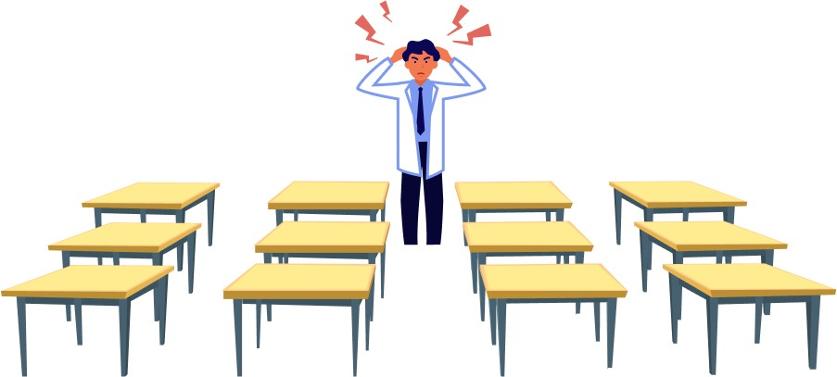

What happens with this arrangement of space? Those sitting in line 3 will get the least amount of

The most important thing is that they have a lot of attention, so they are more likely to be disciplined and feel disengaged from the process.

This arrangement can be considered ineffective space organization unless the teacher is quite active in moving around the room.

But if our goal is to maximize the effectiveness of the lesson, we should try to keep every group of students the same distance from the teacher.

The picture below shows an example of effective space organization. If you arrange the students in a semicircle, everyone gets equal attention. If more than ten students are expected, the chairs should be arranged in a staggered pattern.

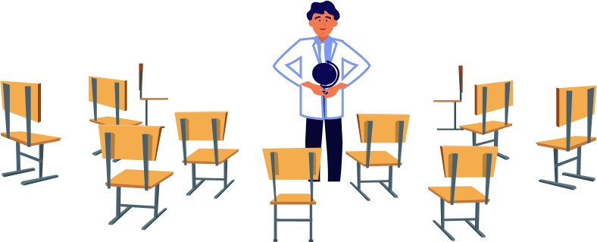

If space does not permit arranging the chairs in a semi-circle, then you should consider how to make the rearrangement.

The teacher's attention should be kept to a minimum, but all students should get the same attention. Let's move on. Tables with equipment for experiments, self-study and other practical activities should be placed at the back of the classroom or a little away from it. It is desirable to separate the general-

The area of the experiments is the same as the area of the experiments.

All unnecessary items (water bottles, briefcases, bags, food and toys) should also be removed.

The table with the equipment and materials should be placed on the other side to control access to ensure safety.

Here is an example of one location where all of these conditions are met.

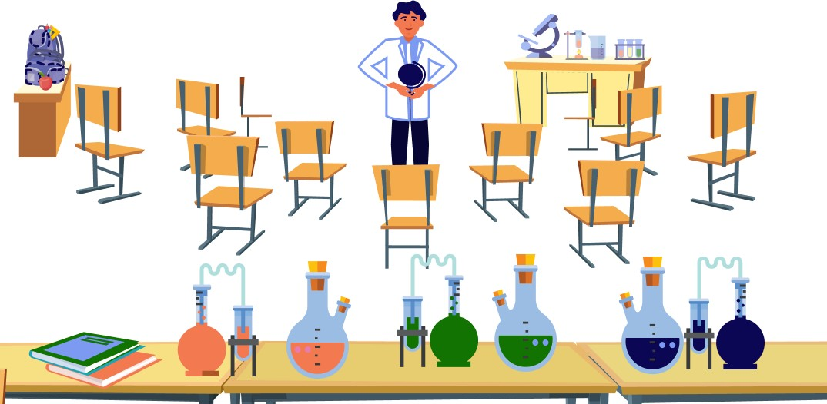

With this arrangement, the lesson begins with theory, after which the students break into groups and move on

to their desks. From time to time they come back to gain new theoretical knowledge or to discuss their work together.

On each desk or other workspace it makes sense to allocate personal work areas for students to work more comfortably.

You can divide the tables into work areas by marking them. This can be done with plain colored tape. Sometimes it is useful to install screens, which provide better insulation.

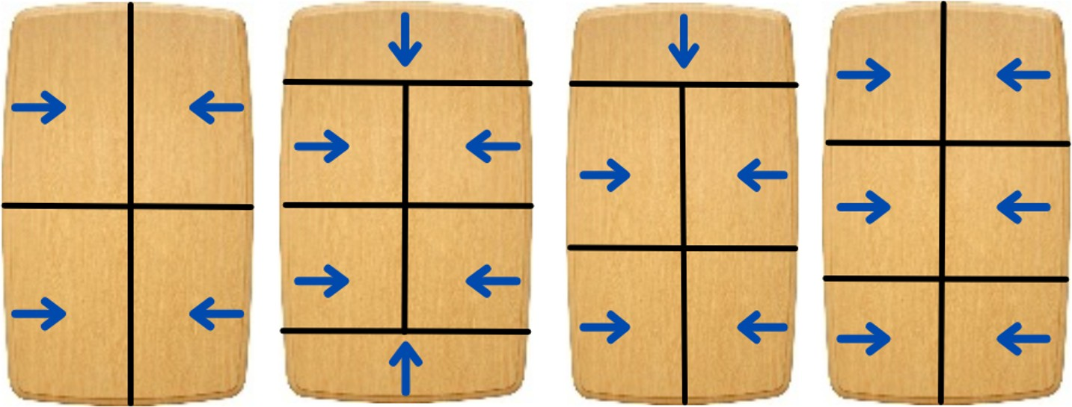

Above are examples of how to mark out working areas at a common table for 4, 5, and 6 students, respectively. However, if possible, do not have more than four children at one table.

The blue arrows indicate how to sit at the table to work. But table markings can be

different and vary from lesson to lesson. It all depends on the lesson and the tasks set.

Markings can also be made on the floor to delineate different areas and workspaces. It is especially important to separate areas where equipment and materials that could be harmful to health - e.g. electrical appliances or chemical reagents - are located.

This arrangement of space allows the teacher and students to feel in a professional environment.

### Atmosphere in the classroom

Transforming a classroom from an ordinary room with tables and chairs into a room with "soul" requires effort, more of it intellectual. However, the result is that everyone will feel at home here, and won't want to leave. People come back to such places again and again.

Additional comfort will be created by pictures related to the topics of the lessons. For example, pictures of a volcano, colorful and unusual fish, a diagram of the planets of the solar system, pictures of insects, and other visual material can be placed in the classroom. Similarly, keywords, science-themed posters and, of course, posters with rules would be a fascinating addition. If the school provides

related courses, especially for the next year, it makes sense to do a little overview of the next step to see what students will be learning in that direction in the future.

It is also worth remembering about the atmosphere in the literal sense of the word. It is worth paying attention to the air conditioning system and where the air flows are directed. Do they have to be diffused? It happens sometimes that the air conditioning only blows on one person, and everyone else feels hot. Such a problem is easily solved by a simple screen of cardboard or a sheet of paper, placed 10-20 cm from the opening of the air conditioner.

How does the fresh air flow into the classroom and how does the ventilation work? Should the filters be cleaned soon or should this have been done six months ago? Is it possible to install an air freshener to create a certain aroma in the classroom?

How is the lighting arranged? Is it possible to turn off the light completely if it is necessary to conduct the experiment in the dark? Are the students' workspaces sufficiently lit?

And, of course, where is the drinking water? How to get to the bathroom? Where is the first aid kit?

It is desirable to know the answer to all these questions in advance and try to use the best possible option.

## Discipline and rules

Everyone is familiar with the word "discipline" from childhood. What is it?

Classroom discipline is the term teachers use to describe the process necessary to keep classroom lessons running smoothly. The term suggests preventive measures with proactive behavior as well as effective responses to student misbehavior.

Not all teachers can handle discipline in the classroom. Some even change careers because of it.

Discipline is critical to the process as it supports curriculum implementation, instructional design, and implementation. Discipline does have a positive impact on how students achieve their learning requirements and goals. Therefore, teachers would be well advised to spend more time and effort on maintaining discipline in an effort to improve the academic performance and overall education level of their students.

Education programs, however, do not emphasize this. That is why teachers rarely make discipline a priority. But once a teacher loses control of a discipline, he or she will have a hard time regaining it later.

In addition, studies by Berliner (1988) and Brophy & Good (1986) show that while the teacher is trying to restore discipline, the level of academic engagement in the classroom decreases.

Classroom discipline implies a clear link between instruction and student performance in the learning environment. Well, or in the classroom, for that matter.

The first factor for regulating discipline is to set the rules.

### Rules

There is a saying that rules are made to be broken. Anyone with teaching experience, especially when working with children, has encountered student misbehavior and knows in practice what systematic rule-breaking is.

In any teaching system, rules are the starting point for developing classroom management strategies. Rules are important and necessary. Not only the teacher, but also the students will have an easier time navigating the lesson if they know what they can and cannot do.

There shouldn't be many rules, and they should be simple and short. No one wants to memorize a complicated rule. Children's brains will have a hard time not only remembering, but also processing such a rule.

Rules are established from the very first lesson, from the moment you meet the students. The easiest way to explain the rules is to talk about the upcoming activities in the classroom and how to do them. For example, showing experimentation equipment or tools. And then explain the seriousness of working with them and the dangers they can pose.

It is advisable to repeat the rules at the beginning of each lesson. You can think of some fun way of repeating them, e.g. by introducing special gestures and words. Then what is said in words will be better remembered. For example, for the science class, you could formulate

to make three such rules.

1. Do not touch tools, equipment or materials without permission.
2. If you want to answer or have a question, raise your hand.
3. Behave yourself (sit properly, don't talk, look at the teacher, don't run).

It is worth explaining to the students that the materials and equipment for the lesson are not yet familiar to them and therefore can be harmful to the students. If everyone starts talking at the same time, no one will hear anything and it will be unclear what to do.

The rules should be tailored to the course, the material to be studied, and the focus of the school. For example, if you are going to work with chemical reactions and materials, it would be logical to increase

Prioritize safety to do so. Allow time for simple physical exercise every 30 minutes when working at a computer for extended periods of time. When working with tools, emphasis should be placed on their dangerous parts and on general safety in such work. On the basis of the rules, the teacher can create a system of rewards and organize the students' work in teams.

manda.

## Working in team

In any class activity there comes a time when the class needs to be divided into teams for further activities. Teamwork skills will be useful to every student in the future. Shy students feel more confident in teams, while more advanced students can take on leadership roles.

When should students be divided into teams?

* When an experiment or project requires the work of two or more participants.
* When one student will need the help of another pair of hands.
* When there are fewer experiment kits than there are students in a classroom.

If you trust the children to break into groups on their own, it will be long and painful, primarily for

teacher. Therefore, it is possible to use such team-building techniques.

### Division based on random selection

For this method, you will need number cards or beads to keep track of the number of children and teams. For example, if there are 12 students in a class and three students in a group, the class should be divided into four teams. For this purpose, prepare three cards with the number "1", three cards with the number "2" and so on.

The cards are to be shuffled and handed out to the students in a random order. Now all the great responsibility of choice depends solely on the mechanism of random choice, and the questions disappear: "Can I be with him or her?" This works especially well if the student draws the card himself or herself.

This technique saves time and allows you to quickly start activities. Also, the random division mechanism obliges students to communicate even with those with whom they were not previously acquainted or were not on good terms.

You can also use this method when you need to distribute some materials for an experiment. For example, the teacher has 12 sheets of coloured paper of different colors. If the choice is left to the students, an argument may arise, for example, over the blue

or red. If the paper is placed in a dark bag from which the students pick one sheet at a time without looking, then again the method of random selection will work. This can be very handy with a limited amount of material.

If the number of students is not evenly divisible by the required number of teams, the remaining students may join any team of their choice or form an incomplete team with the teacher.

### Independent team recruitment

When it is clear after a few lessons which of the children are more outgoing and which are more reserved, it is possible to let the pupils choose their own teams. This method is useful when more than three participants are needed for an activity. The teacher chooses the right number of team captains, who then take turns choosing one person from each of the students. Of course, the leader should be a sociable student or someone who has already excelled in something.

This method allows for the creation of a hierarchy and the assignment of a superior, entrusting them with some control and responsibility for the whole group. In this way, students in the classroom develop leadership skills as well as a sense of responsibility for the team. If the number of students in this method is not de-

The students who have not been chosen can choose which team to join.

In teamwork, each group has its own responsibility and competes with other teams. Each team can choose an interesting name, color, logo, or even a slogan, if time allows. The list of teams can be written on the board. Teams can be awarded points for their activities and compare their results with each other.

* Team 1 ★ ★ ★
* Team 2 ★
* Team 3 ★ ★ ★ ★
* Team 4 ★★★

Teachers can also organize their teams to get more involved if more than one teacher is in the class.

After evaluating the results, you can praise the winners, encourage the other teams, advise them to be more active in the future and point out weaknesses.

## System of rewards and penalties

Once the rules have been established and the norms of behavior have been defined, the next stage of work is to monitor their implementation.

It's that simple. Encourage those students who follow the rules and punish those who break them. A system of rewards and punishments is created for this purpose.

A system of rewards and punishments is a kind of expanded list of rules with consequences for their fulfillment or violation. They should be easy to understand and known to students.

The system can be applied to individual students or to groups of students working in teams.

As a reward, you can provide such:

* The student or group that excels will have a higher priority in receiving the material, will be the first to choose their group or assignment, and will be the first to check their assignments.
* Allow you to spend more time with the equipment for experiments or science games.
* Provide additional materials for experiments, such as an extra color or another set.
* Help to bring an experiment or project to a more advanced level with the help of a teacher or special tools.
* Receive a sticker, badge or other additional points.
* Public praise when repeating the material at the end of the lesson or a praise summary for parents.

You can think of other ways to reward students who excel.

And the following actions can be used as punishments:

* Lower priority in obtaining materials, in selecting and in queuing to check assignments.
* Limit your time with equipment for experiments or science games.
* A delay of one minute or more in receiving material.
* Ask the student to sit on a chair to the side and think about mistakes in their behavior or their unsafe actions.
* Take them out of the classroom and talk to them in person.
* Talk privately with the student's parents, tell them what happened and how it affects his or her grades.

In general, there are a few things to remember about the system of rewards and punishments. It is necessary to praise more and criticize less. At the same time, remember: praise should be publicly, and talk about shortcomings in private.

The interesting thing is that this system can be presented as a game. Then the students will be more motivated to get better. After all, everyone loves to play, even adults. And for children, play is one of the most important ways of interacting with the world.

## D imification

As William Shakespeare said, "All our life is a game, and the people in it are actors. These words are confirmed in our lives everywhere.

The playful approach makes the learning process more attractive in the eyes of the students. They are more interested and engaged in learning and acquiring new knowledge. For example, new activities and crafts become available only after the previous stage is completed. And this is not a teacher's instruction, but the rules of the game. The excitement and the competitive effect are beneficial.

Gamification of learning is a powerful tool worth learning how to use.

Consider several gamification strategies.

### Stickers instead of points

When evaluating students or groups, the usual points or stars can be replaced by more interesting designations. For example, above we showed such a rating system.

* Team 1 ★ ★ ★
* Team 2 ★
* Team 3 ★ ★ ★ ★
* Team 4 ★★★

When the students are familiar with such a system, changes can be made by suggesting the use of interesting stickers or funny images. It could be a cat, a flower, a rocket, a car, a lightning bolt, etc. The simplest sketch, drawn on the board by a marker, can motivate students to get it in one or two minutes, especially if other students become actively involved. For example, girls like cats and boys like rockets. And if you use several markers of different colors, marking, for example, the strongest group or the first three students, it may even cause a fight for the right to be in the front row.

You can prepare in advance a set that will be easy to draw in a couple of seconds. And for leaders, sketches can be large and multi-color.

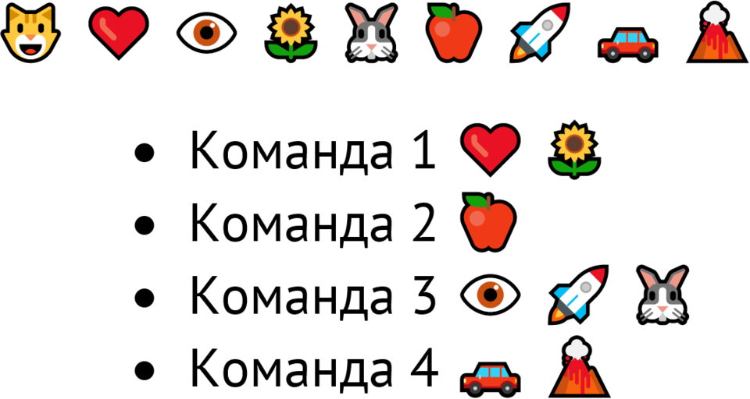

It looks cool, doesn't it?

### Points and internal "money

You can ask students to earn points either in the short term (one lesson) or over the course of a semester or even a school year. Consider a point system for the year. The student will get points for certain achievements. He will have an extra goal - to get the right number of points. If he does more, he gets more.

After a set period of time, students will be able to spend the points they have accumulated on something they need. For example, to buy health-friendly sweets in class, scientific toys, to pay for extra time with equipment and tools with points, to get a discount for the next year or something unique, which is very difficult to find elsewhere.

A point system and a clear understanding of what the points are for will encourage students to accumulate points. It is also possible to introduce internal money throughout the institution to validate their accomplishments. Such conditional currency would prepare students to interact with real money in the future and develop planning skills and a sense of responsibility. They will be able to calculate how much more they need to work and how to do it, as well as understand how not to lose

to take back what we have accumulated.

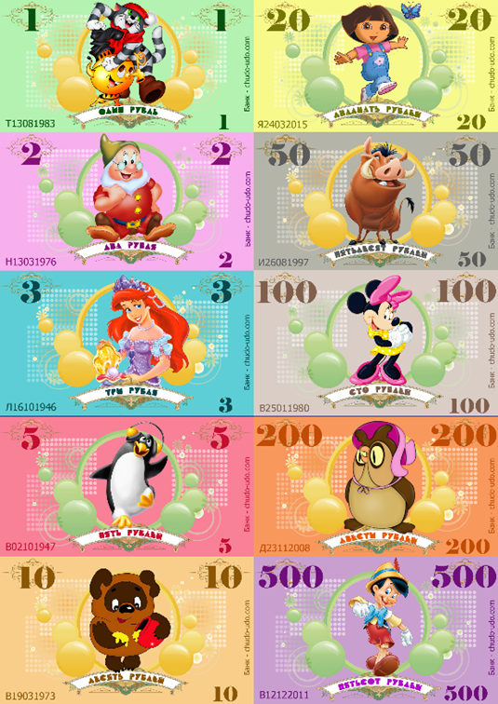

The photo is an example from the Internet. A simple design with elements from the educational process will increase the attractiveness in the eyes of students and raise the brand awareness of the school.

Students will hold onto this money and show others their honestly earned accomplishments. Which will consequently promote the source of those accomplishments. Namely, pride in what they do in the classroom. After all, they have earned currency that has intrinsic value

Parents will probably like this idea, too. After all, financial literacy, especially for children, is not included in the basic school curriculum.

For an example, consider two students: Alex and Alina. They both earn points at about the same rate. Alex spends almost immediately on sweets and small pleasures, while Alina tries to save up for something big and only gets what she wants after a couple of months. Despite their differences, both of these students feel happy because they spend their savings according to their desires.

### Stages and badges

The entire school year or semester can be divided into stages. Already when the course material is developed it is usually divided into logical blocks. If this is not the case, you should analyze the course and divide it into phases yourself.

Students need to understand that in order to move to the next step, they must master the previous one. To

To show this, you can describe to students the steps for moving to the next stage in their learning.

For example, when a student accumulates the required number of points or a positive assessment of knowledge in a certain period of time, he or she receives a certain status and can move to the next level.

A student can earn a badge or badge for the correct use of a tool or for mastering a method of work over a period of time. Badges can be placed on a uniform, if the school has one, next to the student's photo on the blackboard, or attached to a virtual profile in the school's electronic information system. In short, it should be placed where everyone can see it and where information about students is clearly presented.

## Roles

The learning process is underway, the students are already familiar with the basic rules and feel comfortable with the lessons. Partial delegation strategies or roles can now be used.

The method involves partially transferring one of the teacher's functions to a student or group of students. Here is an example of functions that can be delegated:

* distribution and collection of materials for the work;
* control over the safety of execution;
* explaining the meaning of key words, the theoretical part of experiments or methods of work for other students;
* discipline control.



At the beginning of the lesson, it can be explained that the students will now have some of the teacher's functions and powers in some of the activities in the lesson. That is, each student will take on a role to help the teacher and the whole class work better and more effectively. You can then explain what each role means.

For example:

Those responsible for the materials will distribute them to all students in the class.

Safety officers will assist the teacher in supervising safety procedures.

You can ask the people in charge of knowledge and theory if you don't understand something.

Discipline monitors will maintain order in the classroom.

This method may not work right away. It takes time and an awareness of what the students have to do. However, once it is at full strength, it will relieve the teacher of a number of small tasks. Of course, once you have assigned roles to the students, you should not completely forget about these areas of work, especially with regard to safety.

Parents will definitely like this method, as it develops a sense of responsibility and teamwork skills in children.

## Changing the context and the way of action, releasing excess energy

When explaining the theory and doing practical work, the method of context switching works well. You can think in advance about which areas are available in the classroom and use them as intended.

For example, explaining the theory with an example product or simply demonstrating what and how to do with a tool will be easier if you call all the students closer. If there is going to be work at the table, then everyone can be gathered around the table. If one student is already doing the work well, it might be helpful to call all the others so they can see the correct performance. Things that require a lot of space are sometimes easier to explain outside the classroom. For example, when you leave the room, you can show the students the maximum length of a whale or the height of a bear.

The same applies to the way students perform tasks. Looking at things from a different angle can help you learn better. To do this, try shifting the observation point: Look at something from above, from below, in the dark or with a magnifying glass. Using everyday objects for unusual purposes solves the same problem. For example, use a book instead of a ruler, a pencil as a cylindrical object, or trace around a plastic cup to draw a circle.

Every lecture or textbook is about learning. However, all students have different backgrounds, knowledge bases, English proficiency, behavior, attitudes, creativity, and other characteristics. These differences also affect learning. In such cases, a change of context and way of doing things can help. It allows you to address

to other skills of the student - in particular, those that are not normally used directly.

An experienced teacher knows that every child has energy. There's enough energy for moving, running, socializing, and everything else except being diligent and focused. But you can channel their energy where it's needed, too. After all, too much energy in children can interfere with their learning, preventing them from learning, or provoking their brains to be too active, making it difficult for them to keep up with information. You could compare it to a closed bottle of sparkling water. If we want to drink water, we have to let the gas out first, otherwise everything around us will be flooded with water.

It's the same with children. Sometimes classroom management strategies don't work as well as they should. Bad behavior begins to affect learning. In such situations, the teacher may set a simple rule for energetic and naughty children. After breaking it several times, the student should do simple physical exercises. This will help to release excess energy. For example, sitting down, standing up, jumping around and sitting down again is a very simple and fun activity. This should appeal to children - and they will do it with pleasure. But there are two nuances in the practical application of this method.

First, active activities such as running or walking can be very useful in the classroom. Even adults can get bored sitting in one place for long periods of time. So if you want to keep children's attention and make your lessons more engaging, you should add physical activity to every lesson plan.

And second, try not to overdo it. Too much stress can border on corporal punishment, which is unacceptable to the whole learning process.

## Time Management, or Time Management

Everyone knows very well that time is the most valuable resource. Time is always moving forward, it cannot be stopped or reversed. You have to know how to work with it, and it's important to understand how much time each task will take within the lesson.

The approximate time required for the activity should be noted in the lesson plan. This will help the teacher to orient himself or herself better in the lesson. A sense of time comes with practice. It makes sense to always keep in mind or on paper not only the sequence of activities, but also the time needed to complete them. Here are some general tips:

* The process usually takes longer than planned because children do the work more slowly. Their comprehension and fine motor skills are not as developed as those of adults. Children ask more questions and may not understand things that are obvious to adults. Roughly speaking, an average student can be expected to spend twice as much time on each task as an adult would. Therefore, when preparing for a lesson, it is essential to try things out for yourself: at such moments, you understand what can be difficult and where more time is needed.
* A sense of time also develops with practical experience. You can simply accept that expectations and planning may be wrong at first. When analyzing the lesson and the students' work, consider what the children spend more time on and what they do quickly.
* The students should be told about the time and the time commitment. It should be explained to them that if they spend time playing games, they may not have time to finish their experiments, so the results will not be as impressive.
* You must always keep track of time, have a Plan A and a Plan B. Plan A is when everything happens on time. Plan B is how to do it faster and what you can skip if some activity takes longer.

## My move to Shanghai

It was a game of wah-banking! After returning from a short trip to Russia, I decided to move to Shanghai from Beijing.

A new job was found through new acquaintances, and housing was found through a group in "vichat. I arrived on the night of July 25 with 3,000 yuan in my pocket.

Shanghai greeted me with warmth, fresh air, and an atmosphere of its own, which seemed to envelop me in invisible waves. At the time of my move, Shanghai was the most expensive city in mainland China1 - more modern, more organized, and in some ways quieter and more spacious than Beijing.

People from all over the world live in Shanghai. While I was there, I met people from every continent. There's even an entire neighborhood in the center called the French Concession. Of course there are many Frenchmen and French companies in Shanghai who have a strong position in Europe and want to enter the Chinese market.

Narrow streets, old houses, small restaurants and stores: numerous foreigners make it

1 And at the time of editing the book, the most expensive in the world, ahead of Tokyo and Hong Kong.

the place is special. And the tall skyscrapers with night lighting, located in the business district, evoke admiration and excitement.

In Shanghai, there is a special Shanghai dialect that is often spoken by the adults of the city. Other Chinese only have a rough idea of what they are talking about.

You can understand the beauty of Shanghai only if you live here for a long time. Travelling and short trips won't have the same effect. It is only in the everyday life of Shanghai that the culture and customs of China are revealed.

Of course, competition in such a big city is developed in all directions. And education is no exception.

# Chapter 11. Security

Science education in elementary school is crucial to our children's learning. Practical science activities encourage students to explore the world around them. This part of the curriculum is designed to help elementary science teachers create a safe, experimental environment for students.

The information contained in this part has been compiled by me from a variety of sources that are not always focused solely on life safety. This chapter will be a starting point for the introduction to safety practices and is intended as a basic guide to safety actions. Therefore, do not assume that I have given all the necessary warnings and precautions here. And that additional information may not be necessary.

As such, it makes sense for the reader to consult with management and authorities before beginning any school science safety program.

All safety recommendations can be applied to all teaching and learning areas.

Please ALWAYS keep this in mind.

Safety is the most important thing an adult working with children should have in mind. This is especially important for science teachers. If an activity does not meet safety requirements or, in other words, can be harmful to students' health, it should be excluded from the lesson plan or modified.

## Safety of Science classes

### Where to start

Science classes in educational centers and elementary schools are safe as long as the teacher and students are aware of the potential dangers and take all necessary precautions. If the laboratory experiments in the classroom are conducted safely, this not only keeps students safe from injury, but also provides a basis for future classes in higher-level science classrooms.

The safety precautions described in this chapter were written by scientists specializing in chemical safety. These rules will also apply to physical experiments and work with tools.

So, these safety rules will help you:

* Prevent accidents and injuries that may occur during scientific research and experiments;
* to teach children that safety is an important part of science;
* to gain an understanding of the potential dangers that exist in the science classroom;
* Identify safe working practices that students need to know about and follow.

This list is of course not the only source of information on classroom safety. Additional information can be obtained directly from the school, from special courses, from the state Department of Education, from science suppliers serving the school, and from science teacher associations. Science departments at nearby kindergartens, learning centers, colleges and universities are also usually available to help with safety issues.

### Planning

Many potentially dangerous situations can be prevented if the teacher organizes and prepares everything in advance. It is important to familiarize yourself with the procedures, mate-

The students should be familiar with the materials, substances and tools used in the practical exercises, so that they know what to be prepared for. All tasks and experiments should always be done personally before assigning them to students. The following should be considered when conducting experiments and other activities (this list can be used as a checklist):

* Determine what materials will be needed and how to distribute them to students;
* Identify safety issues and plan how to address them with students;
* think about how to instruct students when they do an assignment;
* Consider the risk of emergencies and decide what to do if they occur;
* Make sure the necessary equipment and supplies are available and that the teacher knows how to use them;
* plan the collection of materials and their safe disposal;
* Allow time for students to wash or disinfect their hands if experiments or tasks involve working with contaminants.

When mixing or using chemicals, only refer to reputable published procedures. If there is a desire to perform

If you have your own chemistry experience, you need to find out in advance whether it would be safe to do so. Consult your high school science teacher, science advisor, or research assistant to see if there are any potential problems.

## Use of equipment for protection

Teachers, students and all visitors to the classroom should wear eye protection when conducting or observing hands-on activities. However, wearing glasses is not the only way to protect the eyes when conducting research and experiments or when working with special tools.

The following actions will also help ensure that you and your students are adequately protected during science classes:

* Wear properly fitting splash goggles when handling chemicals, materials and special tools. Splash-proof goggles differ from conventional laboratory goggles in that they protect the eyes on all sides, not just the front.
* Always wear splash goggles by students not only when working, but also when observing when they

use chemicals, hot liquids, loose substances or flying objects.

* Wear an apron or a cotton lab coat if there is any chance of soiling or damaging clothing.
* Use gloves, heat or frost-resistant gloves or other hand protection when handling hot materials, hot glue gun, dry ice, poisonous plants or live animals.
* Gather long hair and secure loose clothing and jewelry - especially when working with chemicals, heat sources, and moving tools.
* Use protective masks when handling loose or volatile substances to protect your respiratory tract.
* Use hearing protection when operating a loud instrument or examining explosions.
* Use blackout goggles when operating lasers or other direct bright light sources.
* Constantly remind students to avoid putting study materials in their mouths, noses, or eyes when doing activities or experiments, and when cleaning up afterwards.

## Checking equipment and materials

### Working with chemicals

* Most science procedures for preschools and the first six grades of school require the use of household chemicals. Before using such products for the first time, you should study the label carefully to learn about possible hazards and precautions.
* If chemicals are purchased from suppliers serving K-12 schools and educational facilities, refer to the Material Safety Data Sheet (MSDS). This document describes the risks of using the chemicals as well as information on proper storage and disposal.
* Always store chemicals and solutions in properly labeled containers designed for storing chemicals and solutions. Never put chemicals in containers that were originally used for food!
* Be sure to dispose of chemicals properly. If you are not sure how to do this, check the Material Safety Data Sheet or consult your supervisor. Regulations may vary from country to country or region to region, so it is best to consult your local experts.
* When using a chemical, keep its safety data sheet handy. If a student is injured in contact with a chemical, the safety data sheet has instructions on what to do. Be sure to send an injured student to the doctor along with the chemical safety data sheet.
* Always wear cotton or insulated gloves, such as garden or work gloves, when handling dry ice. This solid carbon dioxide is very cold and can damage unprotected skin.
* Store dry ice in an open refrigerator or cardboard box to allow carbon dioxide gas to escape. If you place dry ice in an airtight container, the gas pressure will build up and could cause the container to explode.

### Working with a tool

* Keep handling of glass to a minimum, using it only when absolutely necessary. Non-breakable plastic containers are a substitute.
* Cuts are one of the most common laboratory injuries. Take precautions when using sharp objects such as knives, scalpels, compasses with sharp tips, wire, needles or pins. Think carefully about whether or not you really need cutting or sharp tools for your work. If necessary, it is advisable to take

tools with retractable blades. Pre-cutting materials will save you the trouble of giving children cutting tools. If students do need to use sharp objects, demonstrate a safe way to handle them to avoid injury.

* The tools with which the students will be working must be in good working order. If they are lost, they must be replaced.
* Batteries should be stored so that at least one terminal is taped or insulated. Batteries showing any signs of corrosion should be disposed of immediately in accordance with the school policy or local regulations for disposal. Since the contents of the batteries are potentially dangerous, do not cut or disassemble them.
* Do not dispose of old batteries with normal trash. Dispose of them at a public hazardous waste collection point.
* To minimize your environmental impact, consider using rechargeable batteries.

### Thermometers

* Use alcohol thermometers instead of traditional mercury thermometers. The mercury from broken thermometers is difficult to remove from the room and spilled mercury vapor is hazardous to humans and toxic to the environment.
* Thermometers with a plastic or metal backing are best. If you use glass thermometers without this backing, they should be fitted with a cap or triangular ring to prevent rolling.
* Do not allow students to use thermometers as stirring rods!

## Think carefully before bringing plants or animals into the classroom

### Plants

* It should be made clear to students that they should never put seeds or plants used for science experiments in their mouths.
* Every time we have to repeat to our students that they should always wash their hands after working with seeds and plants.
* Store-bought seeds are often coated with insect pesticides or fertilizers, or sometimes both at the same time.
* About 700 plant species are known to cause disease and even death. Learn about harmful plants in your area and avoid contact with them.
* If students will be traveling to areas where dangerous plants such as poison ivy may grow, be prepared to teach them to recognize and avoid contact with these plants.
* Ask students to memorize the signs of plant poisoning so you can respond quickly if you notice symptoms such as headache, nausea, dizziness, vomiting, hives, itching, or other skin irritation.

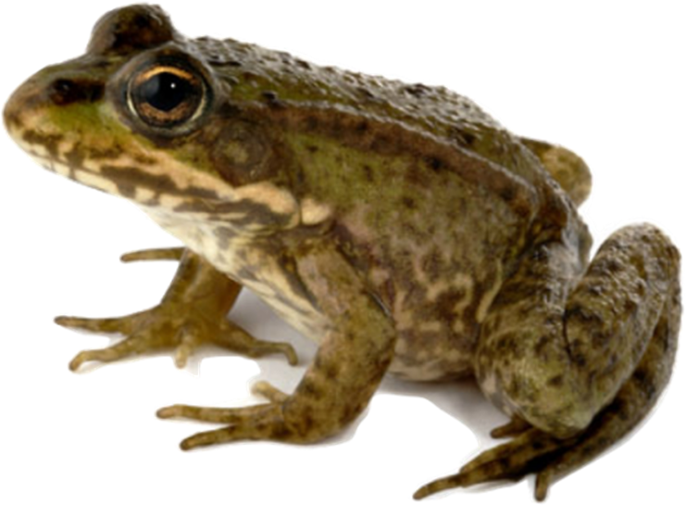

### Live Animals

* Before bringing an animal into the classroom, have a safety lesson to show students how to properly care for and handle the animal.
* Students should touch the animal kindly and handle it gently and only under the close supervision of the teacher.
* Do not allow children to mistreat or abuse animals.
* Animals caught in the wild have no place in your classroom! Wild animals can have serious illnesses such as rabies, or carry infections that are dangerous to humans. For example, turtles can be carriers of salmonella.

## Preventing burns and fires

### Heating materials

* When working with heating elements, always wear protective equipment: goggles, gloves, and appropriate clothing such as gowns, aprons, or sleeves.
* The area around the heating source must be clean and free of combustible materials.
* It is unacceptable for students to work with hot materials, such as very hot water.
* Not all glass can withstand the heat. Do not use ordinary household glass in your experiments. When heating substances, use only laboratory glassware made of borosilicate glass. You can buy them in the respective stores.
* Many household liquids, such as alcohol or oil, are flammable, which means they should not be heated! Only heat water or aqueous solutions.
* The use of alcohol burners is very dangerous! Use them only when absolutely necessary and only after detailed instruction.
* Use the proper type of pliers for all hot materials.

### Heating devices

* Only laboratory-type plates are used for heating chemical materials. They protect against small spills.
* Place the stove where students cannot separate it from the work surface or trip over the power cord.
* If you plan to work with a hot glue gun, you must equip a station to accommodate it.
* Never leave the room when a heating device is plugged in, whether it is being used or not.
* Keep students away from working or still hot parts of appliances unless you are near them or have given them specific instructions.
* Before removing the hob, make sure that it is unplugged and cooled down. You can check how hot the burner is by dropping a few drops of water on it. If the water does not evaporate, it is at a normal temperature and can be touched.
* Always wear protective gloves and goggles when handling a hot glue gun with your hands, as the devices may still be hot from previous use.

### Fire

Try not to use or minimize the use of fire at all. Choose safe sources of fire. But even with them, try to work only with yourself and not with students. If you decide that students need to use fire sources themselves as part of a science activity or experiment, give clear safety instructions and allow them to do so only under your supervision.

Students should use candles only under your strict supervision. Use short and wide tealight candles that cannot be knocked over in normal use. Place other candles in a "drip tray" (such as an aluminum plate). The container should be large enough to hold the entire candle in case it falls over.

* Never leave the room while a flame is burning or another source of fire is being used.
* Remember where the nearest fire extinguisher is and make sure you know how to use it.
* Familiarize yourself with your school's policy on what to do in case of a fire.
* Find out where the nearest fire alarm is located. Keep a map of its location at your classroom door.

## Cleaning up broken glass and liquid spills

* Clean up broken glass with a broom and dustpan. Do not touch or allow students to touch broken glass.
* Dispose of the glass in a separate container and label it so that it is clear to everyone that there is broken glass inside.
* Clean up spills immediately. This will prevent further contamination of the work area and the risk of slipping, falling, or transferring the chemical to another location.
* When using household or other chemicals, follow the cleaning instructions on the label or on the Material Safety Data Sheet.
* Dispose of all paper towels or other products used to clean the room in a separate container for chemical waste.
* Do not dispose of chemical waste in regular garbage cans.

## Installation of emergency procedures

* Work with other science teachers and your supervisor to develop and establish first aid procedures for electric shock, poisoning, burns, allergic reactions, fire, evacuation, spills, or animal bites.
* Find the contact information and keep it handy so that you can contact the appropriate authorities and emergency services in case of an emergency.

## Safety rules for students

Instruct students in safe work practices and explain what they may not understand. You can set up the rules yourself or have students help you develop safety rules for science lessons. Either way, make sure students understand these rules and know why they are necessary. It's a good idea to ask students to draw posters that will hang in the classroom throughout the year to remind them to follow the safety rules. Before you begin the class, make the following requirements known to the students:

* Always get your teacher's approval before you begin a science task. Also, make sure your teacher is watching you when you do experiments. Never do experiments on your own!
* Wear your safety glasses whenever the teacher tells you to. Do not remove your glasses until the teacher tells you the task is complete.
* If recommended, wear an apron or robe to protect your clothes.
* Read all warnings on the substances and tools you are using and comply with them.
* Make sure your teacher is aware of possible allergic reactions.
* Follow all instructions carefully when conducting science classes. Make sure that you use the substances exactly as described in the instructions.
* Keep all materials used in science activities away from your mouth, nose and eyes. Keep your hands away from your face when conducting class or cleaning up afterwards.
* Never taste anything during a science class! If the research involves tasting, this will be indicated in advance.
* Gather long hair and secure loose clothing and jewelry.
* Remember where the nearest safety equipment is located, such as the eyeglass cabinet, fire extinguisher, first aid kit, etc.
* Protective equipment must remain in good working order. Do not play with these items.
* Immediately notify your teacher if you or someone else is injured, has a leak, or other unforeseen incident.
* Clean up your workplace after the end of the practical exercises.
* Wash your hands with soap and water after completing your experiments.

Even the youngest students should follow the safety rules and know how to behave in the practical exercises. Make it clear that students who violate these rules will lose the opportunity to participate in fun hands-on activities. For safety reasons, students who misbehave should be removed from the classroom.

Safety skills will be needed outside the science classroom, in middle and high school science labs, and later in life.

**Part 4.**

**Teaching methods**

I think by reading this part of the book, dear reader, you have already acquired new knowledge and perhaps even put it to the test. This is an important stage, because good learning comes from practical application, and teachers are no exception.

It is known that the application of different methods of teaching contributes to a better assimilation of knowledge. We'll get to the methods themselves later, but for now, let's look at this pyramid of learning.

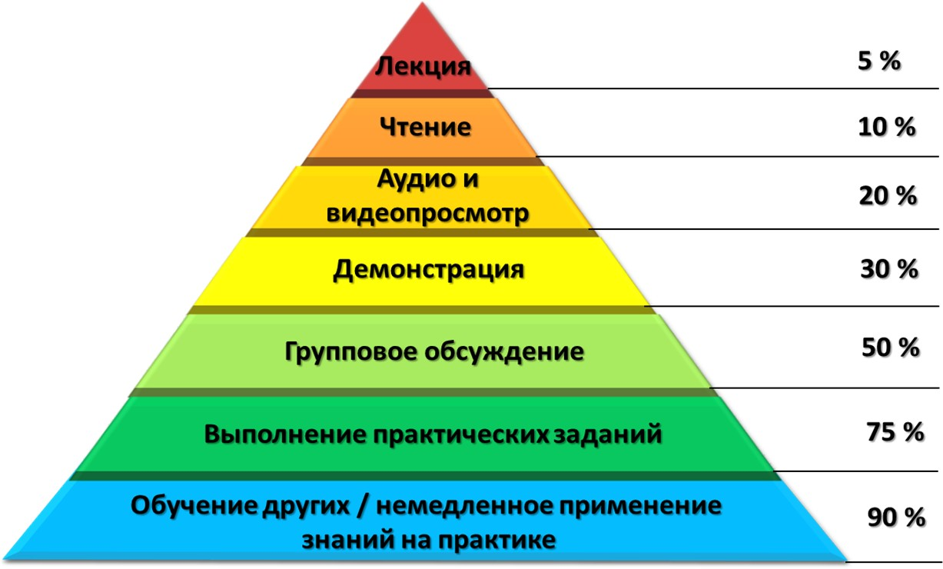

Only 5% of information is absorbed during **a lecture.** That is why it is important to repeat important points several times during a normal explanation of the material. When **reading**, students absorb about 10% of the information. The best way to do this is to

Reading aloud, which requires more concentration on the part of the student.

**Watching a video with sound** can give you an idea of what is physically difficult to bring to class. Up to 20% of the material is already learned. A good video will do this quickly and clearly. A short video demonstration with a teacher's commentary would be an option.

**A** visual **demonstration** is even better at demonstrating what the theory was talking about. Being able to see, touch, and observe in the real world what was discussed earlier increases comprehension by about 30%. Developments in virtual or augmented reality technology will allow elements of the most diverse fields of science to be demonstrated.

**Group discussion** forces the brain to engage, understand the data, and interpret it for repetition. Not surprisingly, the information is already 50% assimilated. Combining group discussion with all of the above methods works even better for retention and retention.

**Putting theory into practice** forces the brain to interpret information and the body to apply knowledge to the material world. It is useful to use not only the theory itself, but also all the other knowledge heard, seen and gained from the discussions. In practical exercises, it often turns out that the result is different from what was

studied in theory. It stimulates to look for what was wrong and to analyze again the information already studied. After the successful application of knowledge in practice, the "theory-practice" bond is reinforced. This is why the level of assimilation is so deservedly high - about 75%.

**Teaching others** is capable of a near-perfect 90% learning rate. If you want to teach others, first learn yourself. This serves as an additional motivation to work through the material. For this purpose, the teacher can allow students to teach one another during short tasks or sessions. The same level of learning is also facilitated by the **immediate application of knowledge** in practice, which usually takes place in laboratories or science classrooms.

# Chapter 12. About the different methods

We are all human beings, and every person in this world is unique. All of us have our own skills and habits. It's impossible to be an exact copy of someone.

It is for this reason that each teacher has his or her own personal teaching style and methods. The combination of teaching methods, enthusiasm, creativity, and adaptation gives birth to a special, unique professional style not only as a teacher but as a person.

What follows can be compared to "carpet bombing" in methods of teaching a subject. Some methods are well-suited for teaching mathematics, others are optimal for teaching languages. But they can all be readily adapted for science courses, as well as for other types of lessons. All it takes is a little imagination and ingenuity.

If I had received this list at the beginning of my journey in education, my experience would be much richer today, and many mistakes would have been avoided.

So, fasten your seat belts. Let's go!

### 146 CLASSICAL LEARNING METHODS:

**Method 1. Lecture**

It is the simplest and most common method of teaching in various educational institutions around the world.

The lecture is considered the ideal method for large classes. It is an oral presentation of the lesson to a group of students.

### Method 2. Classroom discussion

This is one of the best interactive teaching methods, with teachers and students in the classroom exchanging ideas about the topic under discussion. When used effectively, this strategy helps students develop thinking, learning, comprehension and problem-solving skills.

A good teacher will create a positive classroom environment in which students are free to express their ideas. In order to engage all students, you can start by pushing the talkative students into the discussion, and then gradually involve the more shy ones. It is important to be disciplined and let the talkers have their say. On the other hand, discussions are often time-consuming, which also needs to be monitored.

### Method 3. Oral questions

One frequently used teaching method. Instead of passively lecturing, teachers encourage students to ask counter-questions. In fact, this helps the teacher see what points the students are having difficulty understanding and further explain those things.

Classes become more fun and interesting because of the opportunity to clarify the facts immediately

### Method 4. Repetition of key points

The teacher does not just give an oral presentation of the lesson once, but repeats all the important points, completing the topic block, and only then moving on to the next section.

The students recall what they learned in the previous unit before moving on to the next. The repetition of items helps students remember the topic better. Some teachers also ask students to repeat the points covered previously.

### Method 5. Demonstration

Instead of verbally explaining the subject in this method, the teacher provides materials or evidence to clarify the situation. For example, to explain how a complex device works, you can bring a real device to class. It will be clearer and more visual.

Another example would be showing a step-by-step process to help students easily relate practice to theory.

### Method 6. Presentation

This method involves the teacher conducting a PowerPoint presentation in class. The slides can show the sequence of the ideas being conveyed, as well as diagrams, pictures and algorithms, to make the lesson exciting and engaging. The teacher can use a projector connected to a computer to work with a large number of students.

### Method 7. Student Reports

This method is designed to get a response or feedback from students after the lesson is over. They need to prepare reports based on what they have been taught in class. This gives teachers an idea of how much students have understood the material.

### Method 8. Quiz

After the teacher has explained the topic, it is possible to conduct a quiz: ask the students questions about the material studied.

For this method, students can also be divided into groups to make the process more interesting. One or two participants can also act as a group. The method allows the students' understanding to be assessed-

The following is an example of how to use the material and introduce an element of improvisation into the learning process.

### Method 9. Mystery

It is often difficult for students to master subjects such as mathematics or other exact sciences. And puzzling is one easy way to explain the material. In fact, it helps develop creative thinking and problem-solving skills. The levels of riddles depend on the groups of students.

For example, simple word puzzles can improve the vocabulary of elementary school students. Some students have difficulty understanding the material if it is just a matter of learning theory. However, when teachers explain facts using examples and question-and-answer riddles, it is easier for students to understand the lesson. Sometimes teachers use real-life examples, and this

best option. It's easier to learn the theory with examples.

### Method 10. Teaching assignments

In this approach, students are asked to complete the tasks in the textbook after the teacher has finished studying the unit. Such tasks allow for a better understanding of the material studied.

In addition, the applied level of assignments will enhance learning. And some assignments will require additional research, which, in turn, will help students develop self-learning skills.

### Method 11. Summary of Lesson Content

The teacher asks the students to make a brief summary of the topic of each lesson. In doing so, the students can recall the issues being studied and save and use the record for future reference.

All notes can be kept together: they will come in handy during exams. Such notes contain all the important points that were studied in class. With these notes, it will be easier for the students to find the relevant material in the textbook.

### Method 12. Cards

This is one of the best ways to enrich your vocabulary, learn math, science facts or tools. Cards are an inexpensive way to make learning easier.

In addition to being a memory aid, the cards can be used more extensively in the upper grades. For example, students write a problem, question, or control word on one side of the card and a hint for an answer on the other.

### Method 13. Infographics

It is one of the best teaching tools to help convey the material easily to the student. Instead of a huge amount of written information, the teacher uses a visual teaching tool that explains the subject briefly and easily.

It's a well-known fact that the human brain processes images much faster and easier than texts, so learning with infographics is very effective. Even simple sketches or drawings on the blackboard often help to accomplish a task.

### Method 14. Rooting

This method of learning is suitable if you need to memorize large amounts of data or information in a short period of time. Scrambling is the intensive repetition of the same learning material over and over again until it is memorized. For example, rote learning is often used in preparation for exams or important test papers.

Last-minute rote memorization is not usually recommended, but if used beforehand, this technique can be quite effective. To memorize a list of items or an order of operations, students can be given simple abbreviated codes and order plans to memorize. For example, by memorizing the steps of an entire experiment, it is easier to remember the details of each step later

### Method 15. Workbooks

The teacher can prepare the workbooks for his subject by himself, or he can use those provided by the curriculum. This method provides an opportunity to reinforce the lessons learned

during the lecture, and give students some time to work on their own.

Students themselves can use this option to see how much they have learned. The teacher, in turn, will also be able to use this method to assess whether students understand what has been covered in class.

**Method 16. Weekly or Monthly Assessments** It doesn't always make sense to just go from one topic to the next. It is just as important to see how much the students are learning.

The teachers understand what the teacher is teaching them.

Weekly or monthly evaluations will be very helpful in this regard. They will help teachers analyze questions that students have had difficulty understanding and, if necessary, change their teaching strategy.

### Method 17. Laboratory experiments

This is a great opportunity for students to explore, analyze, and reflect on the subjects taught in class. It is one of the most interesting teaching methods!

Through experimentation, it is easy to relate practice to theory. As a result, observation and reasoning ability improve. Among other things, students have the opportunity to learn how to work better with lab equipment and tools.

### Method 18. Reading aloud one at a time

Reading out loud in class one at a time is one of the simplest strategies. This learning practice combines variations in tempo, volume, tone and pitch of voice, pause, and eye contact. By reading loudly to the whole class, students practice the skill of public speaking.

The method includes questions and comments so that the delivery of information is clear and smooth. It is a good way to build vocabulary, improve reading comprehension and fluency.

### Method 19. Interactive reading aloud

This is another type of teaching methodology that involves reading aloud. It combines a series of purposeful activities, including cooperative learning. It requires previewing the textbook, reviewing the preceding topics, and learning to read fluently.

The teacher asks purposeful questions and underlines elements of the story. The students have to find the right passage and read it aloud. After the interactive read-aloud, the teacher summarizes the lesson.

### Method 20. Guided Reading

In this method, the teacher works with groups of students who can read the text at about the same

level. The method develops independent reading skills as well as helps you master complex texts.

The reading text is chosen so that students can read it with the skillful support of teachers.

### Method 21. Reading aloud together

Reading a text aloud together helps students memorize it faster. In addition to improving understanding of the subject, reading aloud also helps students become more active listeners.

By reading and listening to their classmates read, students are better able to remember how to pronounce new words that appear in the text. And because every student will have the opportunity to read, it encourages them to actively participate in the learning process and not to get sidetracked.

### Method 22. Reading by Role

In such a class, students can have an interactive reading experience. They can divide the book or presentation into parts, and each student can read for a specific role or source. And the teacher will guide and assist them appropriately.

The method will help students learn to read and speak fluently through a structured presentation. Students will also be able to practice intonation. This method will make it easier to learn some difficult to read

or boring materials. Students also learn about their classmates' views on reading.

### Method 23. Pre-testing

This method makes it possible to assess in advance how well the student understands the material. The teacher can then use this information to plan his or her teaching strategies.

Determining a student's basic knowledge of a subject helps to better plan instruction, and tests after instruction show how the level of knowledge has changed over the course of instruction.

### GROUP WORK

**Method 24. Group discussion**

In this method, the teacher divides the whole class into small groups and gives a topic for discussion, and the students come up with ideas on the issue or possible solutions to the problem within the allotted time period.

This is an opportunity to get feedback from the students. And for the students, to develop skills for team discussion. As a rule, shy students are more willing to communicate with their peers in small groups than in class.

### Method 25. Debate

This method of teaching shows a range of perspectives on the subject. Students are divided into groups in which they discuss a proposed topic. In most cases, the subjects in the groups are contrasting so that they can argue about controversial issues. This friendly discussion develops critical thinking.

### Method 26. Think about it. Consult. Share

This is a strategy to encourage students to work together. It allows them to work in partnership to solve a problem or a puzzle related to the topic.

It helps to think individually as well as to share ideas with each other to find solutions. All ideas can first be discussed with the assigned partner and only then shared with the whole group.

### Method 27. Puzzle

This class activity allows students to rely on each other to solve a large problem. The big problem needs to be broken down into smaller parts and distributed to the groups formed in class.

As a result, collaborative learning comes to the fore, as one student or group can actively help each other with part of the task.

After all, without solving one part of the problem, you can't put the whole "puzzle" together and solve the big problem. The method promotes group learning and mutual help.

### Method 28. Turn around and talk

This is an oral support strategy in which students have the opportunity to interact with each other, enriching their knowledge of the subject. After introducing the topic, the students turn to each other and begin discussing their ideas related to the issue being studied.

Each student should be given the opportunity to share his or her thoughts about the subject in a friendly environment. The teacher's role is to ensure that the students' partnership is not incidental but strategic.

### Method 29. Differentiated instruction

The method promotes equal learning success for the entire group of students.

The method will be useful for learning applied topics as well as for learning a second language. A student with weaker skills is paired with someone who is more proficient in the language. If they don't understand any part of the theory, you can ask them to prepare questions together.

### Method 30. Mutual Learning

This learning activity involves reading the material in small groups, with the students playing the role of teachers. The teachers themselves first model and then teach the children themselves to lead the group discussions.

The key elements of this technique are creating questions, summarizing, clarifying, and predicting.

### Method 31. Panel discussion

It is a demonstration of factual information and conceptual knowledge about a given topic. The technique can take many forms. Group discussions in the classroom involve a group of several students or representatives of such a group discussing a particular topic after careful preparation.

Alternatively, the group could include subject matter experts who discuss all aspects of the topic, thereby giving the audience an opportunity to gain more in-depth knowledge of the subject.

### Method 32. Peer tutoring

In this flexible strategy, students take on the roles of academic mentors and students. The more successful student takes on the role of tutoring or assisting the weaker student in the subject where he or she is having problems with his or her grades.

Teachers can identify students who are

The students are "experts" in certain topics in order to help those whose knowledge of the subject is weaker. It also promotes cooperation and communication in the classroom.

### Method 33. Heads together

This is a cooperative learning strategy where students are asked to work together in a group. Each student in the group is responsible for learning the subject. When the teacher asks a question, the students can "put their heads together" to find a solution.

Each student is given a number, and when the teacher calls out a certain number, the corresponding student must answer the question. This is ideal for teaching responsibility in the classroom.

### Method 34. Student-centered discussions

The center of learning in this approach is the students themselves. Form a group of five or six students and ask them a question. Allow enough time for the group to think about and formulate an answer. This will help them expand their imaginative skills. Remember to ask thought-provoking questions. Give students the opportunity to go deeper into the subject.

### OUT OF THE CLASS

**Method 35. Homework**

This is one of the most common teaching methods for students of all ages. The teacher gives students a set of tasks to complete at home.

This may include reading comprehension, writing, typing and problem solving, repeating a lesson before a test, or practicing a skill. It also gives parents a chance to see how well their child is doing in the program.

### Method 36. Library research

A very effective teaching method. The lesson presented in the textbook only briefly talks about a subject. To help the children learn more, teachers can assign them the task of exploring the subject in the library.

Most schools have their own libraries with a huge collection of books. Using library books improves students' research skills and deepens their understanding of the subject. And research with the help of online libraries can significantly reduce time. But, of course, it's better to borrow paper books to study complex issues.

### Method 37. Excursions

Students of all ages love this teaching method. A trip to a place that is directly related to the subject makes the educational process more interesting and visual.

Field trips also help improve student interaction, both with each other and with the teacher. They also provide an opportunity to observe, ask questions, and have a memorable classroom experience.

### Method 38. Experimental study

This is one of the most comprehensive methods of learning, based on experience. The students experience learning outside the classroom while gaining enhanced skills and knowledge.

Experiential learning includes independent study projects, internships, field trips, study abroad and more in-depth research. It is a simple but effective approach to learning by doing.

### Method 39. ABL

Activity Based Learning is an approach in which students continuously participate in a variety of activities different from the classroom in order to learn.

This method of teaching actually helps students develop from a personal point of view. Teachers can

The students are able to choose activities that stimulate their senses and guide them in these activities.

### Method 40. Lesson turned upside down

The typical lecture process in this teaching strategy is reversed. Before the actual class, students are asked to watch a video lecture at home. They then use the knowledge gained from this material for exercises and projects, as well as for discussions during class.

### Method 41. Learning in the great outdoors

For this method, students are taken out of the familiar classroom into the open air where they can play, have fun, and learn. Students can participate in social activities and become closer to the environment as well as gain hands-on experience with the subjects taught in the classroom.

Some teachers take their students to the school grounds to teach outdoors.

### Method 42. Literature circles

This approach includes meaningful conversations in groups. Students are able to express their opinions, predictions and questions about the topic in a productive and structured way. This method allows for a discussion of the topic in a structured way.

The first step in teaching difficult subjects such as languages, art, history, or advanced English, which can also be practiced in collaborative reading.

### Method 43. Playground

This is a common method of teaching in the elementary grades and is well accepted by students. When developing a game technique, the teacher takes into account students' interest in the topic and their abilities.

Games such as tag, tag, and hide-and-seek are integrated into the teaching to make the class interesting for the students.

Games can be chosen to develop the pupils' motoric, imaginative and creative abilities.

### METHODS WITH ADDITIONAL SPACE DESIGN

**Method 44. Posters**

To make the material to be studied visually appealing to the students, the teacher can present it in the form of a poster. This saves the students from the boredom inherent in learning a single theory.

Alternatively, you could ask students to prepare posters on certain topics or questions that have already been studied in class.

Such teaching methods increase the ability of students to extract information from the subject and then present it visually to the audience.

### Method 45. The Wall of Words

Another interesting classroom strategy where both students and teachers can contribute to the word wall divide.

For this purpose, a space is set aside in the classroom where you can share your ideas, inventions, data or images with your classmates.

### Method 46. Flannel boards

This interactive tool in education is used in the early grades. Flipcharts make it easier to convey information on different subjects. They enliven and dilute the verbal narration by the teacher.

The flannelboards can be used as a personalized surface for storytelling or as a counting board for math learning. It can also be a playing board or a surface for graphics, depending on the subject to be worked on.

### Method 47. Bulletin boards

Classroom bulletin boards play a big role in creating a positive learning environment

spheres. They can be used to display students' work as well as anything related to the subjects being studied.

Bulletin boards help to memorize important aspects of the lesson. They will also be a good aid when completing a lecture assignment, working with a textbook or in groups. The information on the board will remind students of key elements of the subjects they are studying, including new words or practical techniques.

### Method 48. Training Station

For this method, the classroom should have a space designed for easy access to learning materials on a particular topic, where students will engage in fun activities. The station contains learning materials that allow students to engage independently in their own areas of study. To make learning interesting, students can get work schedules at the station with mandatory

and additional tasks.

### EXPANDED TEACHING METHODS

**Method 49. Classroom projects**

Project-based learning allows students to understand a subject more deeply and remember it for a longer period of time than simply reading a textbook.

In addition to classroom activities, it is suggested that students work on a project that is integrated with the topic being studied in class. The effort of learning a subject over time allows students to look at it from different angles, including a supplemental class project. Project work improves critical thinking, collaboration, communication, and self-management skills.

### Method 50. Storytelling, or Narrative

This is a method in which the teacher presents the lesson in the form of a story. Teachers can also include a story related to the subject in the middle of the lesson to increase interest in the topic and to dilute the theory. Since children usually like to listen to stories, this method is sure to get their attention.

Storytelling is an important and powerful tool in science education that actively engages students' imaginations. We discuss this method in more detail in the next chapter.

### Method 51. Student Teachers

In this method, students take on the role of teachers. They have to prepare the lesson material and explain it to their classmates. Each student is assigned a question and given time to prepare, let's say one week. During this period of time, they should collect information about the lesson.

The following are some of the most important topics of the course. Such teaching methods develop research and presentation skills.

### Method 52. An idea in a picture

This is more of a creative side of learning. Students are asked to express, in picture form, an idea from the class. Each student will do such an assignment in his or her own way, and it will open up the whole class to a variety of solutions.

Teachers may resort to such teaching methods from time to time in order to dilute the usual lectures with something more interesting.

### Method 53. Drama

This is an ideal way to learn languages. In addition to the linguistic knowledge itself, the students get the opportunity to interact through dialogues, gestures and intonation, improving their imagination and mimicry.

Such a communicative activity can be tried in any class and will always promote teamwork. In other disciplines, the students can be asked to take an idea or a subject as the topic of a dialogue. The students are involved in the process as actors.

### Method 54. Pantomime

Since non-verbal actions are often

"louder" than words, some teachers make extensive use of actions and gestures. This is more engaging than reading long lectures. Using imitation techniques in teaching enables students to understand, communicate and actively participate in the lesson.

It is also one of the best ways to learn vocabulary directly related to gestures, movements, and emotions. This technique can be used in many different ways, depending on the subject and the purpose of the training.

### Method 55. Review

This is an easy way to gather information on any subject that will be effective for both teacher evaluation and student perception. The reviews of material subjects or individual topics can be prepared by teachers or students, or existing ones can be explored.

Video reviews are another way to compare lessons and education in different cultures and choose the way that works for most. Reviews can be done in the classroom or online.

### Method 56. Modular tests

The course is usually divided into modules or units. At the end of a module, the teacher may give a quiz covering the key issues of the subject.

of a particular unit. This will help students thoroughly study the section before moving on to the next one, and the teacher can give additional lessons on those modules where students scored the lowest.

Teachers can also set up special classes to help students with areas where performance has been weak.

### Method 57. Role-playing

This method allows students to explore realistic situations in their own learning process. Each student is assigned a role in the interaction process. The students interact with each other in a controlled way in order to try out different strategies. The students can act on specific instructions and repeat them based on reflection and discussion after the first test.

tation.

### Method 58. Puppets

This is a fun way to teach a new language in elementary school. Puppets with moving mouths can be a good tool to learn phonetics and basic number concepts.

This way of teaching is enthusiastic among young professionals, as puppets can be used to liven up the atmosphere in the classroom.

### Method 59. Case studies

This is a great way to demonstrate the applied side of a theory or concept of a subject in real-life situations.

Analyzing the context around the subject matter being studied and the connection to real life provides an optimal learning experience that is much different than simply memorizing the material in textbooks.

The study of events may be based on fact or conjecture, sometimes cases may contain context with multiple solutions.

### Method 60. Pen pals

This is a method where students write letters to people from another community or country. This allows them to become more familiar with different languages, arts, geography, etc. In addition, sharing letters or descriptions increases students' interest in global communities and cultures.

### Method 61. Block diagrams

The sequence of events or activities in the lesson can easily be represented using flow charts.

This method is also suitable for exploring different steps in a process, the relationship between two levels, or the path to a solution. A flowchart can be used to summarize complex ideas for explanation in classrooms.

### Method 62. Vocabulary exercises

This means that the teacher says a word or a sentence and the students repeat after him. The next time the teacher asks a question or gives a hint, it will be easier for the students to come up with the right answer.

The method would be a good option for learning foreign languages, spelling, or mathematical functions such as addition or subtraction.

### Method 63. Think Out Loud

The teacher speaks the thoughts out loud, explaining the subject matter. This can be descriptions of things that help students understand the process and construct meaning from the text.

The method improves comprehension as well as students' thinking abilities. The teacher should also repeat important sentences to make them make more sense.

### Method 64. Brainstorming

This can be either a large or a short group activity in the classroom. This method teaches how to write down ideas on paper. It is a way of generating ideas as a group. Everyone can contribute to the free flow of ideas, giving a possible way of solving a problem.

### Method 65. Alphabetical brainstorming

Another approach to the usual brainstorming session, which can take place in the whole class or in small groups. Students are asked to come up with or express ideas, starting with each letter of the alphabet. This method teaches quick thinking, assessment of prior knowledge or level of learning.

### Method 66. Problem Tree

This tool is used to examine all possible causes and effects of the problem in question.

Clearly defining several reasons helps to better understand the context and to alleviate the complexity of the problem. The method is best used in classrooms, helping students develop comprehensive class projects.

### Method 67. Active listening

A good teacher needs not only to lecture, but also to listen actively. This generates empathy and understanding in the classroom and helps to assess how effective the teaching is and whether the students understand what they are being taught.

### Method 68. ABA

The Applied Behavior Analysis (ABA) training method is a great way to teach children with autism.

Teaching includes prompts that encourage students to give the desired answer and simulations that show how the task can be accomplished.

Discrete Trial Training (DTT) is also part of the process, with large tasks divided into steps or subtasks for simplicity.

### Method 69. Bank Street

This method is also called the developmental-interaction approach, in which the student receives emotional, social, physical, and intellectual education.

This is one of the most common approaches to teaching elementary school children in interdisciplinary learning, based on experience and a mixed environment. The teacher works with children personally, understanding the interests of each student.

### Method 70. Montessori

It is an integrated approach that combines hands-on learning, independent activities, and cooperative play for elementary school students.

The method helps students develop independence in a prepared classroom environment as well as make creative choices in the learning process. Teachers offer age-appropriate activities to guide the process. In this cooperative learning method, students of different ability levels are brought together

into groups. The work implies rewards depending on the success of the whole group, not just one person. Students can perform a common task in groups in a structured way, thereby developing team skills.

### Method 71. Deduction

The students are first given the rules, supported by examples, and then they practice the lesson. The method is ideal for teaching languages or for building small projects in the classroom. These activities are very useful for students with a lower level of understanding, who need a clear basis for starting the lesson.

### Method 72. Induction

Unlike deduction, this approach is more student-centered. It is a "reverse model" of teaching a new language: first the students are presented with examples and then they are asked to formulate their own rules. In this way, the students can discover the patterns themselves and develop their own individual rule. A new theory may emerge from the data.

### Method 73. Gamification

Gamification can be used in the classroom independently of students' grades to make learning fun. All

Students love to play, and this method of teaching eases the tension in the classroom.

As part of the method, game elements (badges, points, and level markers) can be brought into the classroom to easily engage students and keep them engaged throughout the lesson.

Gamification in science education is described in more detail above, in the chapter on class management.

### Method 74. Hands-on exercises (Hands-on)

This method leads to genuine understanding and application of factual or theoretical knowledge, as opposed to mere memorization.

In this strategy, students engage in physics experiments or hands-on activities in class. This applies not only to subjects such as physics or chemistry, but also to mathematics.

Physical and material evidence brings more meaning to theoretical ideas. It develops thought and reasoning processes and makes problem solving easier.

This approach works well in project-based design, where each stage of theory is reinforced by a practical task to do something. And the next step is based on previous accomplishments or crafts.

### Method 75. Hands-off

In this approach, instead of extensive explanations of the topic, students are given only minimal instructions. Teachers encourage students to learn on their own by challenging them and brainstorming. Instead of the usual answers to questions, students need to find their own answers through research.

### Method 76. Modular method

The teacher first divides the lesson or subject matter into several parts (modules) and then teaches each module in turn. Textbooks can be supplied already divided into modules to facilitate teaching and learning.

In this method, the teacher prepares his or her own set of thematic units to make the process easier and to take into account the level of subject knowledge of specific students in the class.

### Method 77. Vee cards

This tool helps you think and learn during your lab sessions. Usually there are six areas in such a map: question, concept map, data and analysis, word list, events and conclusions. This set can be adjusted depending on the subject matter of the lab.

### Method 78. Kubing

This is an easy-to-use approach to explain six different topics in one step. Each side of the cube has one concept or idea on it, and students look at the sides one by one.

This method can also be used in interactive teaching; the cube then rotates, stopping alternately on each side.

### Method 79. Sandwich

This is a fast and effective method of teaching foreign languages. Learning information can be integrated to meet the diverse needs of the target group of learners.

The method consists of placing an idiomatic translation in the native language between unfamiliar phrases of the target language. It is then repeated in order to convey the meaning as quickly and completely as possible.

### Method 80. Seminar

Ideal for higher education. During the seminar, students and professors discuss a certain topic.

Usually, each student is assigned a topic on which he or she will give a prepared presentation. Other students then ask questions to clarify certain areas and come to a final decision.

The problem or to gain a comprehensive understanding of the concept.

### Method 81. The Quiet Way

This is a method of language teaching in which silence plays a major role. The structural program is followed and the teacher concentrates on a small number of useful and universal words. The students are given the opportunity to speak as much as possible.

### Method 80. Spiral

A method in which only the basic facts of a subject are studied first, without attention to detail. Then, as the class progresses, these data are gradually fleshed out. This allows the information on the basic facts that were studied first to be re-evaluated many times, and the lesson is remembered for a long time.

### Method 82. Snowball

This strategy helps students predict, justify, summarize, and think critically about the subject matter. Teachers can personalize this approach to suit their particular purpose.

The students are asked to write on a piece of paper a question related to the topic of the lesson and then make a "snowball" out of that piece of paper. This paper ball should be tossed in the air and another "snowball" thrown by someone else should be caught.

a classmate. Each student must answer the question in the balloon he or she caught.

### Method 83. Dogmatic

The students almost literally reproduce what they have learned, and they don't have to put it into practice. To a certain extent, this helps to develop mechanical memory.

With this approach, students can save time and energy by avoiding unnecessary reflection. It is a good exercise to improve memory.

### Method 84. Aquarium

Develops social skills. This approach gives the whole class an opportunity to closely observe and explore social interactions.

To make it interesting, the teacher can divide the class into two groups. One group is placed in the center, an imaginary "aquarium", while the other group observes from the outside. The participants in the "aquarium" are asked a question or a problem. Those outside are listening. The whole group will be included in the run, as the students take turns moving inside the fishbowl.

### Method 85. Accounts

This is an ideal approach for learning math. The counting sheets can use colorful beads or other materials to make learning more pri-

enticing. In this concept, knowledge is reinforced by tactile sensations. Simple arithmetic operations can be learned through mental visualization.

### Method 86. Simulation

It is a kind of experiential learning where a scenario is realized from which meaning must be extracted. A scenario can take different forms depending on the subject matter being studied.

For example, medical students can practice a procedure in a simulated learning environment before performing it on a real patient.

### Method 87. Fishbone

This technique is based on diagrams. In the fishbone diagram, the head of the fish represents the change to be analyzed, and the ribs represent the reasons for the change. In addition you can make many small ribs with supporting evidence or relevant key terms.

### Method 88. Raft

The method combines reading and writing. Students are asked to write about what they have read or studied to demonstrate the depth of their understanding.

This form of instruction trains writing skills. In the process, students gain an understanding of different writing formats, the target audience, and the possible content of what is written.

### Method 89. The wheel of the future

This method involves the teacher using graphic visualization to tell students about the direct and indirect consequences associated with a particular change or growth in the lesson. The foresight method is similar to a form of structured brainstorming. It is used to show complex relationships and get organized thoughts about the process.

### Method 90. Talking and Chalking

This is an interactive lecture-based teaching method using marker boards or blackboards. Oral presentation takes less time, instead teachers write and draw on blackboards or solve problems using detailed steps.

Students are also given crayons from time to time to solve a problem, to draw an object, or to reproduce what they have been taught.

### Method 91. Mind maps (Mind maps)

This approach can be called revolutionary. It makes teaching and learning more effective.

Maps are innovative thinking tools that help students visualize and visualize complex concepts and easily connect different ideas in a single image.

The base map first contains a central idea of what branches and keywords will be added. For example, a tree is the central map. It has leaves, roots, branches, fruits, i.e. other maps that are connected to the tree. You can add colors or images to make connections easier.

### Method 92. I - A.

In this teaching idea, the application of a theory or concept is taught first, followed by the concept itself. This approach stimulates the interest of the students and helps them to retain the material for a long time.

### Method 93. Opening

This constructivist inquiry-based learning is ideal for problem solving. The student must retrieve and find facts and relationships from existing knowledge and personal past experiences.

Students are expected to interact with their surroundings by examining and interacting with the objects around them, checking for features and finding flaws.

### Method 94. Socrates

In this method, the teacher asks questions but does not give answers. This method stimulates the development of critical thinking and the ability to extract ideas from assumptions.

With such a forum, students gain a deeper understanding of the topic for open-ended questions.

### Method 95. Didactic

In this form of learning, knowledge is combined with many elements, such as ideas, formulas, facts, phenomena, and laws.

Information is organized according to the task, to make it logical and accessible to students. In this method, they have to find solutions to cognitive problems and take part in curricular and extracurricular activities.

### Method 96. Task Cards

Task cards are used in classrooms to develop students' ability to study the subject independently. Usually the card contains problems or questions.

Students can use the whiteboard to reveal answers in detail. This is one of the best tools for reinforcement and assessment that can also be made part of classroom activities. Teachers can mix things up to make the game interesting.

### Method 97. Hybrid learning

The hybrid approach combines face-to-face and online learning. More than half of the classes are taught online. The use of technology gives students a flexible learning environment.

This method helps improve students' understanding of the subject matter due to changing channels of learning, acquiring knowledge and communication skills.

### Method 98. Design Thinking

The method teaches creative problem solving. Teachers can provide hands-on problem-solving exercises based on design thinking in class for pairs or small groups.

This allows students to have an active, collaborative experience of exploring design thinking in a short period of time. They will experience steps such as problem definition, ideation, development, testing and refinement to arrive at a solution.

### Method 99. Accurate modeling by the teacher

In this approach, students are given a clear multisensory model of the teacher's skills or concepts. The teacher gives multisensory instructions (visual, auditory, tactile). The method describes and models this idea or concept for the students, breaking it down into parts that are easier to learn using the advised senses.

### Method 100. Reading comprehension

This approach helps students become focused and active readers who are in control of their own reading. This practice improves their reading fluency, vocabulary, comprehension, and spelling. In this session, the teacher helps the students to correctly understand and interpret what they have read. This includes decoding what they have read, making connections between the content and prior knowledge, and thinking deeply about what they have had to deal with.

encounter in the process of reading.

### Method 101. Periodic revision

Simply lecturing on a topic is often not enough for every student to remember what was taught.

In this strategy, the teacher does the revision at the end of the lesson or before moving on to the next. Some teachers also do this before an exam so that students can recall all the material they have learned, which helps them to succeed in the assessment.

### Method 102. The test "Match this!"

An interesting method that is usually used after a lecture on a topic as part of an assessment or remembrance.

One side of the blackboard lists key points or areas of the topic, and the other side lists everything related to it, but in shuffled order.

Students are asked to connect the corresponding points on both sides with cross lines.

### Method 103. Intelligent Challenge

Unlike conventional lectures, which many students find boring, the teacher in this method creates a tense or stressful learning environment in the classroom.

To do this, he or she challenges the students' thinking with their interests in mind. Give students a problem to solve in a limited amount of time in order to engage them in the learning process. Dramatization and storytelling are a definite plus when presenting the problem.

### Method 104. Pushing Knowledge In

It is an approach in which the general education teacher and a special guest examiner work together. The method also includes changes in the classroom environment. In this method, the explanation is done in different ways and with many examples and detailed explanations

The students are grouped according to their skill level and instructed to solve the task at hand, which makes the process more efficient. And the process is less time-consuming.

### Method 105. Phonetic

It is a teaching method in which students are taught to read and write in the language being taught, taking into account their phonemic understanding.

This approach develops the ability to hear, identify and manage phonemes. This is an effective way to explore the connection between alphabetic sounds and spelling patterns. This explicit and systematic method helps students think up and read words.

### Method 106. Mnemonic

This learning strategy is designed to help students better remember new information. Visual and/or aural cues help link new information to prior knowledge.

Key words or letters can be used as clues. You can also develop mnemonic codes for an action, a process, or any term you want to remember.

### Method 107. With a sense of humor

An approach to teaching where the teacher deliberately adds humor to the lecture. For example, the topic of the discussion can be linked to a comedy or a short story to make the lesson lively and interesting.

### Method 108. Brain dump

This approach creates an evaluation activity. The students share their knowledge or assumptions about the topic, and in this way the teacher is able to find out what the students have understood about a particular concept or topic.

Teachers can use this technique when preparing to teach a new topic. The discussion question can be written on a piece of paper or spoken orally in class.

### Method 109. Exit Maps

In this method, the teacher hands out sheets of paper at the end of the lesson with questions to be answered after the lesson is over. The purpose of this technique is to assess the students' understanding of the material, follow up on their questions, or get feedback on their learning. Exit cards also serve as a good tool to improve students' meta-cognitive skills.

### Method 110. Sugestopedia

Sugestopedia is a teaching method developed by the Bulgarian psychotherapist Georgi Lozanov in the 1970s. It is mainly used for learning foreign languages.

Sugestopedia is a combination of the words "suggestion" and "pedagogy. A common misconception is that it is a combination of the words "suggestion" and "pedagogy.

to refer to "suggestion" as "hypnosis. However, Lozanov meant this in the sense of a sentence, emphasizing the student's choice.

This is an ideal way to teach foreign languages. It can include a wide range of activities: games, music or theatrical texts. The classroom environment can also be changed: dim the lights, bring comfortable chairs or play special music to maintain a calm learning atmosphere.

### Method 111. Symposium

This approach usually involves prepared speeches and further discussion among the audience. This helps to broaden the understanding of a particular topic or issue.

The method combines generalization and evaluation into one approach where students with different perspectives on a topic can come to a common conclusion.

### Method 112. Surprise Tests

Teachers sometimes administer subject tests without prior notice. This is one of the best ways to assess students' knowledge from lessons already taught.

It also gives students an opportunity to self-evaluate the effectiveness of their learning. By making these unexpected tests part of their curriculum, students

The men will become accustomed to being on guard at all times in the event of such a providential ordeal.

### Method 113. Four Corners

In this method, learning is reinforced by movement and discussion. Teachers use this method as a tool to shape the answers to the questions posed. The physical space of the classroom presents several defined zones. Each answer or opinion received from the students is anchored by the position of the student in one of the four corners of the classroom.

For example, opinions can be "agree", "disagree", "strongly agree", "strongly disagree" or "similar". This interactive teaching strategy improves verbal communication, listening, collaboration and critical thinking.

### Method 114. Minute

This class activity usually takes place after the end of a study session. The teacher randomly selects several students and asks them to speak for one minute on important issues of the lesson.

This helps students not only to repeat the main points of the lesson, but also to articulate them effectively in a limited amount of time. This task can be done frequently so that students are not distracted during the lesson.

### Method 115. Board for X's and Z's

The ability to understand is different for every student in the class. Some learn best from writing, some learn best from reading, and others learn by watching.

The interactive learning board for X's and Z's includes several squares for different activities to meet the needs of every student. These include knowledge checking activities, a test of understanding how to apply what they have learned, analysis of information, summarizing, and evaluation.

For more information on how to use this method for students with different levels of comprehension, check the Internet.

### Method 116. Full physical reaction

This effective method of language learning combines the synchronization of speech and physical movement. The students are told what to do in the language they are learning, and they react to it with a real action.

In addition to a passive understanding of the structure of language, students begin to quickly recognize the meanings of words. The approach does not involve teaching grammar.

### Method 117. K-W-L chart (K-W-L chart)

This strategy refers to graphic learning options. Knowledge is labeled with labels such as

"Know," " Want ," " Learn" (" Know," "Want

to Know", "Learned"). This graphic organizer helps students organize data before, during, and after the lesson.

These diagrams are used in the classroom to encourage students to use what they have learned before and their personal curiosity in learning a subject or theme. You can clearly see what they already know about the subject, what they want to learn more about, and what they learned after a particular lesson.

### Method 118. Scaffolding

Not all students in a class have the same learning needs, and this method is designed to meet the needs of every student within the same classroom or learning environment.

This teaching strategy includes demonstration and storytelling, using prior knowledge, giving students time to talk, teaching vocabulary in advance, using visual aids, and having some new experience in each session.

### Method 119. Salt Dough Cards

This fascinating teaching technique makes an excellent visual aid for geography or history lessons.

This tactile method also helps improve students' creativity when learning a new

themes. The exercise includes drawing the outline of a map out of dough, pressing the dough against it, and coloring the elevations.

### Method 120. Training at the stations

This teaching approach is based on the so-called thematic stations, which allows several lessons to be taught simultaneously. In order to engage in different activities, the pupils move from one station to the next over a period of time.

This is a good option for teachers with limited resources to divide instruction according to the interests, demands and learning styles of the students.

### Method 121. Rewarding

This method is quite common in the elementary grades, and sometimes it is also used in the upper grades to motivate students. Rewards can be given, for example, to the person who finds the first solution to a puzzle or gets the most points in a test. This encourages students to compete and creates a desire for more rewards.

### Method 122. One on one

Instead of teaching the whole group, the teacher gives each student an individual lesson. This approach

has been effective in providing special assistance to students with poor group skills.

In individualized instruction, each student is given special attention and personalized instruction, allowing him or her to find a solution to a problem or a personal approach to a topic. This approach gives the teacher the opportunity to explore the strengths and weaknesses of the students.

### Method 123. Fast recording

Students are asked to answer an open-ended question posed by the teacher for about 2-10 minutes.

This strategy promotes writing fluency and the habit of expressing oneself in the learning process. Teachers also use it to informally assess students' thinking.

### Method 124. Manual signals

This approach uses the power of nonverbal signs to assess students' understanding or thought processes. Children memorize a set of gestures to show their level of understanding as they learn.

During the discussion of the topic, the students can hand signify "More explanations", "Need a break", "Disagree", etc. On seeing such a sign, the teacher stops his or her lecture and responds to the student.

### Method 125. The Hackness Method

Students are seated in the shape of a large oval and study the subject without any time limit. This is somewhat similar to the Socratic style of teaching.

During the class, students can discuss ideas in an open and inspiring environment. The teacher's intervention in this approach will be minimal.

### Method 126. Kinesthetic learning

This method promotes the active involvement of the students. Instead of just listening to a lecture or watching a demonstration, they engage in physical activity.

This tactile learning style with a multi-sensory approach involves touching materials to learn more about them.

### Method 127. Logging

Students will find it helpful to keep a detailed journal on a given topic. This develops effective reading and writing fluency. It gives students the opportunity to freely generate ideas about a topic and express them orally and in writing.

Teachers can then evaluate how their students presented the idea, as well as comment on punctuation, vocabulary, spelling, and grammar.

### Method 128. The Kumon Method

This approach allows you to start at any level that suits the students. Neither age nor grade level is taken into account. It is a style of self-study, where students learn the subject by making worksheets of their own. The method improves critical thinking skills, as well as the disposition to discover and explore new topics independently.

### Method 129. Memory Codes

Memorizing every element taught in the classroom is a real challenge for many students. Therefore, teachers can use simple codes to help them remember key areas of a subject, the order of a list, the sequence of events, etc.

A popular example is "Every Hunter Wants to Know Where Pheasant Sits" or "ROYGBIV," which lets you memorize the first letters of the seven colors of the rainbow. Similarly, teachers can develop other simple personalized codes to help memorize difficult concepts.

### Method 130. Object-oriented learning

This is experimental and active learning, which tells about the object of learning in different ways and from different angles. Usually students like this approach best.

Practical teaching methods deepen students' involvement in the subject. In addition, out-of-the-box thinking, analytical skills and group work skills are encouraged.

### Method 131. Query-based learning

Rather than simply studying known facts or using conventional information sources, this approach involves active engagement based on inquiries.

It begins with questions, puzzles, problems or scenarios, and then explores solutions or answers. This process often includes the role of a facilitator providing support and guidance.

### Method 132. Competition

It is important to develop a competitive attitude in students - this will help them succeed in their careers and in life. And healthy competition in the classroom and school will contribute to this.

Teachers conduct their curriculum topics as a competition. The students achieve good academic results in this way. The competition can include public speaking, essay writing, debates, etc.

### Method 133. Self-Study

This is the best form of learning in the current educational system. Instead of relying on the help of the teacher, students act independently with this approach.

Teachers and parents are the only people who can develop this way of thinking in the early grades. Don't spoon-feed the test subjects - let them master the subject on their own!

### Method 134. Task-based learning

The main goal of this approach is to perform tasks. The teacher sets the students a task that is relevant, interesting and unusual. They are expected to perform the task based on their existing knowledge.

This method helps to acquire knowledge in different areas and improves thinking abilities.

### Method 135. Making connections

One effective method of facilitating learning is to make a real connection between the student and the subject matter. The teacher can help by making connections to real events or people. Things that the students are using at the moment and are even in a visible place in the classroom are a good idea. This method can leave a lasting impression in the students' minds. This method is also suitable for remembering information over the long term because of

to remember not just one meaning or fact, but a chain of associations.

### METHODS USING MEDIA RESOURCES

**Method 136. Using movies**

Another interesting way to introduce the subject to a large number of students. The best way is to show the film with a projector on a large screen.

The visualization of this method helps you to learn things that relate to functioning or current processes: plant growth or changes in the system of an organism. After watching such a film, you can have a discussion with pre-prepared questions on the topic being studied.

### Method 137. Teaching Videos

This is one of the best ways to learn about laboratory techniques in detail. Students can watch these videos to memorize the experiment procedure step-by-step. Typically, short videos include an example of an experiment or procedure that students should repeat. Or a demonstration of a learning topic that is difficult to transfer to the classroom.

Some schools and special communities provide students with instructional videos on various subjects. The videos can help you easily learn how to use the

You can use a tool, draw a diagram, or solve a math problem.

### Method 138. Audio recordings

It is an alternative to conventional classroom lectures and an innovative way to make learning more engaging.

During class, students listen to audio recordings of experts in the field of study lecturing on various lessons. Short audio recordings by different authors cover one topic of a lesson or group of lessons.

You can make a copy of these records for use at home in extracurricular activities.

### Method 139. Audiobooks

Students have access to audiobooks in a variety of subjects. They can listen to audiobooks read by subject experts to gain more in-depth knowledge of a subject. Typically, audiobooks cover the topic of learning in a broad and in-depth manner. Listening to one book can take a considerable amount of time.

Consumption of audio materials improves students' vocabulary, listening skills and attention to detail. The method will also help in learning a foreign language - listening will give you the opportunity to hear native speakers.

### Method 140. Mobile applications

Mobile apps are now widely used in the learning process. Apps such as Skype allow you to visually "bring" experts into classrooms, and apps such as Socrative help visualize understanding of material through surveys and tests.

Other popular mobile applications worth mentioning are the following: OneNote (an app for creating digital notes), Google Classroom (a free web-based platform for saving time and paper in classrooms), ClassIn, Zoom, and others.

### Method 141. Smart Cards

These are magnetic cards or cards with a unique QR-code that are linked to the students' personal profiles. The cards are given to each student in the class. Plickers cards are one of these methods to make lessons more technological in terms of surveys and the speed of getting results.

The students are given multiple-choice cards from which they will have to choose when the teacher asks a question in the middle of the lesson. The teacher uses a special device to scan the class and receive the answers. The teacher can then quickly evaluate the answers to see if the students are following the lesson.

### Method 142. Recording

Since listening to a lecture may not be enough for students to absorb the material well, advanced schools offer the opportunity to record lectures in specially prepared notebooks, which the student then uses as a personal reference book. The students can repeat what they have learned and supplement it at home with new information.

### Method 143. Social media platform

Teachers can take advantage of advanced social media tools to enhance learning while offering innovative ideas. This can include anchoring educational resources using VKontakte, Pinterest, blogging for student homework, creating your class Facebook group, creating a video concept for the classroom using YouTube, and more.

### Method 144. Music therapy

Incorporating music into the learning process helps make the classroom environment easier when learning difficult subjects.

For example, when dealing with a difficult topic, the teacher takes a short break to listen to music. This can be done by playing a song or playing an instrument. Quiet music can

The most important thing to do is to make the children too calm, and the energetic one, on the contrary, will tone down the too quiet ones.

Another option is to ask the students to sing as a group or to choose a few people who sing well.

### Method 145. Blended learning

This combination of learning approaches helps you explore a topic in a holistic way. In most cases, e-learning is integrated with traditional classroom methods, followed by time for self-study. In this way, students benefit from all learning styles.

This method allows them to interact with classmates, the teacher, and online content to find information for answers to get the broadest possible understanding of the subject.

### Method 146. Online learning tools

There are a number of learning tools on the Internet that help you learn efficiently and productively in a short amount of time. Some of these tools make it easy to learn complex subjects.

Teachers sometimes use quality instructional materials from the Internet to support students in advanced learning. It is also worth taking advantage of distance learning opportunities for those who live-

The student is in a remote area or is otherwise unable to attend a class.

# Chapter 13. Storytelling

Everyone loves to listen to stories. Stories come into our lives when we are children, when our parents read or tell us stories. The same is reproduced later in cartoons and movies, and even later in self-reading books.

Behind every story or work there is a story that the author delivers to the reader or listener in an enjoyable and interesting way. Remember "Star Wars" or "Lord of the Rings": you can't get away from the story!

Storytelling is the ability to tell stories, capturing the audience's attention. For teaching purposes, this vivid method helps to convey the topic of the lesson in a more memorable way.

### How is this technique used in teaching?

Storytelling suggests that the classroom be taught in developed and adapted materials. This method has long been used by teachers to deliver information. It remains popular with teachers and students alike today. Naturally, every teacher (and even parents!) has their own

The style that you can constantly improve.

Throughout their careers, teachers work to make the information they deliver to their audiences as engaging as possible.

## What is Storytelling?

Storytelling is the art of using eloquent words in conjunction with a coherent story through which the narrator guides the listener.

The plot of a story often contains a moral and a lesson for readers or listeners. Because the use of images and actions is limited, storytelling forces listeners to create their own mental image and interpret the topic in their own way. And given the pleasure of the story, the material is better remembered.

Storytelling is an interactive art because it involves not only the narrator, but also the audience. The way the narration is conducted, as well as the speaker's gestures and facial expressions, enhance the impression of the story itself. The participation of the audience often inspires the storyteller, and this is an excellent motivation for expanding the vocabulary.

The method can take many forms, and inspiration can be drawn from everyday cases,

that are happening in the classroom. The sentences in the story should be easy to understand and the situations should be recognizable. From a cultural perspective, storytelling can be used to teach young people the values of society. This method will help the younger generation not just to learn about such values, but to absorb them and make them part of their personality.

### What is storytelling used for?

First and foremost, storytelling in teaching is an effective way to learn the language and vocabulary used in the story. This age-old educational practice has been recognized as the most effective way to transmit beliefs, traditions and stories from generation to generation.

Here are some obvious advantages of storytelling:

### Opportunity to be included in the curriculum

Because many subjects are best learned visually, storytelling has become one of the most effective ways of teaching. Although this method is mostly reserved for the language curriculum, it can also be successfully applied to the teaching of science, history, social studies and art. Listening to stories gives students

Create a concept of values, become more motivated, interested, and inspired to achieve personal goals by analyzing the mistakes and triumphs of the characters in the stories.

Students listen more attentively to the teacher when he tells the story.

Simply listing information saves time in understanding general ideas, but storytelling makes it easier to remember the material. Storytelling usually uses real words and phrases familiar to students.

### Meeting the expectations of students with different backgrounds

Since Storytelling is present in the life of almost every nation regardless of time, it is an indispensable means of bridging the cultural gaps between different social groups of people. This affects language learning in one way or another, developing students' thinking and understanding of roles in society. Stories related to the country the student has visited help deepen the understanding and appreciation of intercultural differences between the two languages by comparing them. A broader understanding of one's individual background allows one to get closer to people from other cultures.

And understanding someone else's culture, in turn, makes it easier to understand, for example, what the student really meant during the discussion.

### Promotes understanding of humanity

In an era of technology, economic race and self-reliance, storytelling helps students understand the true essence of the human experience. The characters in the stories provide an excellent lesson in human behavior and character. This knowledge is necessary to live life to the fullest. With the emotional involvement of the listeners, the stories can be used to teach any subject.

### Helps improve listening skills

An interesting story keeps students "hooked. Because they want to know what will happen next, they not only concentrate on the story, but they also hone their listening skills. This helps them connect what they hear to the information they already have in their heads and to the overall context of the story.

Because listening is considered an important skill that facilitates learning, storytelling generally increases students' ability to learn.

### Improves imagination

Listening to stories stimulates thought processes. When the teacher tells a story, students make inferences based on the images of the characters as they are presented in the story. Judgments and inferences are often based on students' personal experiences, so each may have a different interpretation.

Storytelling allows the listener to become immersed in the story and see things through the eyes of the character. It helps to develop imagination in life as well as in the communication aspect. And, of course, it promotes the development of imagination!

## Practical application of Storytelling

The practice of storytelling is very important, because it is one of the opportunities to introduce creativity into the lesson.

Some students, especially those in the lower grades, lack motivation to learn. Many of them don't see the point in learning the subject, which ultimately leads to a lack of motivation. So the teacher needs to choose stories that will improve not only listening, but learning as a whole. Sincere interest in a subject makes it enjoyable, meaningful and understandable.

The steps below will help make the stories more interesting for students.

### Pick the right material

There is no general formula for making a story perfect, so specific techniques should be chosen each time based on needs and interests

audience. Most often we choose stories that we ourselves liked as children and that fit the theme of the lesson. Often these are fairy tales and folklore.

Today's teachers have a wide variety of stories and books to use in the classroom. If a piece seems inappropriate for this audience, it can be replaced or adapted. As a rule, it's enough to change just certain elements of the story, preserving its main idea. Better yet, ask the students discreetly what they would like to hear.

### Describe the content of

Bringing the characters to life is a fascinating activity that will engage all students. This way they will feel and understand the characters better. Without emotion, the stories become dry. It is important for the teacher to know them by heart. When you know the content of a story and the meaning behind it, it will be easier for you to characterize and reproduce it. Read and copy the characters, and practice in front of a mirror. Show how they feel using body language, gestures, facial expressions, and tone of voice.

When a character is angry, draw the audience's attention to it. Remember: Change your facial expression and voice from time to time so the audience can tell the characters apart.

### Maximum literacy opportunities

Even the most careless student would be interested in listening to the story. It is also one of the most effective ways to improve literacy. Storytelling also allows students to develop their reading and listening skills, while retelling develops oral, written and communicative skills. When using storytelling, teachers should choose materials appropriate to the students' level of knowledge and curriculum.

### Using blanks

The story should contain certain ideas. To make it easier to understand, cards or flashcards are often used. Storytelling is an effective way to travel through time and space.

Since most children find it easier to learn with visual pictures, using props when telling a story will help with deeper comprehension. Props help bring the story to life and capture students' attention, making them concentrate more on what is happening. Props can vary in color, shape or material. They should be based on the characters in the story. Using blanks increases children's attention and has a positive effect on their learning.

It also makes the lessons more engaging and easy to remember. Often, it uses props such as puppets, large models, or sounds to add more effect to certain story sequences.

### Involve students

Tell the story so the students can discuss it later. For example, you could ask them to repeat the lines you underlined. You can also verify their understanding of the text by asking them to repeat some parts of the story. For younger students, you can use animal sounds. After telling the story, the teacher can ask the students to think of an ending. Or ask questions and have the students answer them.

With students at a higher level, you can practice retelling the story in front of the class the next day. Involving children in the lesson not only develops their cognitive abilities, but also increases their confidence in speaking.

### Conclusion

Storytelling combines the study of a subject with the development of descriptive and linguistic skills. If students enjoy learning, they are constantly looking for ways to learn more about the subject of interest.

of the things that are important to them. Their curiosity about learning also affects their worldview. Studies show that storytelling is an effective way to improve literacy. It improves all language skills: reading, listening, speaking and writing. And because storytelling is inherently participatory in the classroom, it promotes the active use of the language being studied and the objects involved in the story.

Learning with Storytelling is rich in linguistic and cultural aspects. It is a good way for children to model language and communication skills. Most of the curriculum actually focuses on story-based lessons. If the materials are well chosen and the teacher can tell the story in an accessible and interesting way, learning the curriculum is easy and enjoyable.

## Personal experience Storytelling

As I read the written text about storytelling several times, I was reminded of a story. It happened to me when I was about nine years old.

In the summer I went to a summer camp on the Black Sea for 3 weeks. A lot of different and interesting things happened

there. Contests, performances, excursions. I even taught myself how to swim. And one evening I remember quite well even now. Not so much the details, but more the emotions and impressions that I experienced.

The evening before lights out, when all the children had gone back to the building, about a dozen kids had gathered in the Great Hall. The children asked one counselor to tell them stories. The counselor was about 40 years old and welcoming to everyone. He agreed, of course. It was dusk outside the window and getting darker by the minute. Everyone was seated in a circle on the floor, and our friend the counselor

lit a candle.

At first there was the usual conversation, and some of the children interacted with each other. Then the plot of the story began to unfold. The voices fell silent. The counselor did not speak loudly. The flame of the candle reflected the glow on the faces of the listeners.

A few mischievous kids came in. They were late. One girl said in a serious tone: "Sit down in silence or go away." They, too, sat down and listened.

All I remember is that the story was about a young man named Joshua. By coincidence, he ended up in a strange place, where amazing things began to happen to him... Some kind of mystery. A beautiful girl. Danger. He lost an eye. And somehow he survived by putting his nearly unconscious body on a horse, which carried him to the people.

When the counselor finished his story, he stopped talking. So did everyone else. Then the conversations and judgments gradually began. I think there was a second story, but it was the first that stuck with me the most. That was more than 25 years ago. The emotions are still there.

Of course, I would like to revisit the story. Whether it was invented by a counselor or retold from another source, I don't know. And if a dear reader has a similar story in mind, I would be happy to receive it. E-mail me at [yadigital@gmail.com](mailto:yadigital@gmail.com)

## Science education by the system STEM

In Shanghai, I first learned about the methodology of STEM science education and how it disseminates theoretical knowledge.

When I was in high school, science subjects seemed boring to me. The monotonous routine and complex presentation of information made these lessons an unnecessary chore.

How surprised I was to find out how I could present the same knowledge to the children in a different way! There was a desire to involve every student in the class in the topic of the lesson. What can I say: Often the teachers themselves were interested in explaining a topic.

The entertaining presentation of scientific subjects stimulated students' interest in their study. The topics were logically interconnected. One knowledge flowed from another, and the whole was put together into a common understanding of complex material.

I realized that this approach can and should be applied to all the disciplines I study. And now I can confidently say that STEM education provides all the conditions to meet the necessary knowledge needs of today's world, which changes every minute.

**Part 5.**

**About science and its directions**

If we talk about science, it means describing features of the world around us. For example, physics describes the processes and behavior of elements in nature. Chemistry reveals the properties of substances, and engineering provides insight into how certain materials can be used in machines and mechanisms.

There are so many of these features that research and the knowledge gained from research will never end.

There is always something new to discover.

Science has its own language for describing these facts and processes. And this language is universal for any country.

In this part I would like to highlight the peculiarities of this language - the main directions in mastering the world around us. And also methods which help to do it faster and more effectively.

Why do this when there is already an overabundance of information about teaching science lessons and teaching-related methods?

The answer is that understanding the big picture of science and its directions will help in creating and developing teaching materials for other teachers.

For some, it will be the next step in their development as a textbook developer or methodologist. For some, it will help improve the quality of their own lessons and look at things from a different angle.

The experience of developing lessons also helps one understand the concept of presenting the material being studied to the students, which of course helps the teacher understand the student.

# Chapter 14. How Science Works

In order to be able to develop quality instructional material, it is necessary to understand the fundamental bases of knowledge on which all instructional materials are built. That is, about science. What is science?

Science is not just a collection of facts and knowledge. It is also discoveries that are made by formulating theories and then conducting research. According to Wikipedia, "Science1 is a field of human activity aimed at producing and systematizing objective knowledge about reality. This activity is carried out through the collection of facts, their regular updating, systematization, and critical

of the analysis.

This is the basis for the synthesis of new knowledge or generalizations that describe observed natural or social phenomena and point to cause-and-effect relationships, which makes it possible to make predictions.

Those hypotheses that describe a set of observable facts and are not refuted by experiments are recognized as laws of nature or society.

1 https://ru.wikipedia.org/wiki/Наука

That's a lot of work, isn't it! Let's start with the main areas of science.

## Areas science

There are hundreds of different fields of science, but most of them fall into one of three main groups: **biology, chemistry, physics, mathematics, and mechanics**. This list is also called the natural sciences

This simple classification helps to better understand and relate these fields of knowledge to each other. The natural sciences are the basis for learning and getting to know science as a whole.

### Exploring the Living World

The scientific study of living things, from the smallest cells to giant whales, is called **biology**. Biologists study how organisms work, how they develop, how they grow and interact with each other, and how different species (types of organisms) change over time.

1. *Animals*

The study of animals, their behavior, and the way their bodies function is called zoology.

1. *Plants*

The study of plants, from the tiniest twigs of moss to the tallest trees, is called botany.

1. *Environment*

Some biologists study how living things interact with each other and the world around them in order to survive. This field of science is called ecology.

1. *Cells*

All bodies are made up of tiny cells that you can only see under a microscope. This field of science is called microbiology. Microbiologists study these cells and how they work.

1. *The human body*

Some biologists specialize in studying the human body and maintaining its health. Anatomy is the science of the human body and the treatment of diseases.

### The Study of Matter

The scientific study of material compounds is called **chemistry**. Chemists study how particles (atoms and molecules) interact to form different substances.

1. *Atoms and molecules*

Atoms and molecules are the building blocks of all chemicals. For example, a water molecule contains one oxygen atom and two hydrogen atoms.

1. *Chemical reactions*

When two or more chemicals come together, their atoms can rearrange and form a new chemical. This phenomenon is called a chemical reaction.

1. *Substances*

Chemists have created many useful substances that do not exist in nature, such as the non-stick coating used in the manufacture of saucepans.

### The study of forces, energy, and motion

**Physics** is the scientific study of forces and energy and how they affect everything from atoms to stars in the universe.

1. *Energy*

Energy is what makes things change and move. It can take many forms, including light, heat, and motion.

1. *Forces*

There are two types of forces - push or pull, which can change the way an object moves or the shape of an object.

**Mechanics** is the science of motion and the interaction of bodies. Mechanics is a branch of physics. The mechanical motion of a body is the change in its position in space relative to other bodies over time.

### Exploring Earth and Space

Some scientists study the structure of the planet Earth or the more distant planets and stars in space. This field of science is studied in detail in high school, which is why the fundamentals of earth and space are given for the understanding of the world in the lower grades.

Earth science (**geology**) and space science (**astronomy**) overlap with many areas of physics, chemistry, and even biology.

1. *Earth*

Geologists study rocks and minerals, the Earth's internal structure, and the processes that cause earthquakes and volcanic eruptions.

1. *Space*

Astronomers use telescopes to study the moon, planets, stars (including the sun), and huge star clusters called galaxies.

### Learning the numbers

The science of numbers is called **mathematics**. It is a fundamental science, taught from an early age. Mathematics is the science of quantitative relations and spatial forms of the real world.

I can tell you that it's not uncommon to find adult parents who have long since forgotten the basic facts of science. This is not unusual. In today's rhythm of life, information overload quickly forgets unused knowledge. I therefore see the task of education as making this knowledge as comprehensible and as easy to remember as possible. Then it will be remembered for decades to come.

And for that to happen, attention must be paid to proper instructional design and teaching techniques. A number of methods that can speed up the process of developing lessons will also help.

## Scientific method

Most scientists conduct research to confirm or disprove their theories. Research is just one link in a chain called

"The Scientific Method. This method can be applied to all areas of science in order to find an answer to the question of interest. Here is a clear example of how the scientific method works in practice.

### Make an observation

The first step is to notice an unusual pattern. For example, you see that the grass growing on old cow manure is taller and greener than elsewhere.

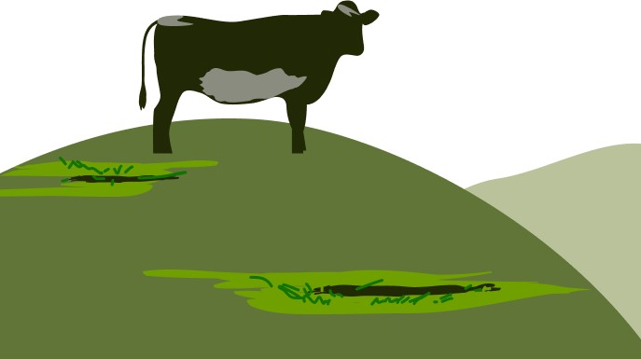

### Formulate a hypothesis

The next step is to form a scientific theory to explain the pattern found. This theory is called a hypothesis. For example, we can assume that a substance in cow manure helps plants grow faster.

### To conduct an experiment

Then, to test your hypothesis, you need to conduct an experiment. In this case you can try growing plants in three types of soil:

* soil with a lot of cow manure;
* soil with a small amount of cow manure;
* soil without additives.

To improve your experiment, you can grow several types of plants in each type of soil.

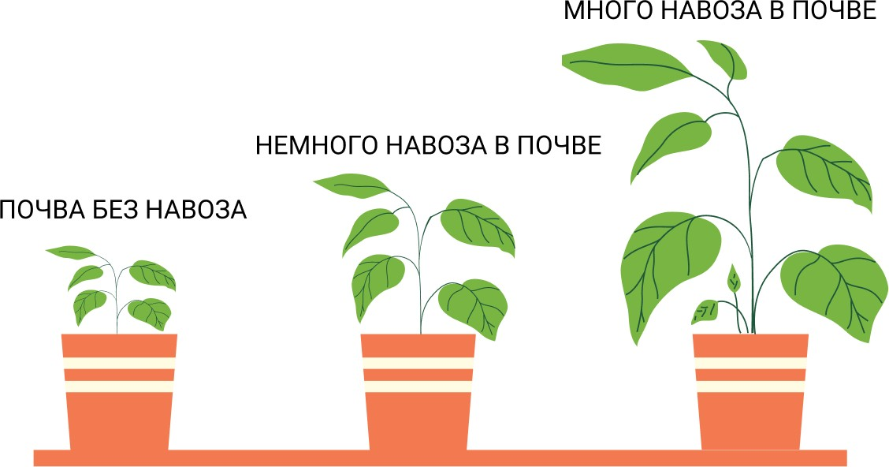

### Collect data

Scientists are very careful to collect the results (data) of experiments. Usually measuring instruments are used for this: rulers, thermometers, scales. For example, to compare the growth process of plants, you can measure their height with a ruler.

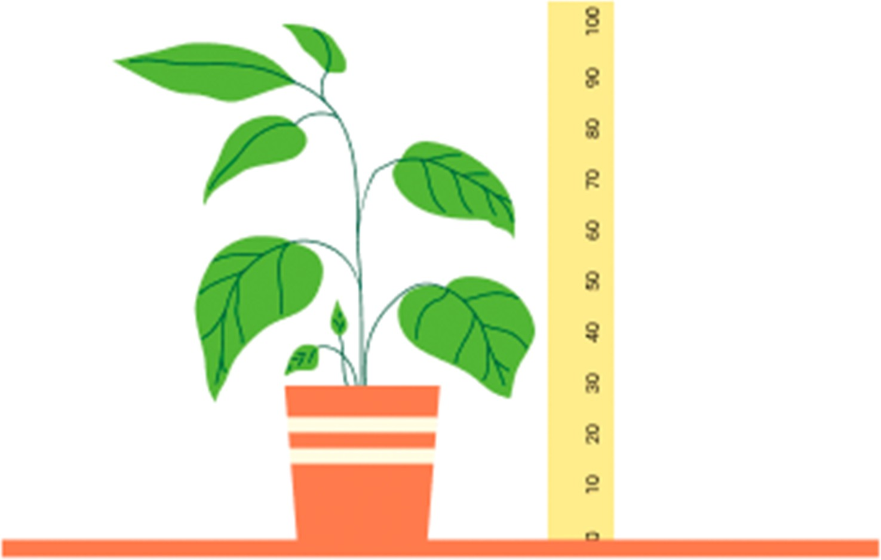

### Analysis of results

To analyze the results, you can put them in a graph. The graph shows the average height of plants grown in different soils. Cultivating a large number of plants makes the calculation of the average value for each soil type more accurate. The results of this experiment will confirm the hypothesis that manure helps plants to grow.

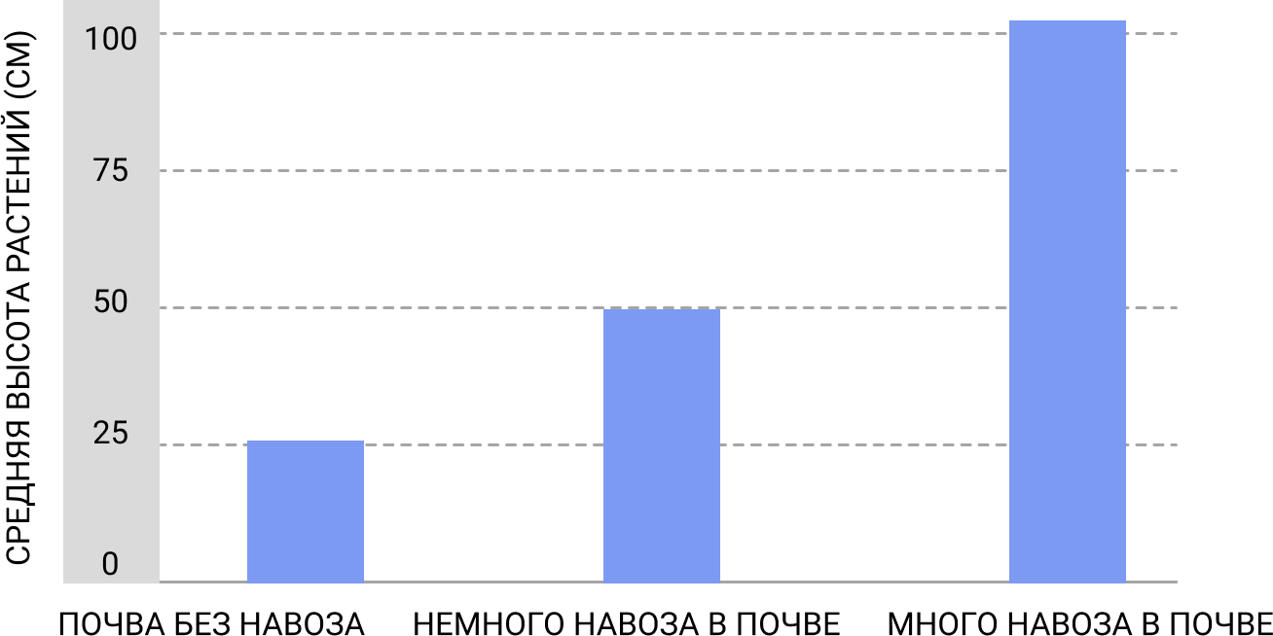

### Repeat the experiment

However, a single experiment does not prove that the hypothesis is correct; it simply provides additional evidence. Usually scientists share the results of their experiments so that others can repeat them. Only after many successful experiments is the hypothesis accepted as fact.



As a result of this method, we came to a conclusion about fertilizer. It is not difficult to understand that this method can be applied to any task.

Understanding the whole process of the scientific method, one understands that resources, including human resources, will be required for its successful completion. In general, it is quite difficult to conduct and organize such procedures alone, especially on a regular basis. And that is why teamwork is important.

### Teamwork

Teamwork in science is very important. All scientists build on the work of their predecessors, either supporting their ideas with new data or refuting them. Scientists work in teams, combining their efforts and expertise, and sharing the results when they finish their work. Teams of scientists can also compete for first place in research.

## Science in work

Working on the basis of science means that we will work cautiously and methodically. This reduces the likelihood of making mistakes. Scientists always try to avoid making mistakes when conducting experiments.

### Taking measurements

Many experiments involve measuring something. For example, when doing a chemistry experiment, you might measure the temperature of a liquid. To get the most accurate data, it would make sense to measure the temperature several times, but you may end up with several different readings.

### Accurate, but not correct

Suppose you have measured the temperature four times and all four values are accurate to two decimal places. But the thermometer is not working properly. The readings are accurate, but not correct.



### Correct, but not accurate

Now imagine that you are using a different, original thermometer, but the reading is slightly different.

The thermometer tip may have hit a different spot each time. The readings in this case are correct but not accurate.



### Correct and accurate

Finally, you stir the liquid before you measure the temperature, and all four readings are exactly the same and correct. Whenever scientists take measurements, they make sure the readings are accurate and correct.



### Offsets

Scientists also try to avoid what is called "bias" because it often leads to measurement errors. For example, imagine using a stopwatch to measure how long a chemical reaction takes. The instrument may be perfectly accurate and in working order, but it takes half a second to press the button itself, which means that all your readings will be incorrect relative to the start of the measurement.

## Engineering design process

When a future professional completes basic education, the question arises: What area of knowledge is worth studying next?

Future scientists or engineers can link their future development to more advanced areas of science called engineering. Here is a list of areas:

* Automotive Engineering
* Architectural Engineering
* Bioengineering
* Genetic engineering
* Mining Engineering
* Knowledge Engineering
* Computer Engineering
* Marine Engineering
* Software engineering
* Industrial Engineering
* Systems Engineering
* Construction Engineering
* Structural Engineering
* Transportation Engineering
* Nuclear Engineering

All engineering professionals, regardless of discipline, follow the same basic principle when solving a problem, which is called the **Engineering Design Process.** It looks like a series of steps, some of which need to be repeated over and over again, especially when improving or testing a design or prototype.

Let's look at the engineering design process as an example of solving a problem from the field of structural engineering.

### Statement of the Question

The first step is to ask exactly what the problem or challenge is, and gather as much information about it as possible. For example, the problem may be to figure out a new and convenient way to get across the river. In order to solve it, you need to answer a number of additional questions. How many people

will cross it and how often? Are there roads nearby? What is the width and depth of the river?

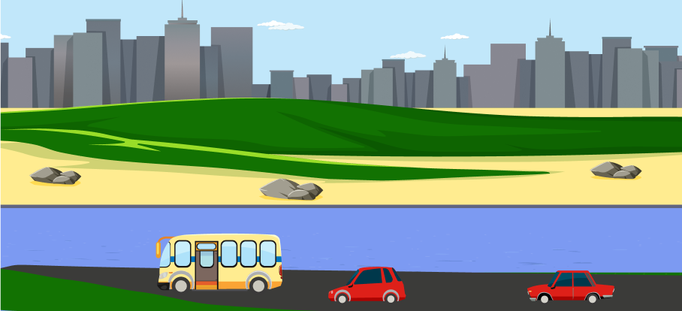

### Idea

The next step is to come up with the maximum number of possible ideas to solve the problem. At this stage, imagination is used to its maximum. You could build a bridge, dig a tunnel, or use a ferry to ferry not only people but also cars across the river. For each option, the pros and cons are considered, the cost is evaluated, and then the best option is chosen from all the options.

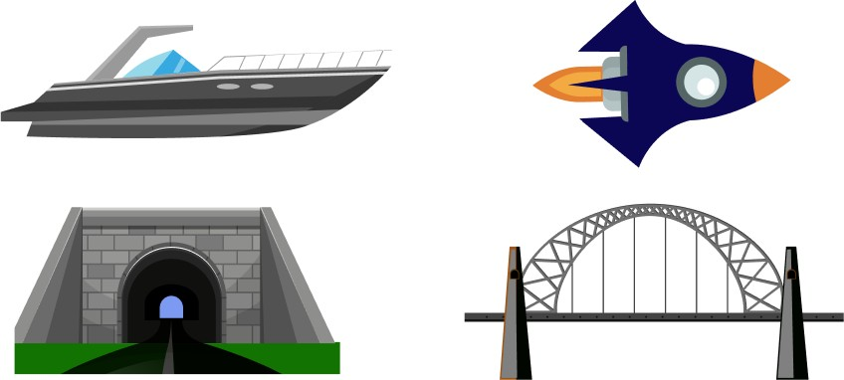

### Plan

After deciding which idea you want to develop next, you need to make a plan. For example, if you decide to build a bridge, you should draw sketches. How big will it be, what type of attachment and what materials will be needed to build it?

### Model

The next step is to build a model of the selected design. This can be a scale model made of plastic, wood or metal, or it can be a digital model made on a computer using a CAD program.

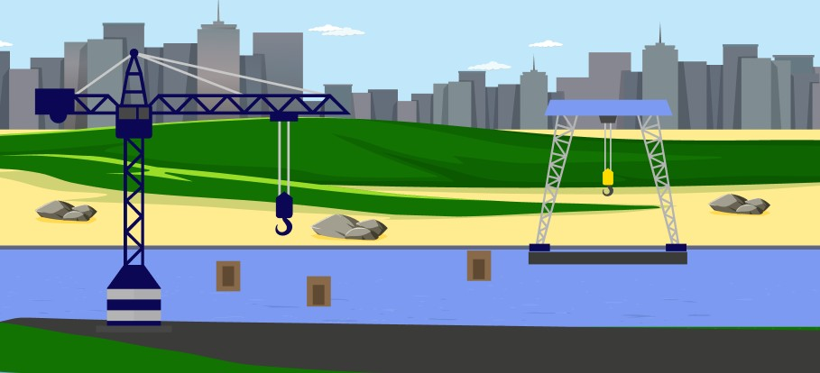

### Testing and improvement

Once the model is built, it should be tested to see how well it works.

If there are any problems, the model should be reviewed, corrected and tried again. Several cycles of testing and improvement may be necessary. Models that have been tested are called prototypes.

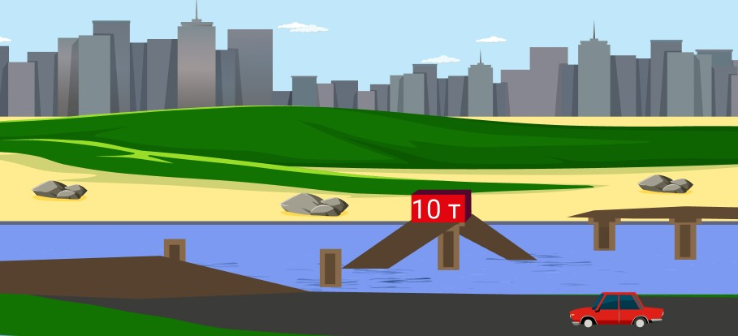

### Publication of results

The final step is to share your results by writing a report or making a presentation. Professional engineers present their results to the client who hired them to work on the project. Then, if the client is satisfied with the solution, the construction of the facility begins.

The publication phase is important because it allows other scientists and engineers to use the knowledge and accomplishments to solve other problems.

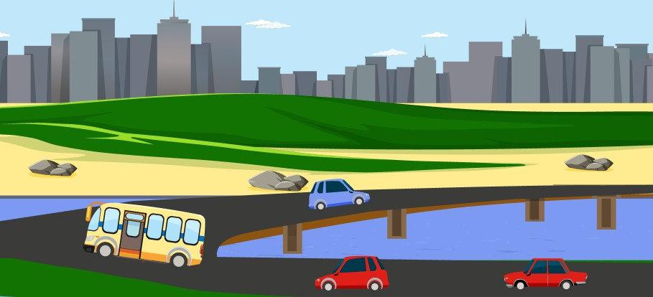

# Appendix 1.

**About safety in science classes**

The rules for practical and theoretical scientific exercises in educational institutions at all levels, as well as in various training courses, are the subject of intense scrutiny all over the world. Why is it necessary to cover safety aspects even when explaining theory? Because the desire to try things out in practice can arise at any time and needs to be prepared for this.

As a result, elementary science teachers should have as much knowledge as possible about the safety of laboratory work. They are expected to adhere to the rules of conduct at all times and to establish appropriate safety requirements for their students. Unfortunately, however, the more rules there are, the greater the likelihood of accidents. Therefore, it is important to keep the rules as few and simple as possible.

This appendix is intended to provide readers with information to help them minimize future risks. Using knowledge of your

The knowledge of the author of this book is not to be compared with Wikipedia, where you can find anything you want just by asking the right question. Of course, the knowledge of the author of this book is not to be compared with Wikipedia, where you can find anything by simply asking the right question. However, this document will give a general understanding of which issues have a special

the importance for the safety of science lessons.

Every country in Europe, America and Asia has its own standards for occupational health and safety, health and safety in general. Our overall goal is to find the best standard or combination of standards to apply in our classrooms. As a result of such a search, this application has used:

* My personal experiences at school and university (sometimes in the most unexpected places);
* information from courses on the basics of life safety, the basics of occupational safety, and ecology;
* The notes from various professional development courses and data from the sections on safety in educational institutions in Europe and Asia;
* information on the U.S. National Science Education Standards, providing deeper insights into issues and assessments of safety in teaching.

The appendix is divided into ten parts, and each part answers one of the questions most commonly asked in science lessons. The overall goal of Appendix 1 is to provide a handy quick reference guide to commonly encountered situations.

You can obtain additional information on site-specific issues from the relevant administrative services: the health department, the police, the fire brigade, the environmental services, the occupational health and safety services. You can also establish working partnerships with more experienced instructors in scientific disciplines that interest you or participate in safety training programs.

## Chapter P1. Where can I find a general checklist questions

## on the safety of science lessons?

### General Questions

The following general requirements must be met in the place where science classes are held:

1. **Have and enforce** safety agreements signed by students and their parents.
2. **Identify** each student's medical and allergic conditions in order to anticipate possible risks.
3. **Provide access and minimize barriers** for students with disabilities.
4. **Check, publish and require** students, parents and fellow teachers to follow all safety procedures. Use safety posters showing basic safety rules for the current educational process.
5. **Knowledge** of local area/provincial/state codes and regulations related to first aid and adequate storage of first aid supplies, providing for constant access to them.
6. **Immediately report** all injuries, including scratches and animal bites and allergic reactions to the appropriate person.
7. **Know** your school's **fire safety rules**, evacuation plans, and where to store and use firefighting equipment.
8. **Publish and display** to students and visitors emergency evacuation and notification plans and emergency phone numbers in each location where science classes may be held.
9. **Ensure** that the following elements are available in elementary school classrooms, lab equipment rooms, and science class materials:

* goggles of an appropriate size to protect against chemical splashes;
* hypoallergenic gloves;
* Non-absorbent, chemical-resistant protective aprons;
* eye wash;
* hoses with safety splash / shower;
* fire extinguishers of categories A, B and C;
* flame-retardant blankets.

1. **Ensure** that you, your students, and all visitors to your class are adequately protected if your scientific work involves interaction with glass (not recommended), heat, chemicals, flying objects, or materials that raise dust.
2. **Implement** sanitation plans for glasses that are used by multiple classes.
3. **Maintain** order in the science classroom.
4. **Limit** the number of students in the work group to such a number that it is safe to perform the required tasks without turmoil or accidents.
5. **Prepare** records, including Material Safety Data Sheet (MSDS) (see question 5), for all chemical materials used for safety awareness and elimination of laboratory incidents.
6. **Provide** comfortable work space for each student, including low tables for students in wheelchairs. Each workstation should be supervised by a teacher (the number of teachers is determined by the school's standards and regulations or by law).
7. **Do not allow** food or drink in the research area.
8. **Do not under any** circumstances store chemical and biological samples in the same refrigerators as food and beverages.
9. **Do not use** mercury thermometers for elementary school students. Any mercury thermometers found in such groups must be removed!

### Precautions when working with glassware

1. **Replace** all glass products in elementary classrooms, labs, and science classrooms with plastic products.
2. **Use** a hand brush, a dustpan and a container for broken glass if any glassware is used (not recommended).
3. **Make** sure students understand not to drink from glass/plastic utensils used for science experiments.

### Precautions when handling chemicals

1. **Provide** equipment and chemicals with legible labels indicating risks and other necessary information.
2. **Store** chemicals in a designated area, such as a locked cabinet or pantry, on wooden shelves with a front rim and without metal supports. Place chemicals at or below eye level. Keep storage area cool, dry and locked.
3. Teach students that it is unacceptable to mix chemicals "for fun" or to "see what happens. Explain that it is not allowed to try

chemicals taste good, and you should wash your hands after working with them.

### Precautions related to electricity

1. **Explain** to the students that DO NOT experiment with electricity at home, at school or elsewhere just to "see what happens". All electrical work should only be done under the supervision and guidance of a teacher!
2. **Make sure that** the electrical cords in the room are not loose and are plugged into the nearest outlet. Make sure that students grab the plug, not the cord, when disconnecting electrical equipment. Electrical cords should be in good condition. Use of extension cords should be minimized.
3. **Make** sure that students' hands and surroundings are dry when connecting electrical cables and when turning appliances, tools, and switches on and off. Water conducts electricity well - it can cause accidents.
4. **Make sure** that all electrical outlets are equipped with ground fault interrupters. Ensure that outlets that are not currently in use are equipped with covers.
5. **Use** only three-pole (grounded) plugs when operating small electrical tools, such as terrarium or aquarium heaters, heaters or small motors. Do not use extension cords!
6. **Instruct** students not to handle any electrical device that has just been turned off, as it can get very hot and cause serious burns.
7. **Explain** to the students that connecting a wire to the battery terminals can lead to hot water, which can cause serious burns.
8. **Remind** students that even hand-held power tools and other non-electric power tools (such as hammers, screwdrivers or hand drills) can slip out of their hands and fly off or cause serious cuts. Always wear appropriate personal protective equipment when working!

## Chapter P2. General checklist of work procedures for laboratory work

### Regulatory safety rules

1. **Knowledge of** local, district and state/provincial statutes and regulations relating to animal care, chemical storage and fire safety. Is there a written chemical hygiene plan in place? Or a safety policy for scientific classes?
2. **Keep** Material Safety Data Sheets (MSDS) for all chemical stocks. Keep a second copy in the main office. Such data should include, among other things, general chemicals and/or chemicals purchased from stores.
3. **Require** eye protection equipment that meets the standard (usually Type G, H, or K chemical splash goggles) as well as gloves and aprons to be used during all activities, including demonstrations that use chemicals, glass, fragile flying objects, or heat.
4. **Dispose of** unwanted chemicals and materials in accordance with area/state/provincial regulations and local rules.

### General safety rules

1. **Learn** about safety risks before the class begins. To identify unintended risks, conduct a "rehearsal" of the class without the students.
2. **Use** only equipment that is in good working order. Use only equipment that is in good working order.
3. **Maintain and ensure** immediate access to first aid equipment (if emergency treatment is permitted by local rules and regulations). The same applies to biological and chemical splash protection materials and equipment.
4. **Never use** unfamiliar chemicals without first obtaining information about them from the MSDS. Before using chemicals for the first time, study the MSDS information and labels on chemical containers.
5. **Never use** mercury thermometers in classrooms/laboratories.
6. **Prevent** contamination due to unused chemicals not being returned to their original containers.
7. Date label all containers in which laboratory chemicals are stored and samples are obtained. Label all containers where laboratory chemicals are stored and samples are obtained.

Label all containers of secondary chemicals and samples (for demonstration purposes).

1. **Use** sturdy plastic equipment wherever possible. **Have a** separate container for broken glass. **Collect** broken glass only with a brush and dustpan.
2. **Check** with the school's medical staff at the beginning of the school year on students' health conditions: allergies, epilepsy, etc.
3. **Refer** to safety guidelines to determine the toxicity of chemicals and plants before using them.
4. **Fasten** long hair at the back. **Secure** loose clothing and dangling jewelry. **Avoid** wearing open-toed shoes and sandals during laboratory work. Clothing must cover the upper and lower parts of the body.
5. **Wear** appropriate safety glasses to reduce the risk of chemical and physical injury, and wear protective laboratory aprons and gloves.
6. **Never allow** anyone to eat or drink in science classrooms/laboratories.
7. **Advise** students not to do lab activities alone, which can only be done under your supervision and after discussing safety procedures and reviewing and approving student "action plans.
8. **Require** students to wash their hands and clean their nails immediately after contact with animals, plants, soil and water samples, chemicals, and lab surfaces. Always wash their hands after completing an assignment.
9. **Teach** students to pick up and carry the microscope by holding it with one hand under the base and with the other grasping the body.

### Classroom management

1. Supervise students at all times. Do not allow them to conduct unauthorized experiments or work unsupervised. Do not ask students to perform experiments at home that pose a risk of injury.
2. **Keep** all students in the field of vision at all times. Organize the science classrooms in such a way that every student is visible, whether working individually or in a group. Periodically update and evaluate everything related to such spaces.
3. **Do not obstruct** exits, access to emergency equipment, or areas with personal belongings.
4. **Involve** students in determining classroom rules, lab safety procedures, and emergency plans.
5. **Do not encourage** agitated behavior (pranks). Immediately and correctly **apply** established rules and procedures.
6. **Personally check** the procedures and rules before the students follow them. This will help to detect unintended consequences and avoid responsibility for them.
7. **Discuss** safety issues with students before each lab session and monitor their behavior.
8. **Ensure** that students with visual impairments are familiar with the venue and equipment and always use both correctly. These children should work with other students who can read instructions (if Braille documents or sound recordings are not available), and in emergencies, direct them to a safe place.
9. **Rehearse** in class the safety procedures required before class begins and have students follow those steps.
10. **Use** student safety contracts. Require parents to read and sign these documents.
11. **Have** a set procedure for accidents or injuries to students. For example, a personal student, telephone, Internet contact, report to the supervisor about an accident or injury, etc.
12. **Lock** science classrooms, lockers, vestibules, etc. when not in use. Do not allow students in chemistry/equipment storage rooms.
13. **Turn off** gas and electrical equipment and close open containers during breaks. If gas is available in the classroom, it should be shut off using the main valve when not in use.
14. **Require** students to report to the teacher about any unusual situations.
15. **Require** students to check classrooms daily to identify safety risks.
16. Only **give** students assignments that are appropriate for their age.
17. Separate the container and label it "Broken Glass" if you are using glass equipment (which is not recommended).
18. **Limit the** size of study groups to the number of students who can safely complete assignments without creating a disturbance.
19. **Display** commercial or student-made safety posters and no-hazard rules in the classroom.
20. **Do not allow** elementary students to give other students chemicals or touch containers that contain hot liquids. **Do not expose primary school students to hot liquids or touch containers that contain hot liquids.**

**decide** to taste something or inhale an odor. If the students are to investigate an odor, they should direct the vapors to their nose by moving their hand. **Under no circumstances should** they sniff the fumes directly!

1. **Dispose of** all chemical waste correctly. A separate container should be used for each type of solid waste. Liquids and solutions that are not hazardous must be discharged into the sewer system one at a time and flushed out separately with large quantities of water.
2. Immediately **wipe up** spatter or ice on tables and floors. Take measures against contamination, if necessary.
3. Require students to wipe down their work areas, including sinks and the floor, at the end of their daily assignments.

## Chapter P3. How to prevent accidents and minimize their consequences?

In the elementary classroom, as a teacher, you should repeat and rehearse all safety rules repeatedly. You are also expected to give an appropriate safety briefing before the students begin their experiments and tasks. You should continually observe the students doing the experiments and the entire classroom environment to spot unsafe activities or situations and respond to them in a timely manner. Students need to know exactly what behavior is unsafe and what is dangerous. They should also be made aware of the reasons why certain safety instructions came into being. The presentation of this information should be simple and easy to understand.

Safety briefings should be given at the beginning of the school year and repeated at regular intervals throughout the year. Pre-action instructions should always include general safety rules as well as specific recommendations and warnings relevant to the work at hand. Here are some rules for student safety instruction. Remember that each briefing should be consistent with the scope and purpose of the safety and emergency procedures that have been developed for your school and district.

1. **Post** short, easy-to-understand safety rules in the classroom and repeat them often with the students. A good way to remind students of safety rules is to post post posters made by the students themselves on the walls.
2. Make sure children are familiar with safety procedures and any risks before beginning experiments or tasks.
3. **Require** students to wear appropriate eye protection.
4. **Detect** allergies in students so they are not accidentally exposed to agents such as animal dander, pollen, or peanuts.
5. **Have** on hand and know how to use approved safety equipment: fire extinguishers, eye wash, and blankets treated with flame retardants.
6. **Conduct** regular safety drills consistent with published fire evacuation plans, as required by law.
7. **Show** students how to call for help (e.g., using the phone or Internet in the classroom) in case of emergencies.
8. **Do not leave** students in the classroom unsupervised except in serious circumstances that require your immediate response. In such situations, leave a trained facilitator in the classroom.
9. **Maintain** the classroom space in order. Provide the necessary space for research/experiments.
10. **Require** students to report any accidents or emergencies to you immediately.
11. Contact the school nurse (if available) and/or your supervisor immediately in the event of any emergency.
12. **Provide** necessary first aid (such as first aid or cardiopulmonary resuscitation) if you are trained and authorized by local regulations to do so. NEVER give students any medication.

If an accident occurs, you must act quickly and follow the procedures approved by your school and local authorities. These procedures should list and describe the specific actions to be taken in emergency situations. Like the safety instructions mentioned above, such procedures should be consistent with the scope and purpose of the safety/emergency procedures. You should also be aware of all applicable laws in such cases.

The following are some general rules of thumb for situations where the classroom is

The school is not allowed to have any accidents. In all accidents it is your responsibility to notify the school nurse (if there is one) and/or the school administration immediately. **These**, in turn, must notify parents and/or seek first aid, depending on the severity of the injury.

### CHEMICALS

**Eyes**

Immediately flush eyes with 16-32 degree Celsius drinking fluid, flow 3

-5 liters per minute. Eyes should be opened as wide as possible and flushing should be done for at least 15 minutes or until emergency personnel arrive.

### Leather

Rinse injured area as soon as possible. Rinse for at least 15 minutes using large amounts of cool tap water or by placing victim under shower. Do not use ointments, baking soda, ice or gauze.

### Clothing

If you get splashed on clothing, wet the splashed areas with cool water and cut/remove the clothing as soon as possible to break its contact with the skin.

### Swallowing

Immediately follow the steps outlined in the MSDS. If the incident involves poisons or corrosive substances, immediately contact your local Poison Control Center or call the emergency phone number. If the student vomits, turn his/her head to prevent stomach contents from entering the lungs. If it is unknown what substances have been ingested, retain all chemical containers and collect a small amount of vomit for emergency personnel to analyze.

### FIRE

**Clothing**

If a student's clothing catches fire, extinguish the flames with a special blanket, shower, and/or method

"Drop and roll," whichever suits the situation best. Never point a fire extinguisher at a student above waist level.

### Leather

DO NOT use ointments or ice if the burn occurs. If the burn seems minor, flush with plenty of cool water and apply a loose, wet dressing. For more severe burns, DO NOT flush with water. Apply a clean, dry bandage. Keep injured student warm to avoid shock.

### Materials

When burning materials, use the nearest Class A, B or C fire extinguisher (A for paper, wood, cloth, rubber or plastic, B for burning liquids, gases or grease, C for electrical equipment) to fight the fire. When using a fire extinguisher, use the PASS method (pull out the stud, point the base of the extinguisher at the flame, squeeze the handle and rotate the extinguisher from side to side). Practice using the PASS method ahead of time without catching fire.

### BODY FLUIDS

**Wear** non-allergenic, disposable gloves for the duration of cleaning. Clean immediately after liquid appears using a pre-prepared 10% bleach disinfectant solution.

**Wipe off** liquids with a paper towel or other absorbent material, then dispose of contaminated material used to remove liquids in a marked container for biological waste (or in a double-layer bag with plastic clips) and mark its contents as hazardous.

**Wash** the area after cleaning with a solution containing 240 ml of liquid chlorine and 4.5 liters of clean-

of standing water. Afterwards, dry for at least 20 minutes.

### PORES

**Wear** disposable, hypoallergenic gloves for approved bleeding control procedures.

**If the cut is minor,** rinse with cool water to wash away any debris, disinfect with 3% hydrogen peroxide solution (pharmacy grade) and, if the school nurse is not available, apply a sterile dressing yourself. If possible, send the student to the nurse for proper care in all cases.

**If there is blood spatter**, follow the contaminated area cleaning procedure above (for biological fluids).

**If you have a serious cut,** call the school nurse immediately and tell the school administration to call a parent and/or the emergency services. Apply sterile gauze to the wound. If necessary, apply direct pressure to the closed wound to stop the bleeding until the school nurse or ambulance personnel arrive. Try to remain calm and reassure students.

## Chapter P4. How to identify chemicals for use

**in the elementary grades and how to handle them?**

Before conducting an experiment or study, you should carefully review the safety of the chemicals, materials, and equipment that students will be working with in the classroom. Your high school chemistry teacher, science department head, or supervisor can provide you with important information about the use of chemicals, materials, and equipment in the classroom. For example, they can help you determine whether you must use the chemicals described in the assignment or whether they can be substituted for others. They can also help you with the identification, purchase, handling, storage and disposal of chemicals. Familiarize yourself with the regulations of the district in which your school is located to find out the specific requirements and obligations associated with the necessary materials. DO NOT allow students to have access to chemical storage areas.

The volume of chemicals used for scientific occupations

The number of types should also be limited. Also, the number of types should be limited. Many chemicals are available at local stores or pharmacies. Read and follow the instructions carefully. Use chemicals only for their intended use.

The Chemical Safety Data Sheet (MSDS) provides safety data for each type of substance. Below are some general guidelines on the purchase, labeling, storage, and disposal of chemicals.

### CHEMICAL PURCHASE

1. **Before purchasing chemicals** from commercial suppliers, review the MSDS overview for each substance. These resources provide important information on physical properties, toxicity, storage, and handling of chemicals. MSDSs are available online at https://www.msds.com/, [http://](http://www.msdsonline.com/) www.msdsonline.com/, or similar resources.
2. **MSDS** data **should be kept as files** and should be available for all chemicals, whether purchased locally or obtained from suppliers.
3. **Whenever possible,** use departmental chemicals that can be found at home, at the store, or at the drugstore. These chemicals can replace laboratory-grade chemicals. Examples of such chemicals are:

* **vinegar** (acetic acid);
* **aluminum foil** (aluminum metal);
* **tablets with vitamin C** (ascorbic acid);
* **ammonia** (ammonium hydroxide);
* **chalk** (calcium carbonate);
* **lime** (calcium oxide);
* **gypsum** (calcium sulfate);
* **rubbing alcohol** (isopropyl alcohol);
* **talc** (magnesium silicate);
* **baking soda** (sodium bicarbonate);
* **table salt** (sodium chloride);
* **table sugar** (sucrose);
* **English salt** (magnesium sulfate);
* **starch** (corn starch).

1. **Limit the amount** of chemicals you buy to the amount you can use in a given storage period. Do not stock too much.
2. **Elementary school students should not use** substances with a flammability category higher than G2 in accordance with GOST 30244-94 or higher than category 2 in accordance with U.S. National Fire Protection Association (NFPA) standards. Exceptions may be made only by experienced high school teachers under their own responsibility.

### CHEMICAL LABELING

1. **Include the name of the manufacturer or supplier** of the chemical, along with their address and contact phone number.
2. **Please indicate the chemical name/trade name** of the product on the product label.
3. **Record the date** of receipt of the chemical.
4. **Use the appropriate risk symbol**. Most chemical kits contain self-adhesive labels or other symbols.
5. **Specify the concentration** of the chemical, especially if it was prepared by yourself.
6. **Place and underline** clear and concise emergency and first aid instructions on the label.
7. **Use a protective coating on** the label, such as clear nail polish or self-adhesive tape, to prevent the label from rubbing off or deteriorating during use.

### CHEMICAL STORAGE

1. **Allocate a separate, lockable space** for chemical storage, preferably away from the classroom.
2. **Use the appropriate warning symbols** to mark the storage location.
3. **Keep a complete list of** all stored chemicals.
4. **Keep a copy of the list of stored chemicals and all related MSDS data** at the storage location. Additional copies should also be kept with the building manager, district science supervisor, or local fire department.
5. **Check and update** the list of stored chemicals annually.
6. **Use the approved guidelines** (e.g. Fire Safety Regulations for the operation of buildings and facilities of educational institutions, enterprises, institutions and organizations of the USSR Ministry of Higher Education PPB-S-1983 (approved by the USSR Ministry of Higher Education on July 30, 1982) Appendix 8 or [http://www.ﬂinnsci.com](http://www.ﬂinnsci.com/) for proper separation and storage of chemicals. It is recommended to use wooden shelves with a front rim that prevents containers from slipping out. DO NOT use uncovered metal supports or brackets.
7. **Store acids, bases and flammable substances** in separate, well-ventilated areas. Such chemicals should be stored only in the manufacturer's original containers or in containers with approved safety features.
8. **Properly dispose** (see below) of chemicals that are unlabeled or unreadable.

### CHEMICAL RECYCLING

1. **Use the information in the MSDS** to dispose of the chemicals correctly.
2. **Observe local regulations** when disposing of chemicals.
3. Contact your local hazardous waste management agency or equivalent county/state/provincial agency, environmental protection agency, fire department, or department of education to determine if specific chemicals require special disposal methods.

## Chapter P5. What protective equipment should elementary school teachers and students use during science classes?

Although materials used in elementary classrooms may not be as hazardous as those used in middle school, teachers should make sure that classrooms are provided with appropriate personal protective equipment to prevent injury and splashing.

### Safety glasses

Standards GOST 12.4.253-2013 (EN 166:2002) or

ANSI numbers Z87 or Z87.1 require that chemical splash goggles be provided to each student if there is a risk of chemical splash or particulate dispersion. These goggles must be available in sizes appropriate for elementary school students.

### Cleaning materials for eyeglasses

Commercial alcohol wipes (not brushes!) are good for killing bacteria and some of the lice that can get on eyeglass frames and temples. Wipe all surfaces that come into contact with your pupils' skin. Ensure that glasses are completely dry before use.

### Non-absorbent, chemical-resistant aprons

Protective aprons must be provided to each student whenever there is a risk of spilling or splashing chemicals or hot water. Aprons are provided by the teacher in sizes appropriate for elementary school students.

### Protective gloves

Elementary students should wear protective gloves when handling animals, plants, soil samples or any other material that may contain dangerous micro-organisms or allergens. Gloves may also be used when handling certain chemicals that can irritate or stain the skin. You should know if any of your students are allergic to latex.

### Eye wash

Portable nozzle-type eye wash devices (available from a number of science equipment suppliers) should be on a flexible hose that allows the student's eye to be flushed if chemicals or foreign particles (salt, sand) get into it.

### Fire extinguishers

You must have the required number of category A, B, and C fire extinguishers at your disposal (A is for

B - for burning liquids, gases or lubricants, C - for electrical equipment). Fire extinguishers must be located no more than 20-30 steps away or be accessible within 10-15 seconds from any point in the room. At least once a year they should be inspected and a certificate issued to certify that the extinguishers are fully filled and ready for use. Remember to use the PASS method (remove the pin, point the extinguisher at the fire, squeeze the handle and move it from side to side). Do not point the fire extinguisher at students!

1. **Body and face sprinklers with elbow or forearm control** Water sprinklers with flexible hose

The fire extinguishers should also be positioned according to the requirements mentioned above (20-30 steps away and within reach for 10-15 seconds). They are used to extinguish burning hair or clothing.

### Ground fault interrupters and outlet covers

These devices must be installed on all electrical outlets in the room where elementary school students are taught. Roof

The socket outlets prevent objects from being inserted into the outlets. Socket outlets should be located along walls or desks at a distance of 1.8-2.5 m from each other and covered when not in use.

### First Aid Kit

If allowed by local and state/provincial regulations, keep first aid kits in the classroom for emergencies. Coordinate with the school nurse regarding the contents of the kits. You should be aware of whether students are allergic to the materials contained in the first aid kit.

### Safety posters

Posters with safety rules for younger students (best if made by the students themselves) should be prominently displayed throughout the room.

In addition to the equipment described above, descriptions of procedures and emergency telephone numbers should be prominently displayed. The locations should be chosen so that they can be seen quickly if necessary. The same is required for descriptions of how to dispose of the following items: Bacterial growth containers

Therrium, chemical waste, animal waste, dead plants, and spilled liquids.

## Chapter P6. What guidelines define the characteristics of elementary classrooms, laboratories, and science classrooms?

The following guidelines may be considered exhaustive, but it is important to remember that our world is far from perfect. Therefore, they should be regarded as guidelines (in some areas/states/provinces they may be mandatory under the relevant building codes). If possible, these standards should be adhered to in the planning and completion of building construction and renovation.

1. **Provide access** for students with disabilities.
2. **Organize a storage space/room for** supplies and equipment with lockable cabinets and open shelves mounted on the wall or floor. The size of the storage area should be based on the number of students.
3. **Organize sufficient space** in each room for scientific classes. The required space is determined by regional/state/provincial regulations.
4. **Maintain adequate natural light** and/or diffuse workplace lighting (538.2 to 1,076.4 lumens per square meter) for all activities.
5. **Provide a telephone** to notify medical personnel or school administration of emergencies and accidents.
6. **Provide two exits from the classroom**. Both exits should open to the outside and be at least 1.5 meters wide so that they can be used by students with disabilities and equipment carts can pass through them.
7. **Have three classes of fire extinguishers available: A, B and C** (A for paper, wood, cloth, rubber or plastic, B for burning liquids, gases or grease, C for electrical fires), as well as fire blankets and eye wash equipment. All of this equipment must be at a height appropriate to the age and height of the students in the classroom. Eye wash equipment should be located no more than 10 seconds and no more than 20 paces from any point in the room. They should be checked monthly and activated weekly. Variations of these requirements can be found in local regulations.
8. **Do not secure tables to the floor**. Tables must be secured to the floor. Do not fix the tables to the floor.

The first step in this process is the creation of a new space.

1. **Provide** each student **with** the space necessary to perform their assigned science experiments. A maximum of four students should work at each table. The limit may be increased for large communal tables.
2. **Maintain a safety ratio** of 1 teacher per 24 students in science classrooms. In the case of project work to create products, use a ratio of 1 teacher per 6 students.
3. **Ensure good ventilation** and adequate air exchange for student comfort.
4. **Provide black plastic** (good) or epoxy (excellent) that is resistant to chemicals and heat for constant use with chemicals or heat sources.
5. **The floor should have** a non-slip vinyl coating.
6. **Use electrical outlets with covers**. Ground fault interrupters should be installed near sinks, 1.8 to 2.4 meters around the perimeter of the tables. If outlets are not in use, they must be covered.
7. **Ensure that shut-off valves** for gas, electricity and water **are installed.** They should be located near

The teacher's desk, locked cabinets on display desks, or other places inaccessible to students.

1. **Provide large sinks**, 40 by 50 cm, with mats, and sources of cold and hot water (but not boiling water!). All sinks should have valves with curved tubes that direct the flow of water downward.
2. Provide space for computers (one computer per student), televisions, and other equipment on the perimeter tables. They should not be near sinks and activity centers. Outlets (see above) should be equipped with ground fault interrupters with surge protection.

## Chapter P7. What are the precautions to take when there are animals in the classroom ?

Every science teacher will attest that studying animals in the classroom allows students to develop observational skills as well as an understanding of the interconnections and complexities of life. However, the teacher must have knowledge of how to properly care for animals when studying them in the classroom, as well as the precautions necessary for student safety. In addition, the teacher should be clear about the learning objectives for which animals must be present in the classroom. Before bringing any living creature into the classroom, familiarize yourself with the relevant regulations of your school, district, or county/state/province.

### Animal Care

1. **As a teacher** it is your responsibility to make sure that the animals in the classroom receive proper care, including proper lighting, climate control, proper nutrition, and sanitation. Care for the animals should be continuous, including weekends and vacations.
2. The goal of animal care should be to ensure the **comfort and humane treatment** of the **animals.**
3. Cages should **be adequately sized**, cleaned daily, and kept securely locked in a safe, comfortable environment.
4. For all mammals, you should use

### water bottles.

1. Animal **waste** should be wrapped in newsprint, then placed in a plastic bag and sent to the trash can. Usually such waste is not harmful to the environment.
2. **The interaction with animals should be minimal**, gentle and only after proper instructions and demonstration. Students should wear hypoallergenic gloves when in contact with animals and wash their hands thoroughly afterwards. Avoid sudden movements that might frighten the animal.
3. **A new animal** should be given a few days to get used to the unfamiliar environment. Only after this period may students be allowed to approach the animal. Take precautions when approaching a new animal for the first time. Until the animal has become accustomed to its surroundings and its handling, only you or someone familiar with the animal should come into contact with it. Wear thick gloves when handling the animal.

### Students should not be allowed to tease the living

animals, throwing things into their cages, or disturbing

them, especially while the animals are eating, sleeping, or giving birth.

### Precautions for handling animals

1. **Always buy healthy animals** from trustworthy sellers.
2. **Do not allow students to bring wild animals into the classroom**. Wild animals such as turtles, snakes, birds, spiders (spiders or ticks), and insects can carry serious illnesses and behave unpredictably.
3. **Do not encourage students to bring their pets to school**. If it is allowed to bring a pet into the classroom, only the owner should have contact with it. In addition, make arrangements for the proper care of the pet during such a visit. Be sure to ask the owner for a veterinarian's certificate to ensure that the pet is healthy.
4. **Never allow poisonous animals in the classroom**. These may include some types of spiders, insects, lizards, and snakes.
5. **Determine in advance if students have any allergic reactions** related to animals. These may include reactions to guinea pig dander, hogs and other animals with thick fur, as well as re-

The school nurse should have anti-allergic medication on hand in case of an allergic reaction. The school nurse should have anti-allergic medication on hand in case of an allergic reaction.

1. Only **pick up rabbits, hamsters, mice and lab rats** by the neck crease at the scruff of the neck, supporting the animal's body with the other hand from below. When interacting with a cub, take its mother to another cage, as she may instinctively defend the cub fiercely.
2. **Do not allow students to stick their fingers** in the cages of animals, as they may bite, scratch, or hit them in defense.
3. **Report bites and scratches** immediately

to the medical leadership of the school.

1. **Do not leave dead animals** in the room, as the exact cause of death may not be known. Contact a veterinarian to examine any animal that was in the classroom and died unexpectedly.
2. **Make plans** for caring for animals (or removing and returning them if necessary) during the vacations and at the end of the school year.

### Experiments with animals

1. **It is optimal to** use invertebrate animals **in the elementary grades.** It is good practice to order live animals from a scientific supplier

with a proven reputation. When ordering, consider the delivery date because animals can be very sensitive to environmental conditions.

1. **Experimental procedures causing pain or discomfort should not be performed** on mammals, birds, reptiles, amphibians or fish. Research on vertebrates must be limited to observing their normal functioning, such as growth, feeding or life cycles.
2. **Animal dissection by students is** generally not recommended for elementary grades. If you decide to allow older and more experienced students of the upper elementary school to perform dissections, use only preserved lower animals (e.g. worms, insects and crustaceans). In any case, students should be fully briefed on the procedure and safety precautions and their actions should be closely monitored. For those who do not wish to take part in dissection, information should be provided on alternative methods of investigation, e.g. using multimedia tutorials.
3. **Live cultures of bacteria and fungi** should not be used for science classes in the elementary grades. If such cultures are to be displayed, make sure that the container is sealed tightly and cannot be opened by students.
4. **If you must bring pond water into the classroom,** never take it from contaminated or contaminated sources. Make sure students wash their hands thoroughly immediately after class.
5. **Watch for allergic reactions** when examining insects and be aware that some insects may bite or sting.
6. Clean **the owl bobbins** for the classroom study beforehand. Find out if any students are allergic to down and feathers - they are often found in owl coils.
7. **When studying chicken bones**, carefully remove any remaining meat and soak the bones in a weak bleach solution for at least three days before allowing students to examine them.

### Students should always wash their hands thoroughly

after animal research.

## Chapter P8. What precautions should be taken when using plants in the classroom?

Elementary schools often use a variety of plants for both classroom design and learning. Plants in the classroom help students understand the needs of living things and improve skills such as observation, measurement, and classification. Taking care of plants is relatively easy, even during field trips or short vacations. Still, you should keep in mind some precautions and safety considerations.

### Plants in the classroom

1. **Explain to the students that you should never taste** any parts of unfamiliar plants, including berries and seeds, whether in the classroom or on a field trip. Help the children understand the difference between edible and inedible plants, vegetables, and fruits.
2. **Plants containing poisons** should not appear on school premises.
3. Examples of plants that can be poisoned by ingestion are **azalea, lantana, delphinium, iris, phytolacca, tussock, hemlock, foxglove, datura, diffen-**

### bahia, philodendron, caladium, horse chestnut and belladonna.

1. Examples of plants that secrete poisonous sap include **borage, oleander, milkweed and campsis.**
2. Plants that are poisonous to the touch because of the oils they emit include **poisonous willow, poisonous oak, and poisonous sumac**.
3. Some plants with edible parts may also have inedible or even poisonous parts, such as **potato leaves, rhubarb shoots and leaves**.
4. Students should never touch unfamiliar plants!
5. **Teach your children not to touch any mushrooms** they may find in the street, since many varieties of mushrooms are poisonous.
6. **Symptoms of plant poisoning** include headache, nausea, dizziness, sweating, chest pressure, vomiting, skin rashes, itching, or dermatitis. When these reactions occur, students should be treated immediately.
7. **You must be able to distinguish** poisonous plants to prevent them from entering the classroom and ensure that students avoid such plants if they see them on the school grounds.
8. **Find out if** students are allergic to any plants. Many people tend to be allergic to plants.

The following are some of the most common reactions to pollen or mold, so exposure to such plants should be avoided or minimized.

1. **Substances** for **plant nutrition or** care chemicals must be labeled and locked away in cabinets. Chemical Safety Data Sheets (MSDS) must be available for each such substance. Always wash your hands and clean your nails after using these substances. Protective eyewear and gloves should be worn when handling feed or chemicals and precautions should be taken against dust.
2. **Think before you burn something** on your skin: some plants release toxins when they burn, which can get into your respiratory system.
3. **Wash your hands thoroughly** after every contact with plants, especially before eating.
4. **Get the phone number of** the nearest poison control center and place it in a place where it can be easily and quickly seen.

### Experiments with plants

1. **Most of the work with plants** in the classroom involves germinating seeds and planting plants. It is safe to use either beans and seeds from the store or specially packaged seeds prepared for germination. Do not use-

Do not use seeds that are intended to be planted in the garden or field: they may have been treated with chemicals. Such seeds often have pink, blue or green spots on their surface. They can irritate sensitive skin and, if eaten, can lead to poisoning.

1. **Wash your hands thoroughly** or wear hypoallergenic gloves when working with plants. Avoid plants with thorns or sticky parts.
2. It is safer to use sterilized soil in airtight containers **when studying soil.** Soil taken outdoors can contain mold and fungi. When studying soil in nature, students should use the proper tools for digging and exploring. Do not do this with your bare hands!
3. **Be careful when examining aquatic plants** taken from ponds and marshes. The water in a body of water may contain contaminants that can cause disease. Avoid direct contact with water or mud if you are not wearing gloves. Wash your hands thoroughly after such work.
4. **Rinse all surfaces** thoroughly after handling the plants.
5. **Purchase** plant specimens from reputable scientific suppliers.

## Chapter P9. What safety issues should be considered when planning and conducting field trips and field experiments?

Both science and environmental educators agree that field experiments are essential to effective learning for elementary students. The experimental background provided by research and various nature-based activities is an excellent complement to academic instruction and reinforces civic skills and personal responsibility.

Whether such activities take place on or off the schoolyard, two basic elements are necessary for their success and safety: careful planning and accurate execution.

### Planning

1. **Familiarize yourself** with and follow your school or community's outdoor safety guidelines.
2. **Visit and study the** field **beforehand**, instruct students in advance

possible problems (e.g. deep water, allergenic plants, slippery places).

1. **Make sure parents or guardians are fully informed** about the upcoming field experiment, know what clothes the students need, and all other relevant information.
2. **Ask about medical and physical problems of** your students that might affect the field experiment (e.g., allergic reactions).
3. **Sign a safety contract with parents and students** that includes rules and expected student behavior.
4. **Collect and retain** signed forms from parents or guardians authorizing the class before proceeding. Include contact or other emergency contact information and a copy of each student's insurance card. Make sure that the decision forms have been approved in advance by the appropriate school or district leaders. The forms should be taken on the field trip so that they can be given to the doctors/hospital in case of an emergency.
5. **Use school-provided vehicles and drivers** if transportation of students is necessary. For long field trips with students, it is recommended to have a school medical

and material insurance. Discuss **the rules of conduct** with the students beforehand and remind them periodically during the tour.

1. Include **additional** adult **observers.** Count on having at least one adult (approved by the school) for every 10 students. Consider "assigning" specific students to specific adults in the group. Adult chaperones should be warned in advance of all risks, rules, and emergency procedures.
2. **Take your cell phone with you** in case of emergencies, and a basic first-aid kit to treat minor abrasions and scratches.
3. **Make** sure students have a good understanding of what they will be doing and are aware of possible risks to be avoided.
4. **Make sure** that if the field experiment involves water, at least one adult observer is trained in water rescue, including CPR. If student activities are planned in or on the water, children should wear life jackets.

### Execution

1. **Check the weather forecast** before you go out in the field. Pay special attention to the possibility of storms or other extreme conditions.
2. **Make sure all students** are dressed appropriately for the field experiment.
3. With students and chaperones**, review expected** student **behavior** and precautions on site.
4. **Emphasize the learning objectives** associated with the field experiment and focus students' attention on their goals or objectives.
5. **Pair or group students together** to reinforce mutual responsibility. Accompanying adults should help students stay together and focus on the goals of the field trip.
6. **Move around** all the time, observing what the students are doing.
7. **Use only plastic containers** if the task involves collecting anything; avoid glass containers and use hypoallergenic gloves.
8. In the event of an accident**, seek professional medical attention** as soon as possible.

## Chapter P10. What is the legal responsibility of an elementary school teacher for the safety of science classes?

These materials are intended for science teachers in elementary grades. They include safety issues both for independent science instruction in the laboratory and for science programs distributed by county departments. These guidelines are not intended to be comprehensive, but rather to be indicative. For more comprehensive information on the safety of science classes, please refer to the regional/state/provincial legal regulations.

Negligence, as defined by the courts, is conduct that does not meet statutory standards or professional requirements to protect others from unreasonable risks or the exercise of due care. In the absence of specific laws or local regulations, it is assumed that such standards are prescribed by the profession.

The elementary school teacher, like all science teachers, must remember the three main responsibilities associated with the modern concept of negligence:

* **the duty of instruction;**
* **duty of observation;**
* **duty of maintenance.**

Teachers who are well aware of their legal responsibilities apply reasonable evaluations and take all necessary steps to avoid perceived dangers and not to worry that students may be injured. The law does not require you to be clairvoyant. It only requires that you take all reasonable precautions to protect yourself and your students. The best option is to document your instructions and precautions taken for every action you take. For example, a "Safety" section should be included in all lesson plans that involve hands-on activities. Failure to fulfill any of your responsibilities could result in the teacher and/or school administrators being found responsible for the damage.

**The duty of instruction** implies adequate instructions (if possible, in writing) to be given before carrying out a scientific activity, study or field experiment. Such instructions should:

* to be exact;
* to fit the situation, attitudes, and developmental level of the students;
* Consider any foreseeable hazards and risks related to the activity;
* Explain how to properly perform the necessary procedures/methods;
* include comments on acceptable/unacceptable behavior during instruction.

Instructions must comply with professional and local guidelines or those of the region/state/province. Consult with your supervisor, and familiarize yourself with established safety policies and procedures. Does your community have a scientific safety policy and a chemical hygiene plan? Does your school have its own scientific safety plan based on the district rules? Make sure that any activities, investigations, and field experiments you plan to conduct are appropriate for the grade level and age of the students. If in any doubt, consult with the building administrator, the lead instructor, or the district science specialist.

Teachers who neglect proper safety procedures and thereby set a bad example for their students may be found guilty if students follow these unsafe practices and get hurt.

**The duty of supervision** is defined by professional, legal and district guidelines. Its purpose is to ensure that students behave appropriately in light of any foreseeable risks. The following should be kept in mind:

* You can't ignore any type of misbehavior;
* Lack of action in the case of unacceptable actions of students is grounds for liability;
* The higher the degree of possible risk, the more careful monitoring should be;
* The younger the students and/or the more students who need more help or attention, the higher the level of supervision;
* Never leave students unsupervised, especially in non-routine situations where the risk to them may be greater than anticipated. Even in emergency situations, try to minimize risks or transfer responsibility to another person before leaving the com- pany.

For field experiments or studies requiring a high degree of attention and observation, the instructions should identify additional responsible adults. These persons must be trained in the procedures/methods involved and understand the foreseeable risks.

**The obligation to maintain** means creating a safe environment for students and teachers. The teacher is required to:

* Never, for any reason, use defective or improperly sized equipment;
* Keep instructions for use for maintenance and repair of potentially hazardous conditions or defective equipment;
* Establish regular inspection plans and procedures for checking the safety of classrooms and first aid facilities;
* Follow all school and district safety guidelines regarding labeling, storage, handling, and disposal of chemicals.

The school management should keep folders of all risk notices and inspections. In the event of an accident, this may minimize or even eliminate your and the school's personal liability.

## Links

1. Legal Reference System "Consultant+[" http://www.consultant.ru/](http://www.consultant.ru/)
2. Garant Legal Reference System [http:// www.garant.ru/](http://www.garant.ru/)
3. Reference legal system "Codex[" https:// kodeks.ru/](https://kodeks.ru/)
4. MSDS Online: <http://msdsonline.com/>
5. Safety of Scientific Learning, Institute for Laboratory Safety: <http://www.labsafety.org/>
6. U.S. National Association of Biology Teachers: <http://www.nabt.org/>
7. U.S. National Firefighters Association: [http:// www.nfpa.org/](http://www.nfpa.org/)
8. Center for Academic Safety Information, Wellesley College: <http://www.wellesley.edu/>

### Yaroslav Artsishevsky

How the mind is born

Practical methods of teaching science education to children in China

*Editor* Anastasia Fokina *Editor* Anna Stolyarova *Corrector* Venera Akhunova

*Cover design* by Miguel Jurado

*Illustration design* by Alexander Yakovenko

*Photographer* Alice Lood

Created in the intelligent publishing system Ridero